15/4/ 25 - JavaScript fundamentals. – Everything in JS happens inside the execution context. It has 2 components variable env and thread of execution.

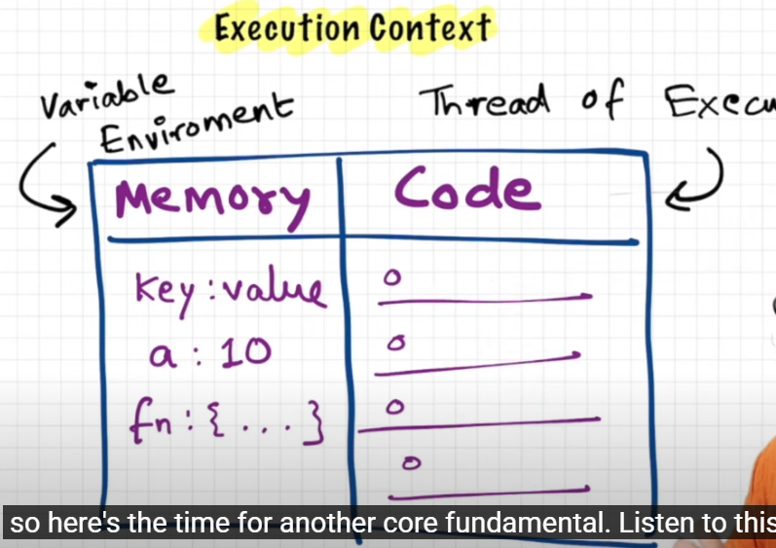

16/4/ 25 - Code in JS is executed in 2 phases –

1. Memory allocation phase
2. Code execution phase

Memory allocation phase

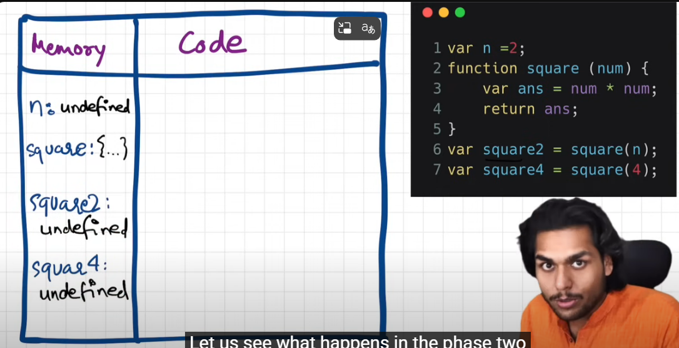

Code execution phase

First line 1 is executed and n becomes 2

Then we see there is nothing to execute until line number 6. Here another execution context is called and same phases are invoked as the global execution context.

Num gets assigned undefined and ans is undefined at the first phase

Then code execution takes place, num=2, num*num is executed, ans is returned and ans=4

4 is returned back to line 6 as the function was invoked from that line.

after the first square function is called

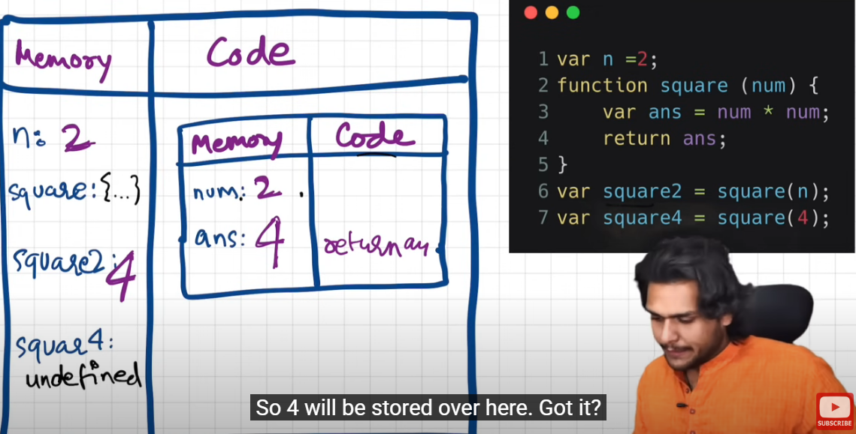

After function execution the, the whole execution context will be deleted.

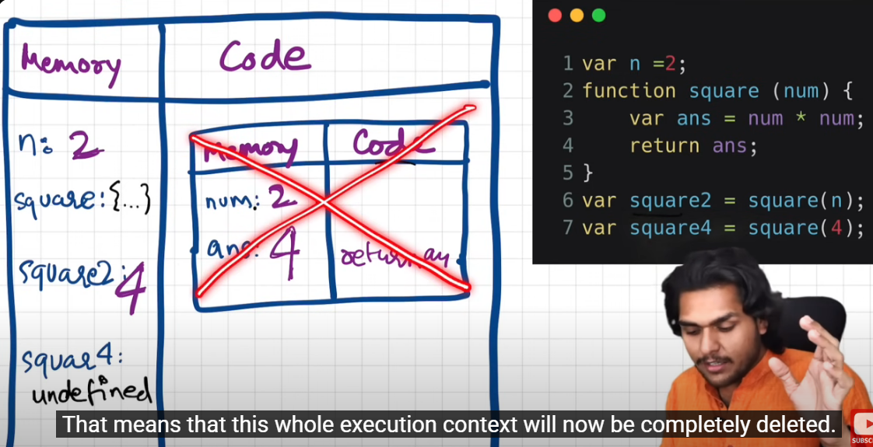

Line number7 is encountered and same process will repeat,

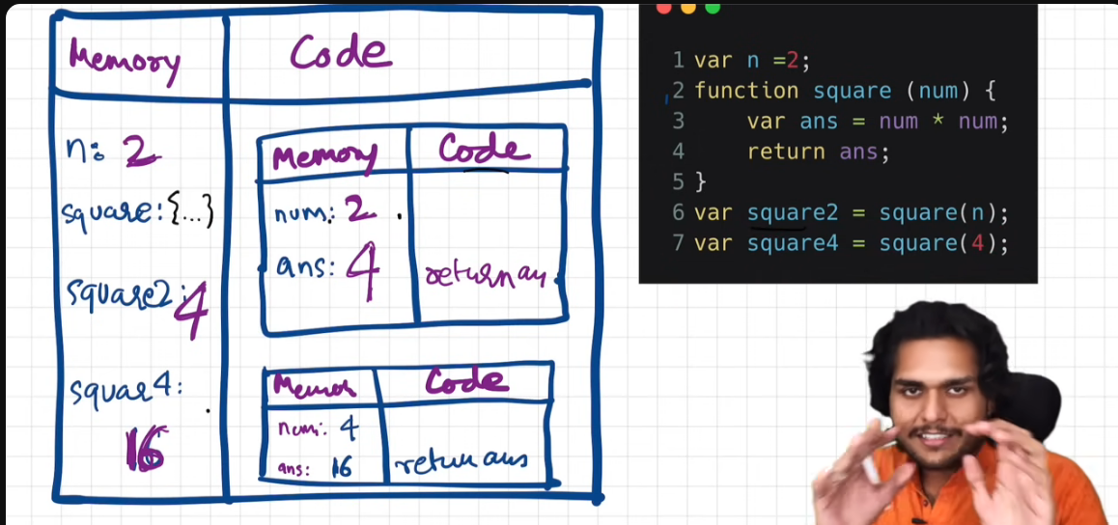

At the end of the program after the program is completed the entire global execution context is deleted.

Call stack is maintained by JS to manage the execution contexts

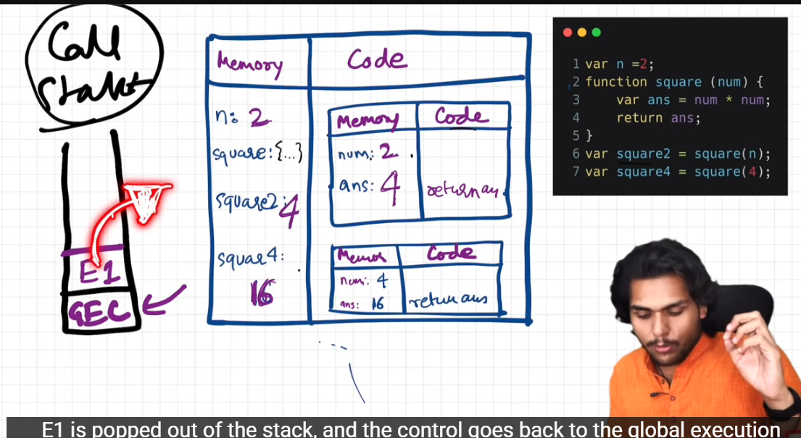

Call stack maintains the order of the executions of the execution contexts.

Call stack has many other names

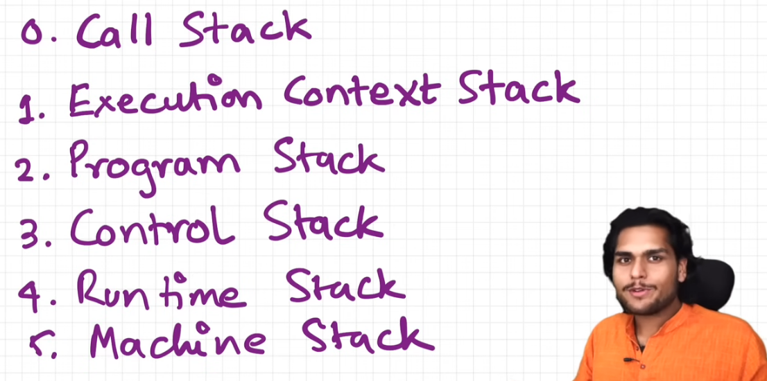

17/4/2025

Hoisting in JS

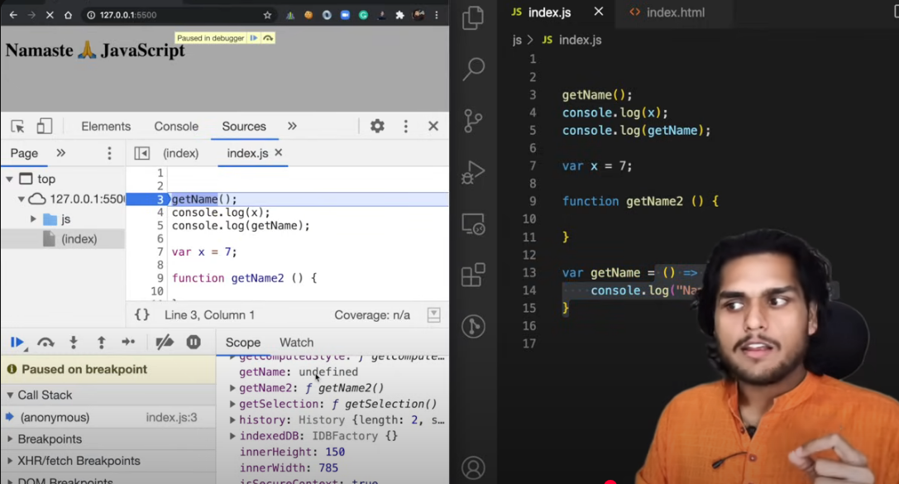

Hoisting in JavaScript is a behavior where variable and function declarations are moved to the top of their scope before code execution (The process by which phase 1 is executed, basically). This means that you can use a variable or a function before it is declared in the code.

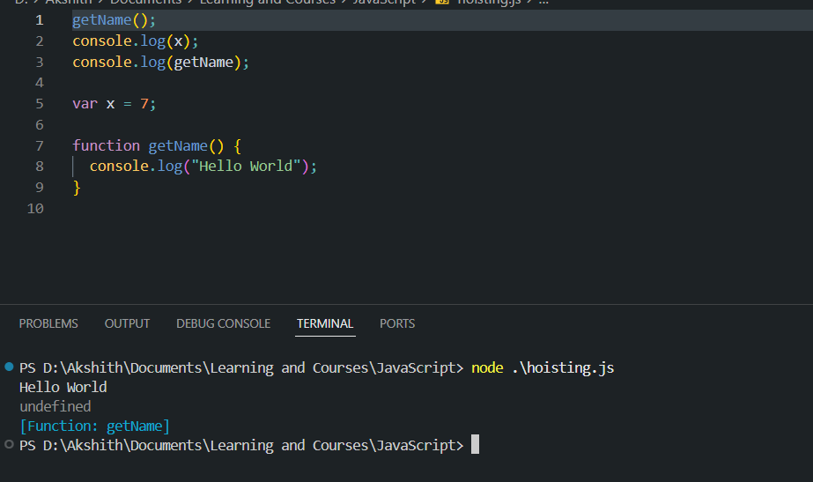

We get error because we are trying to execute an undefined variable

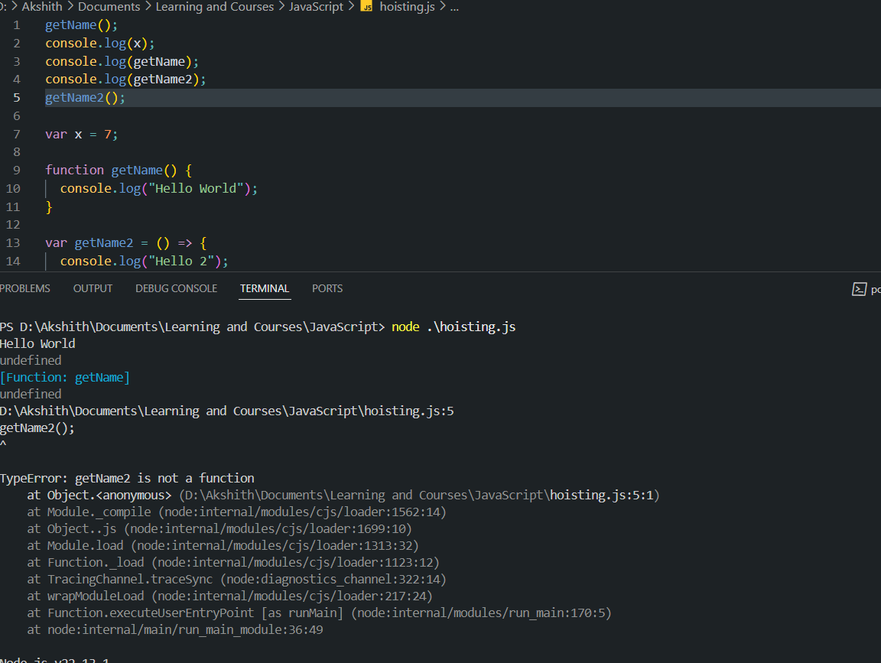

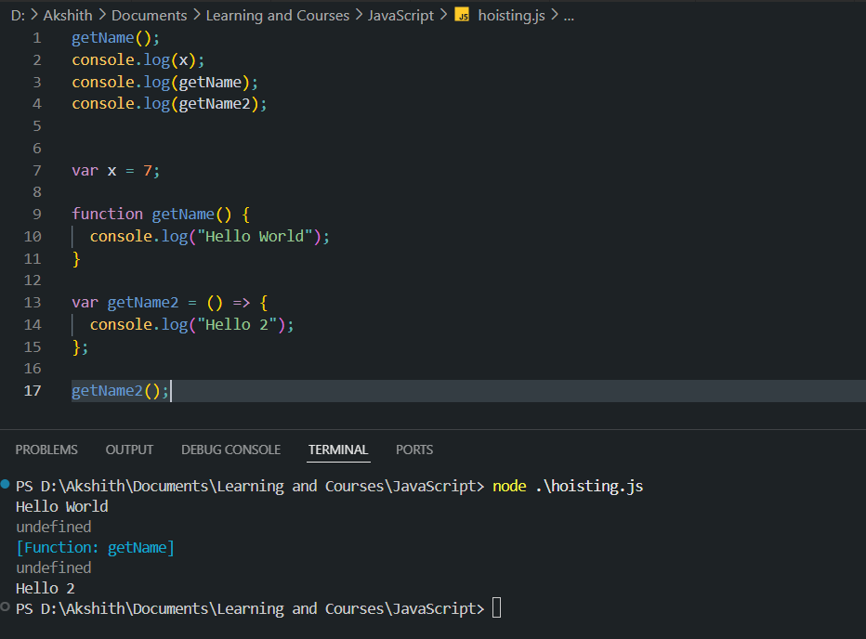

18/4/25

Function invocation and functions in JS –

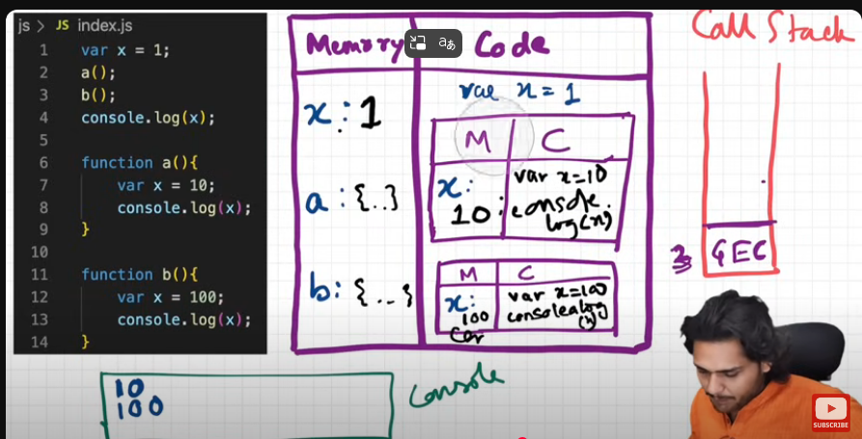

Undefined vs Not defined

Undefined

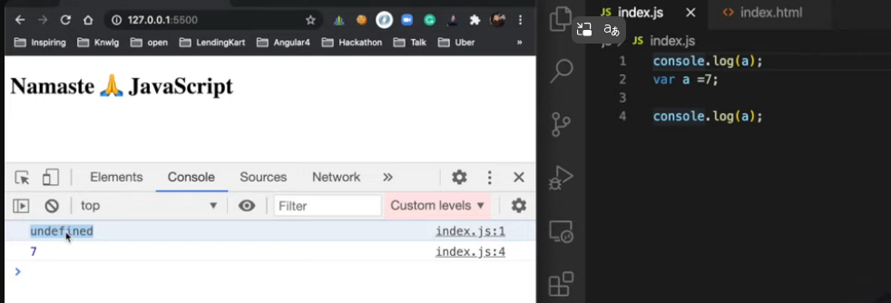

Not defined

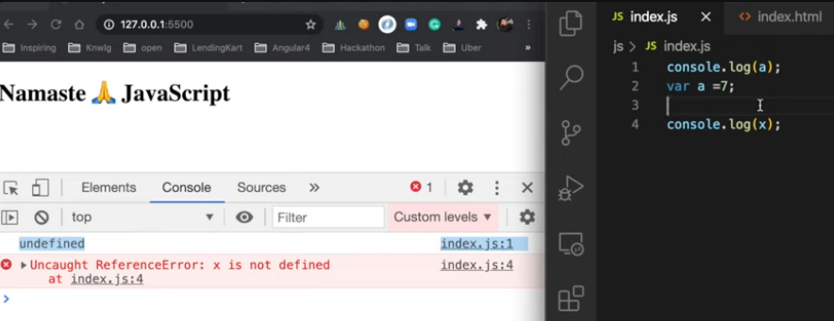

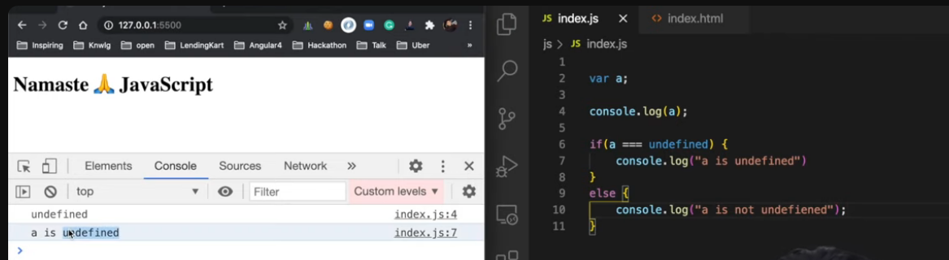

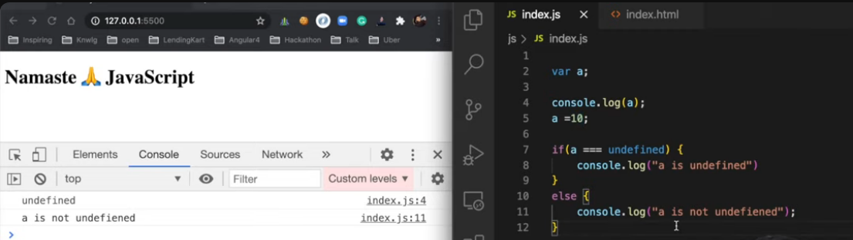

JavaScript is a loosely typed/ weakly typed/ flexible language, variable types can be interchanged.

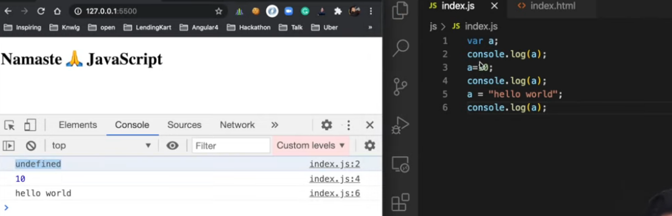

19/4/25 - Scope in JavaScript

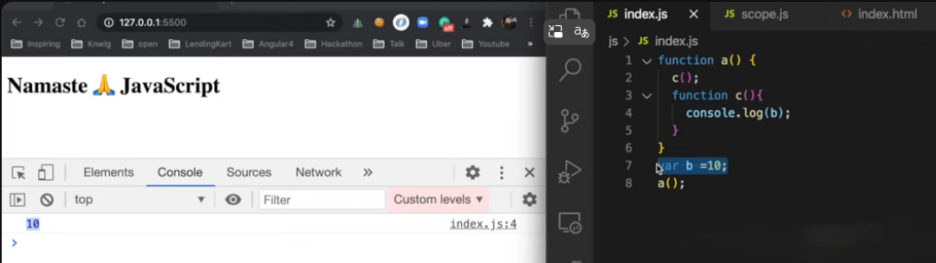

I can access b within function c which is within a, though b is defined in the global space.

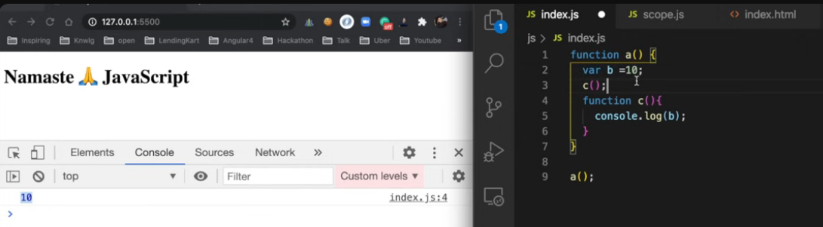

I can access b again with b defined inside a as function c also is defined inside a.

But in the below case I cannot access b in the global space as b is defined locally inside a only, It is available inside “a” and within functions defined in “a”.

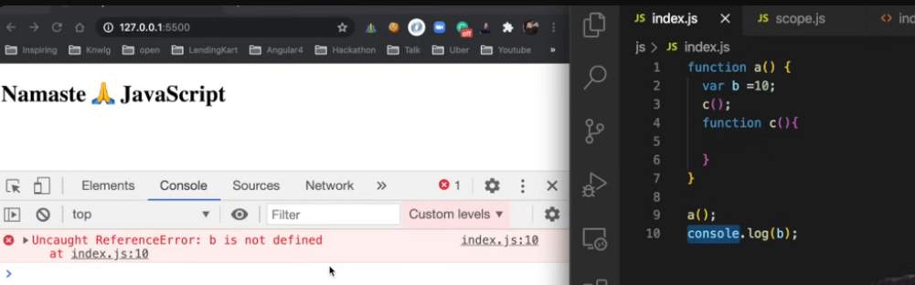

Understanding lexical environment and Lexical memory-

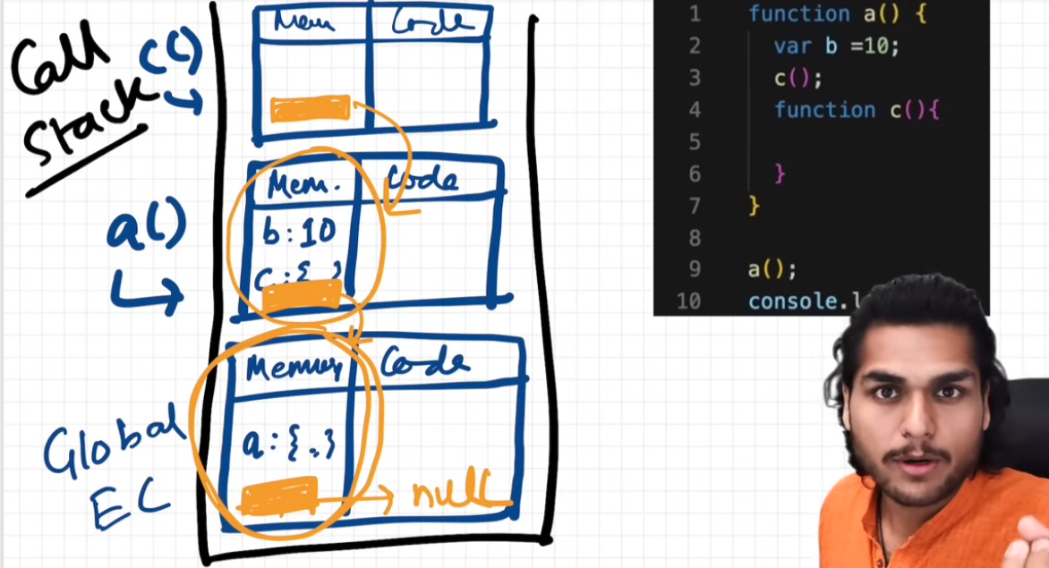

Scope in JavaScript determines the accessibility or visibility of variables, functions, and objects within different parts of the code. It helps to avoid naming conflicts and manage variables effectively.

A lexical environment in JavaScript is a structure used to store information about variables and functions within a specific scope. It is created whenever an execution context is established, such as when a function is called or a code block is entered.

The scope chain in JavaScript governs variable accessibility. When a variable is accessed, the JavaScript engine searches for it in the current scope. If not found, it moves up the chain of outer scopes until it reaches the global scope.

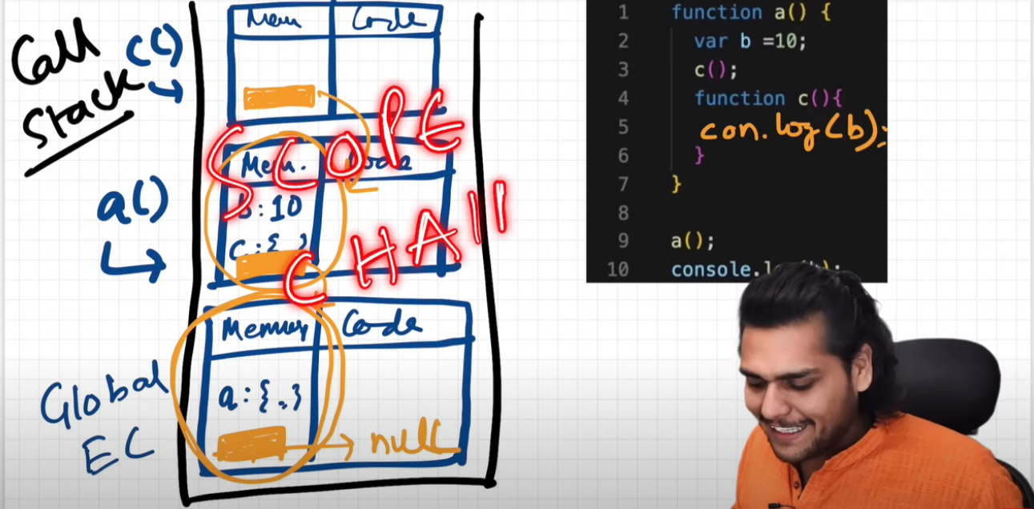

20/4/25

For var normal hoisting

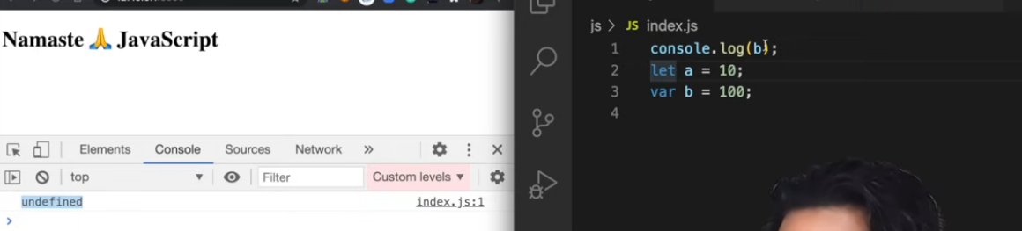

Let gives reference error.

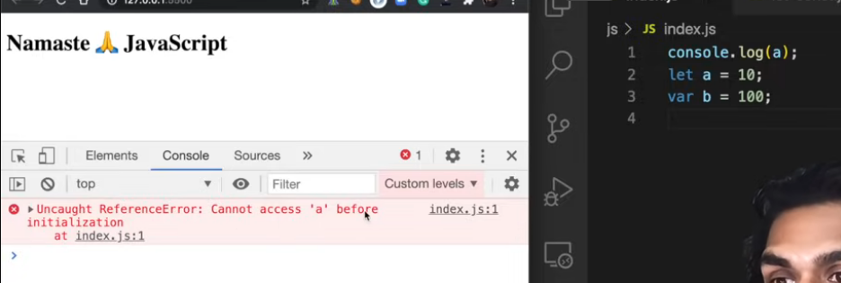

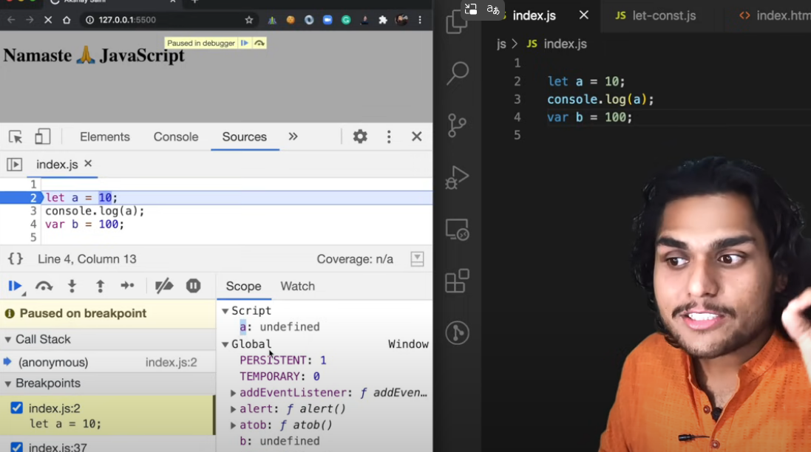

Even let and const are hoisted, but they are not available in the global space like vars. They are in the temporal dead zone before they are actually assigned a value. This is the time between the hoisting of a variable and assignment to a real value. If accessed in TDZ, it gives a ReferenceError.

Reference Error

X is not there at all in the program

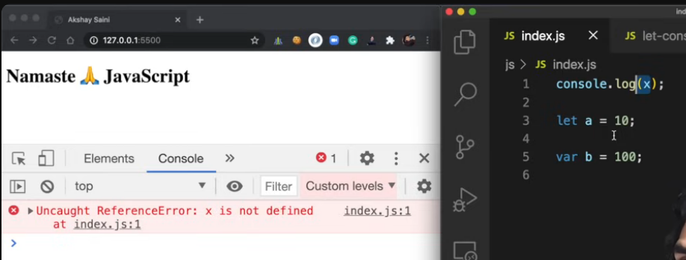

But in case of a we get cannot initialize error

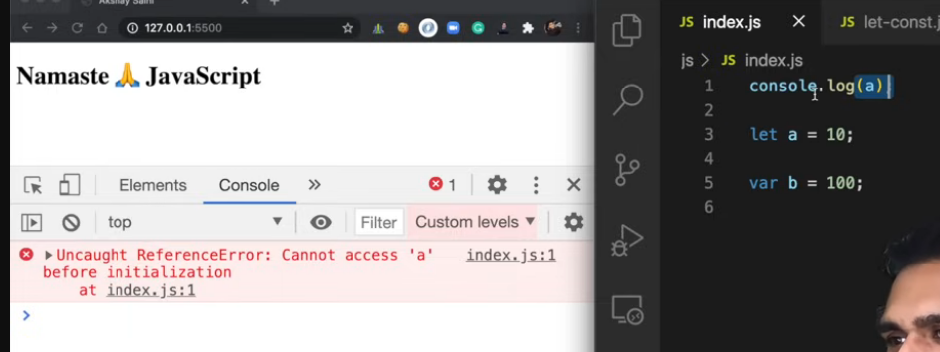

Let and const variables do not attach themselves to the global window object, like the var variables. They are in a separate memory space

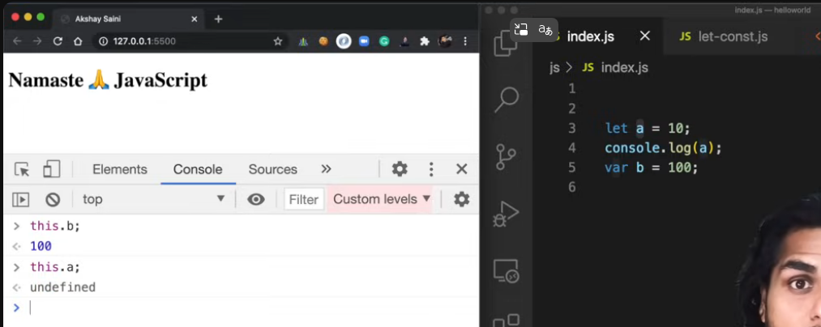

No redefining in let

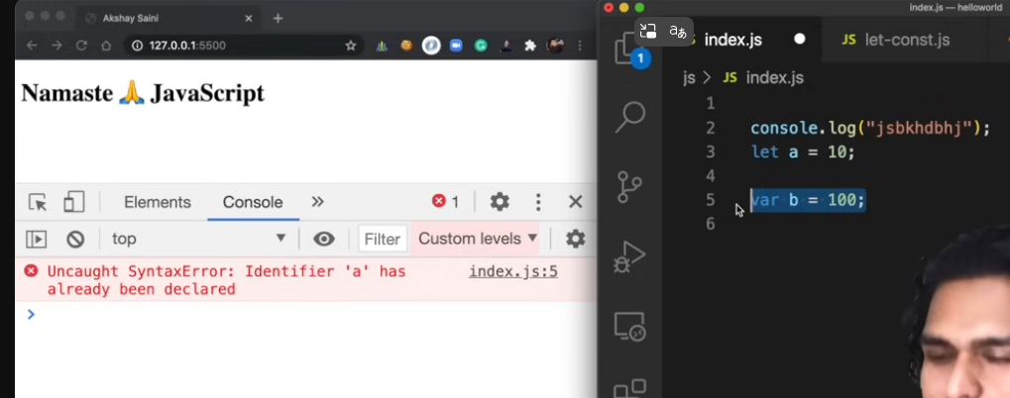

Reassignment possible in let

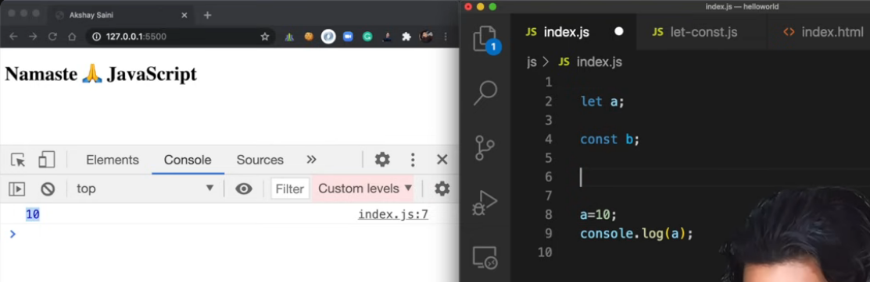

Reassignment also not possible in const, even more stricter than let

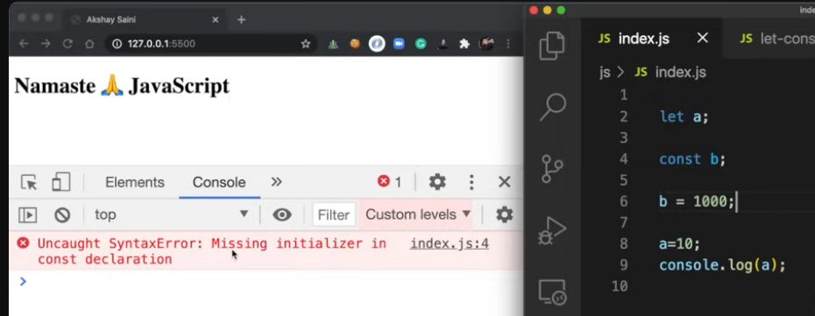

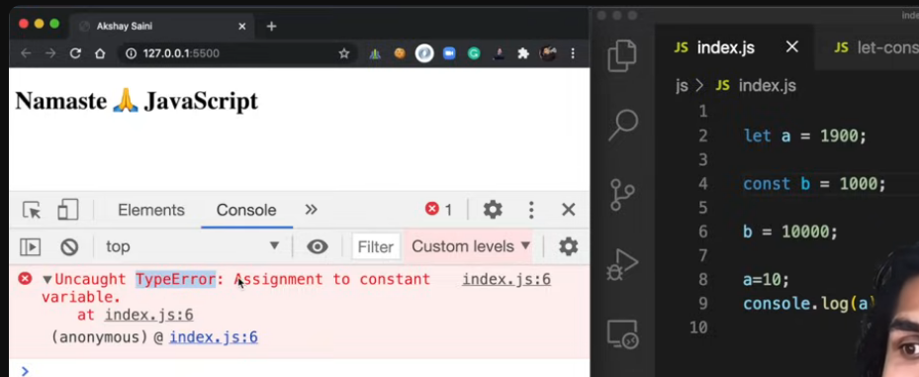

**1. Hoisting in JavaScript**

* **var** declarations are hoisted to the top of their **enclosing execution context** (which could be function or global), and **initialized with undefined**.
* **let and const** are also hoisted, **but not initialized**. They reside in something called the **"Temporal Dead Zone" (TDZ)** from the start of the block until the declaration is encountered.

**2. Global vs Script Environment**

Let’s now look at the **difference between Global and Script environments**.

* **Global Environment Record (GER):** This refers to the outermost context, typically the window in browsers or global in Node.js. Variables declared with var are **added as properties** to the global object (window.a).
* **Script Environment Record:** Introduced in ES6, it's a type of Lexical Environment used specifically for top-level let, const, and class declarations in scripts (and modules). These **do not become properties of the global object**, but they are still accessible globally in the scope chain.

**3. Why This Behavior?**

When your script runs:

* var a is hoisted and initialized as undefined in the **Global Environment Record**.
* let b is hoisted but uninitialized, and lives in the **Script Environment Record**, and you cannot access it before declaration — doing so throws a ReferenceError.

**In short:**

* **var** goes to the **global environment** and gets undefined before initialization.
* **let and const** go into the **script environment**, not attached to the window/global object, and are **not initialized** until their declaration line — hence the TDZ and ReferenceError.

21/4/25

Block and compound statements.

In JavaScript, **a block** is any code enclosed within curly braces { ... }. This includes:

* if statements
* for/while loops
* switch statements
* functions
* standalone { ... } blocks

When we say let and const are **block scoped**, it means:

Variables declared with let or const are only accessible **within the block** in which they are defined.

Block is where we can write multiple statements, so that we can use it wherever JS requires 1 statement. Eg writing if condition

This throws error because if expects a statement here.

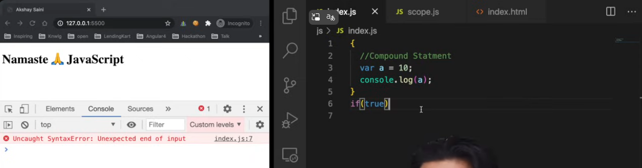

This is true and allowed

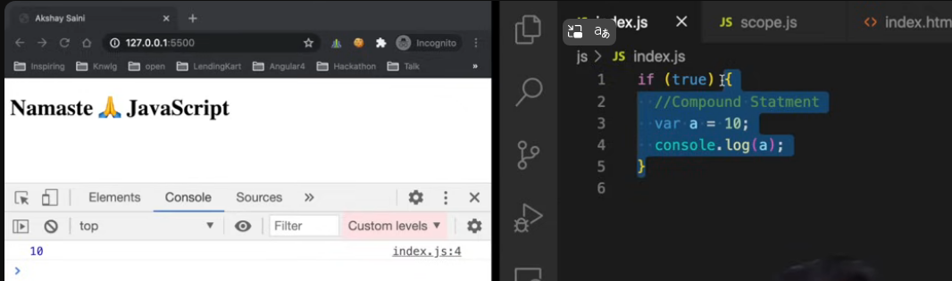

Let and const are block scoped, defined only in Block , var defined globally, var is function scoped.

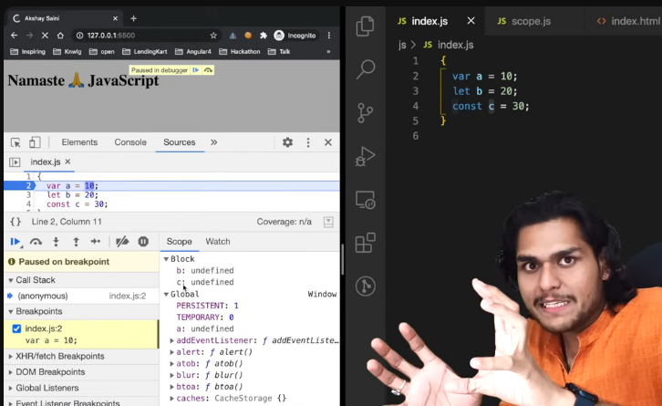

A is accessible outside, b and c only inside block

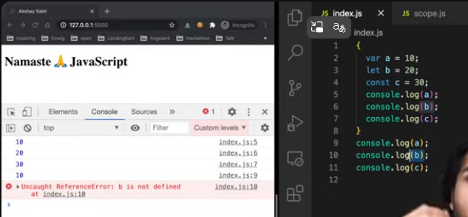

in JavaScript, **block scope** (e.g., inside { ... }) **is temporary** and **goes away after**

**in Microsoft Edge DevTools or other browser consoles is *not* the same as undefined — and here’s what’s really happening:**

**🧠 What does <value unavailable> mean?**

**This usually shows up when:**

* **You're inspecting a paused script (e.g., during a breakpoint or step-through debugging),**
* **The variable existed at some point but is now out of scope,**

**execution** of that block completes.

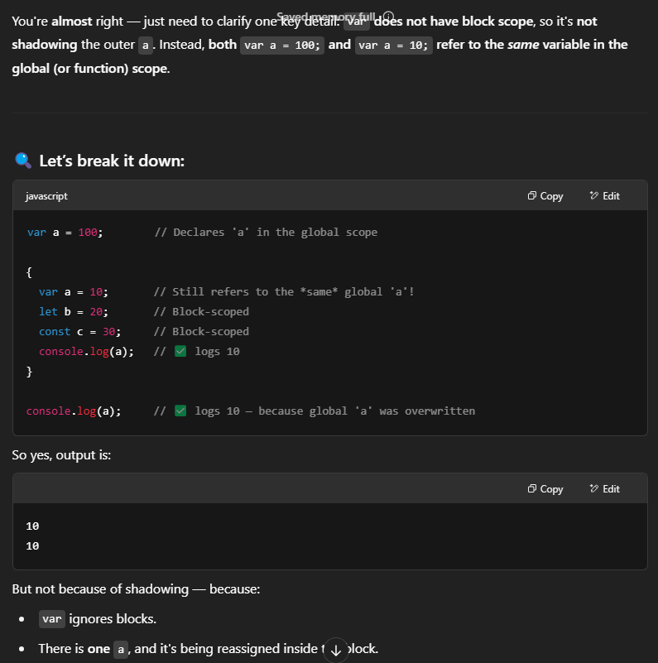

‘var’ variables are shadowed( not true shadowing as it’s the reference to the same variable), that is, the variables defined inside the block as var will modify the variable in the global scope.

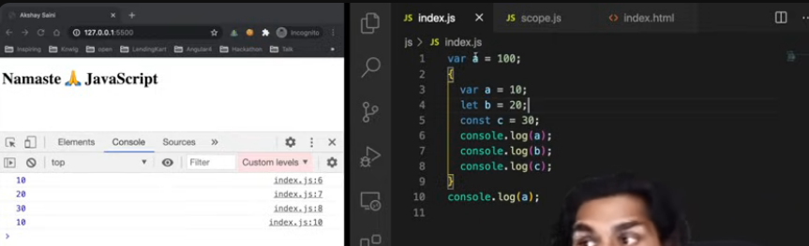

Same is not the case with ‘let’-

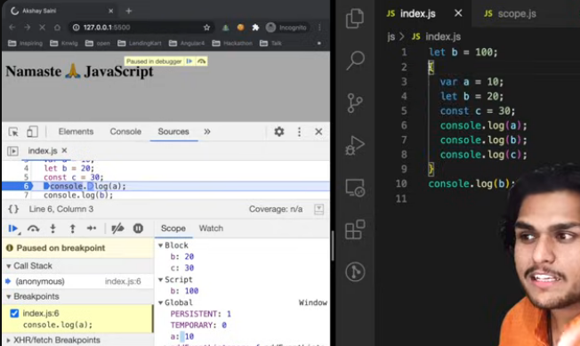

In let and const same shadowing is seen as seen in var, but the variable defined inside and outside are in different scopes and point to different locations in memory and log different values.

Same is seen with function scope as well in const, let and var as var is function scoped.

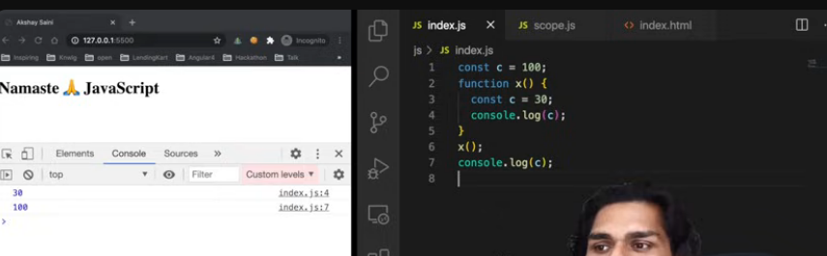

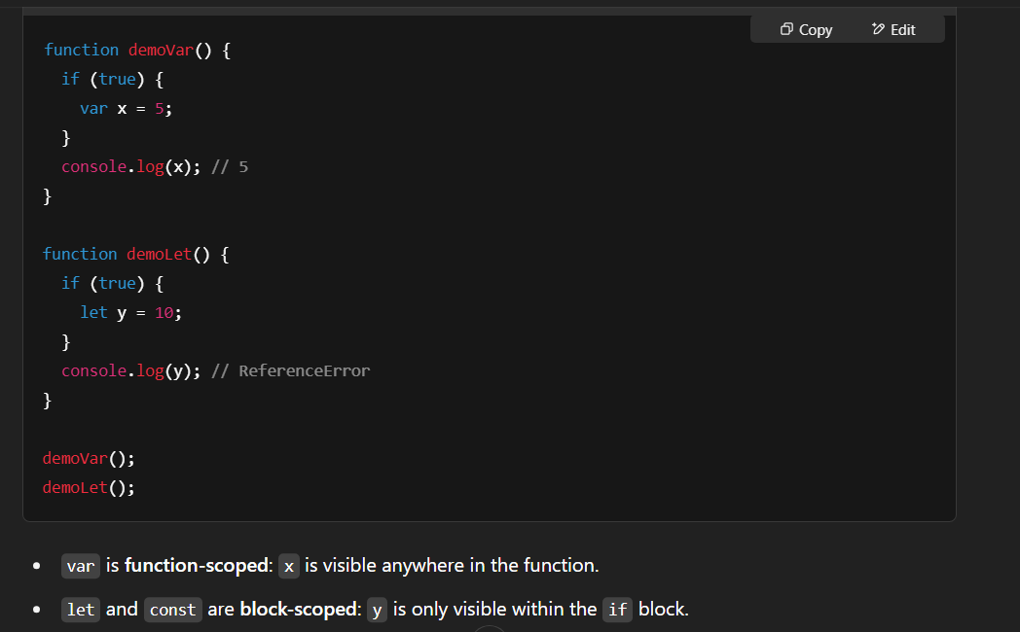

Illegal shadowing

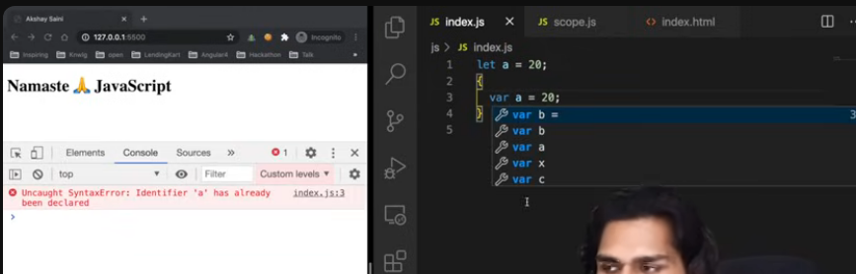

Block also follows lexical scope

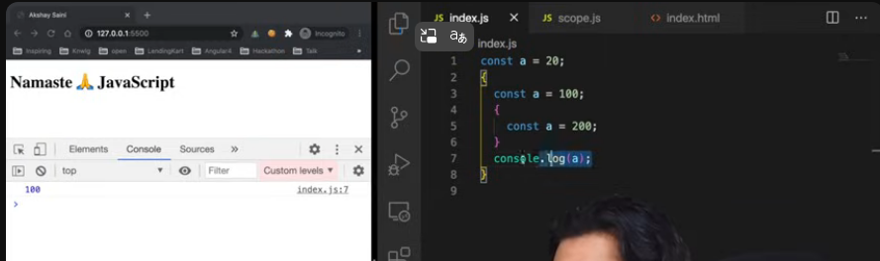

Each const has its own scope and follows lexical scope pattern

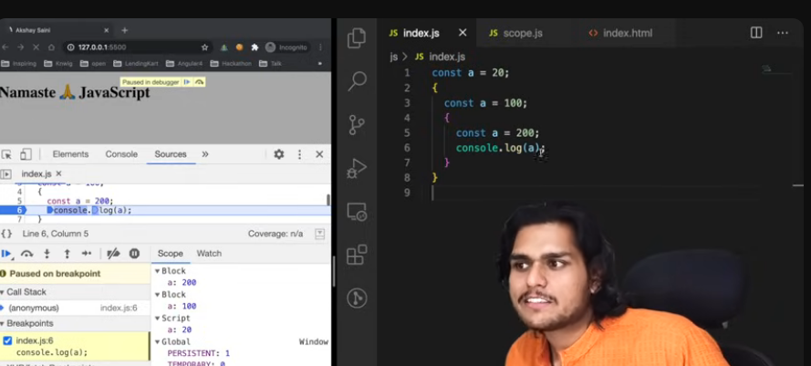

If not found in its own scope it checks parent scope.

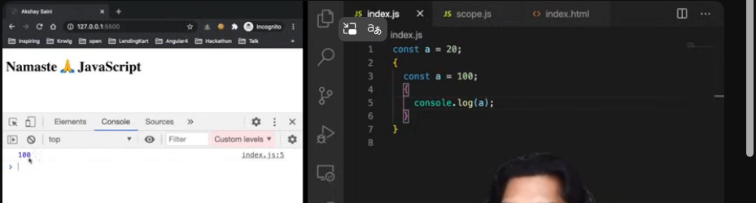

**🔁 Shadowing vs. Reassignment: The Key Difference**

**✅ Shadowing happens when:**

A **new variable** is declared in an inner scope with the **same name** as a variable in an outer scope. The inner one "hides" (or *shadows*) the outer one **within that scope**.

Example:

let x = 5;

{

let x = 10; // <-- This is shadowing

console.log(x); // 10

}

console.log(x); // 5

Here:

* The inner x is a *new* variable.
* The outer x is **not modified**.
* This is **true shadowing**.

**❌ Reassignment (NOT Shadowing) happens when:**

You redeclare or reassign a variable in the **same scope**, even if it's inside a block — and var does this, because var **ignores block boundaries**.

Example:

var x = 5;

{

var x = 10; // <-- This is **not** shadowing. It's just reassigning.

console.log(x); // 10

}

console.log(x); // 10

Here:

* There is **only one x** in the global scope.
* The second var x = 10 doesn't create a new variable — it just **overwrites** the existing one.
* No shadowing is taking place, because there’s no new scope for the variable.

**✅ When Shadowing Happens**

* With let and const (because they are block scoped)
* Inside new scopes (functions, blocks, etc.)
* A **new declaration** is made, hiding the outer one

**❌ When Shadowing Does *Not* Happen**

* When var is used inside a block (it's still the same variable)
* When you simply **reassign** an existing variable

**Visual Analogy**

Think of it like **layers**:

* **Shadowing** = putting a sticky note **on top** of the original — you temporarily can't see the outer value.
* **Reassignment** = going to the original sticky note and changing what's written on it.

22/4/25

Closures in JS-

A closure in JavaScript is the combination of a function and the lexical environment within which that function was declared. This environment consists of any variables that were in scope at the time the function was created. Closures enable a function to access variables from its outer scope, even after the outer function has finished executing.

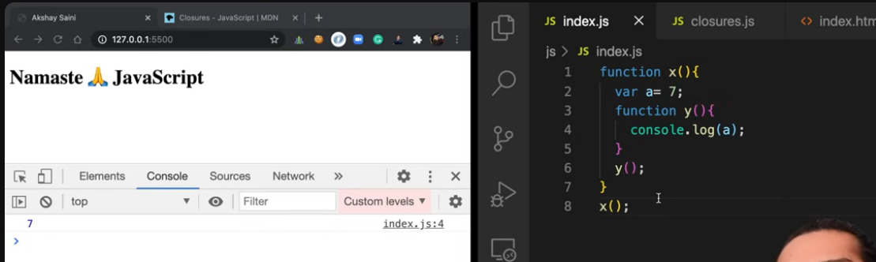

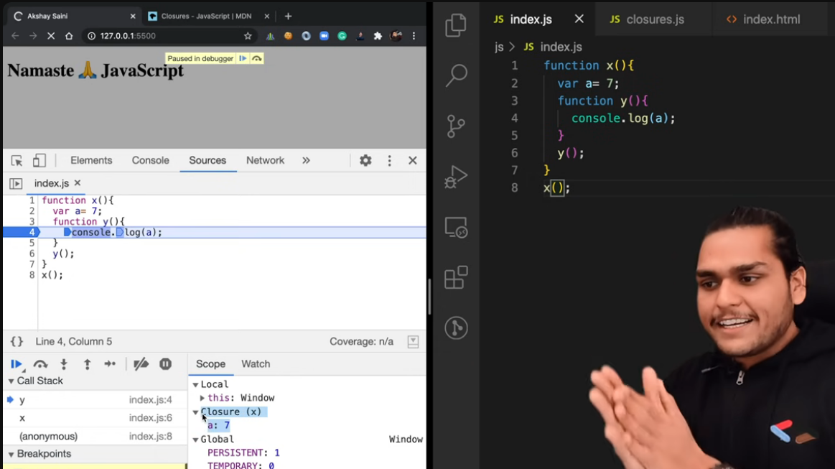

When we log z, it will print the entire function y()

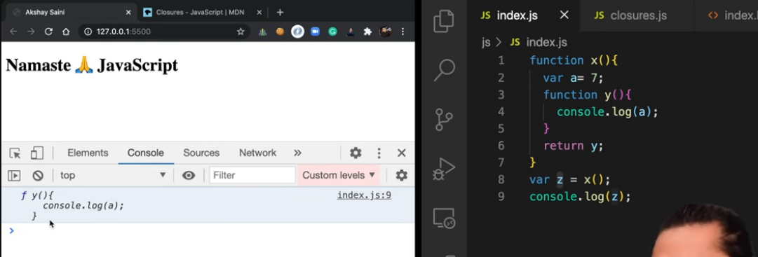

Now fxn ceases to exist and with it even var a is destroyed and there is no reference, so what will happen when we call z() because it has ref to var a.

This below logic is also returns same closure

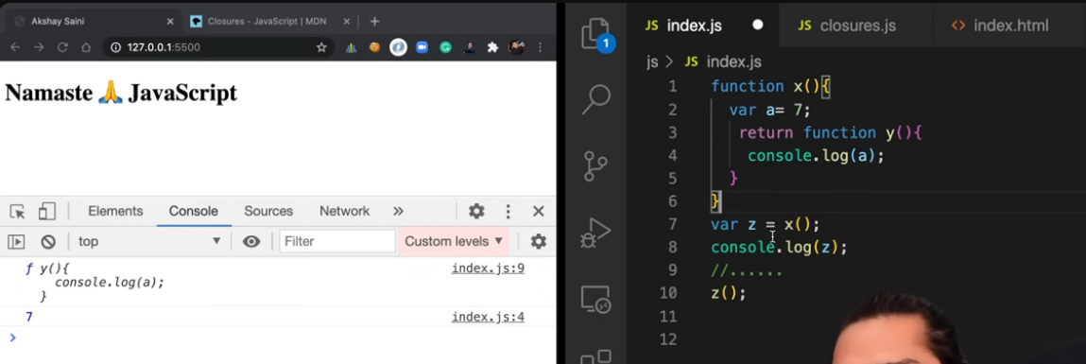

Corner cases with closures (refer notes for explanation)

Corner case 1

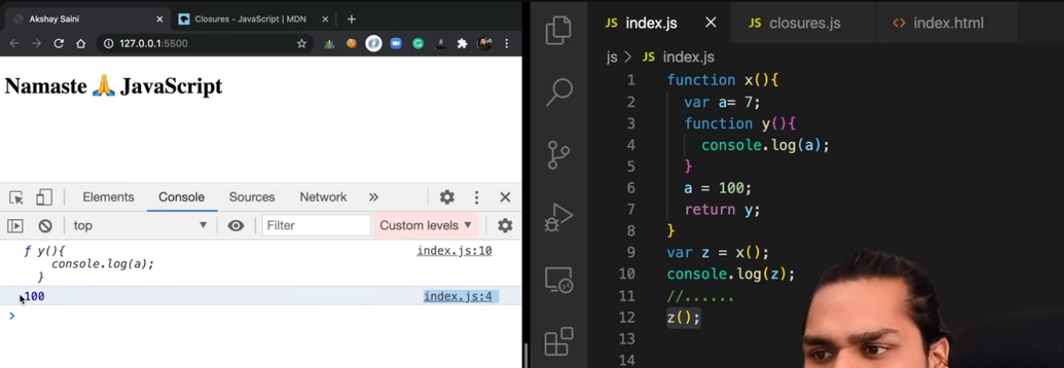

Here op is 100 because closure contains the function and the reference to the variables in the LE. Therefore it does not store numerical values but only the label ‘a’. Therefore a was pointing to 100 when z() is executed.

Corner case 2:

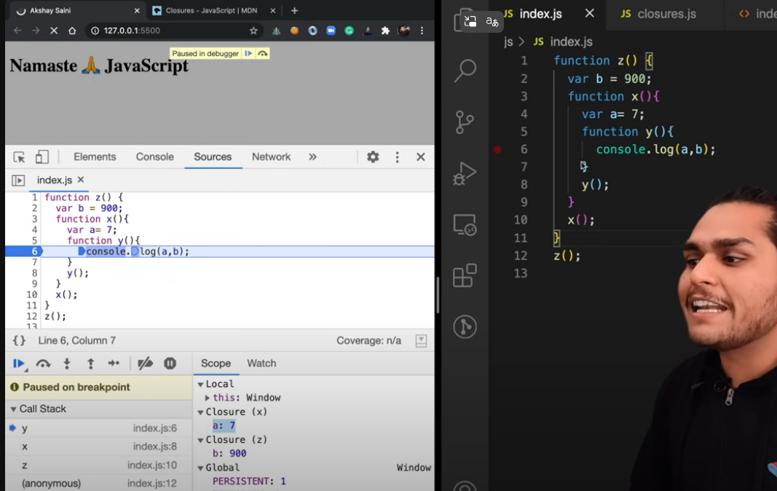

23/4/25

Closures and setTimeout in JS

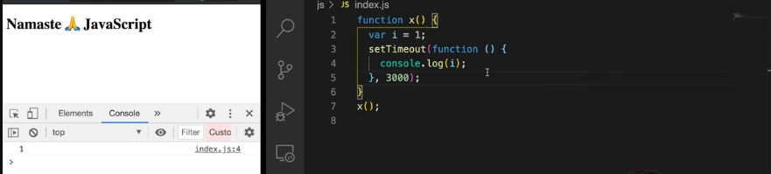

Print 1-5 each after its own number of seconds (1 after 1 sec, 2 after 2 secs, 3 after 3 secs…..)

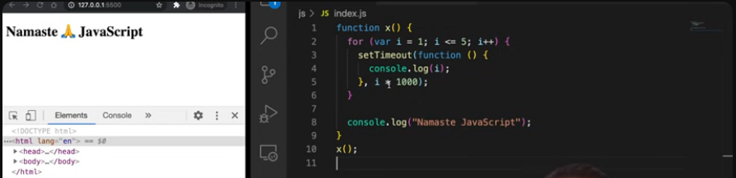

This above fxn is a classic WRONG answer for this problem, refer notes as to why it is wrong

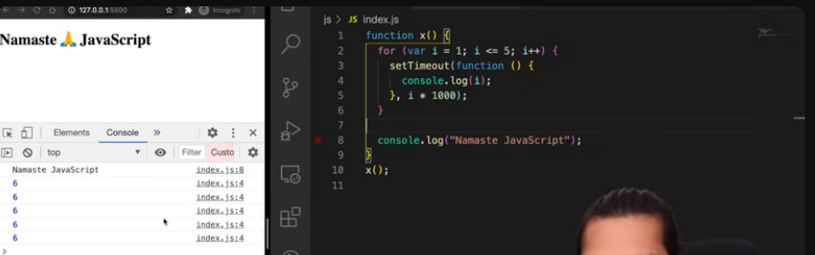

This is the problem that closure point to reference of I and not actual value of I, by the time the closure is executed the value of I in the closure is 6.

Quick sol – use let

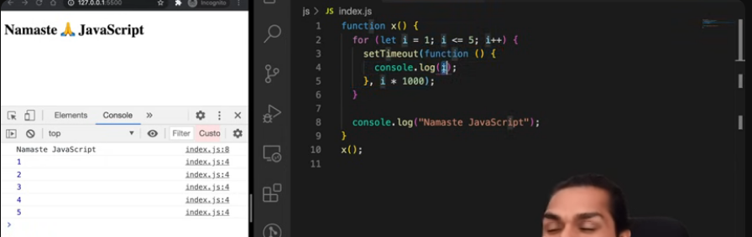

Proper solution-

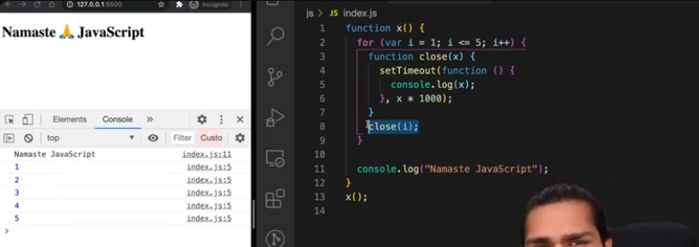

24/2/25

Js mock interview video

1. What is a closure and explain with an example

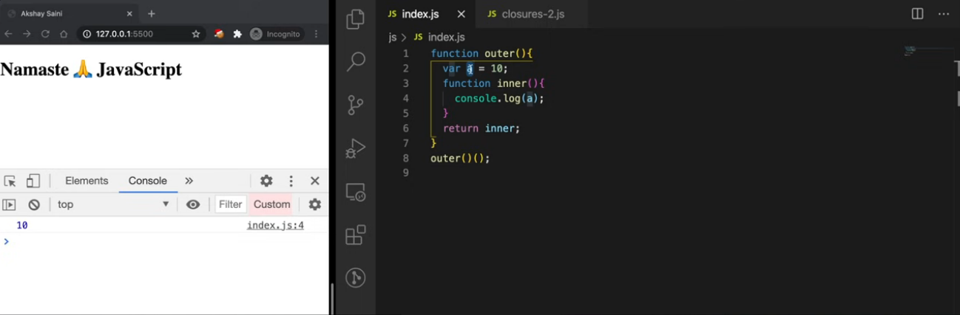

1. What is the ()()Double paranthesis – the first outer () will call the outer function and it will return the inner function and the 2nd () is calling the inner function which was returned.

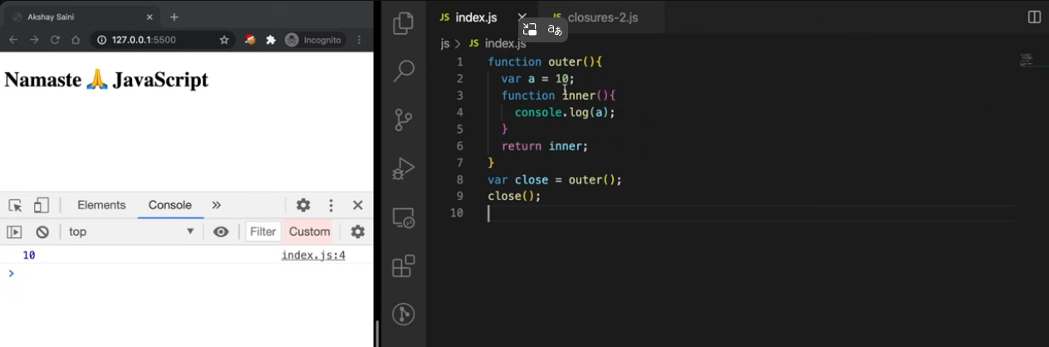

1. Explain code below -

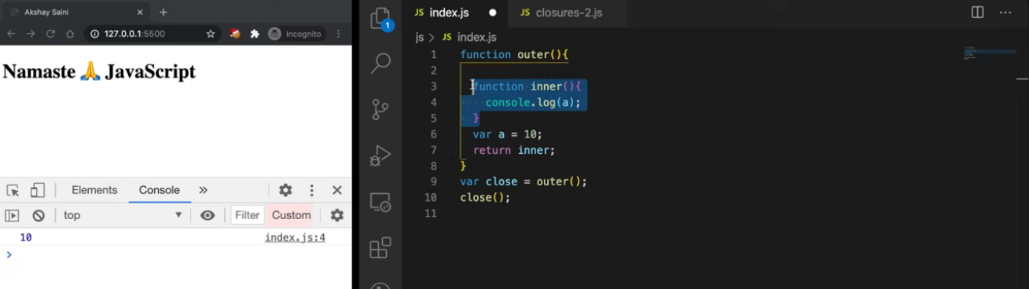

This will still form a closure because the function forms a closure with its outer environment and this does not happen in any particular order.

1. What will happen if we change var to let.

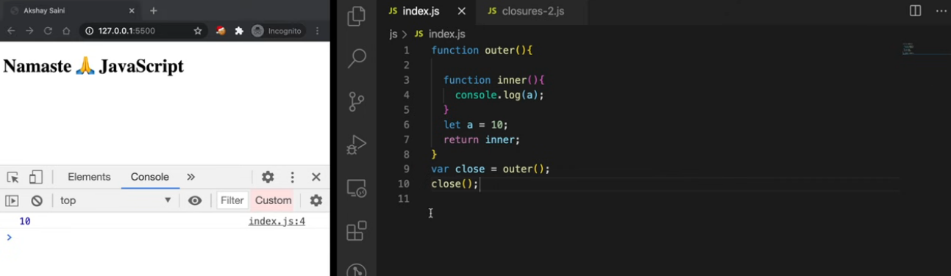

Changing var to let also will still form the closure and we will get same result as the behaviour is still the same.

closures capture variables from the **lexical environment**, and let variables are part of that lexical environment as well.

So even with let, the inner function closes over a, and the reference to a is preserved after outer returns.

1. What if we pass a parameter into the outer function –

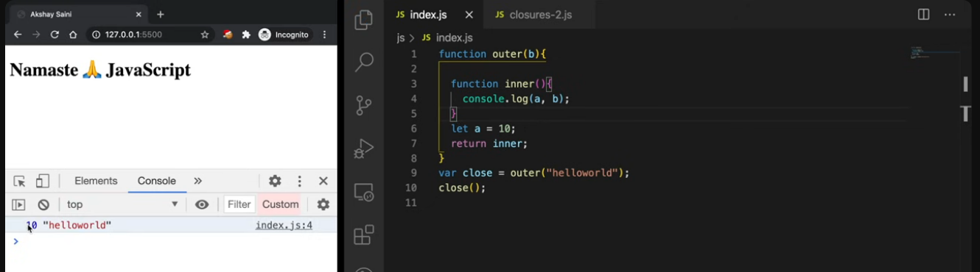

It will still form a closure and now b also will be available to the inner function as it is in the outer env of the inner function.

1. Explain the Nested case with another function.

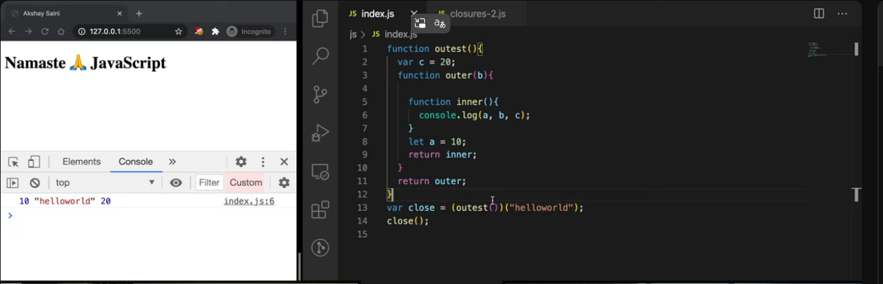

Still will work the same way as closure has access to all scopes of fxn.

1. Another case of declaring a “let a” at a global level –

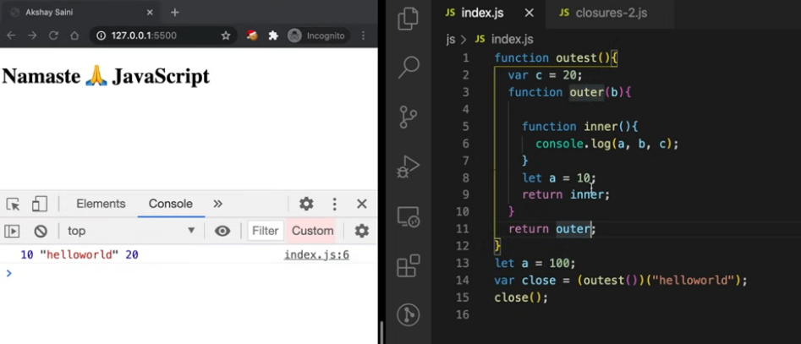

Here the value of a printed will still be the same 10 because let is block scoped and the a in the lexical environment of inner function is still 10.

1. But in this case –

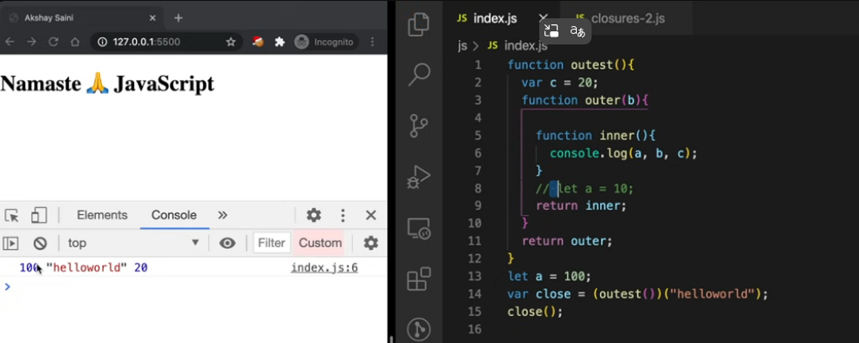

Since a Is not found in the outer fxn, the fxn looks for it in global scope and prints 100

1. What about the case when a is not declared at all

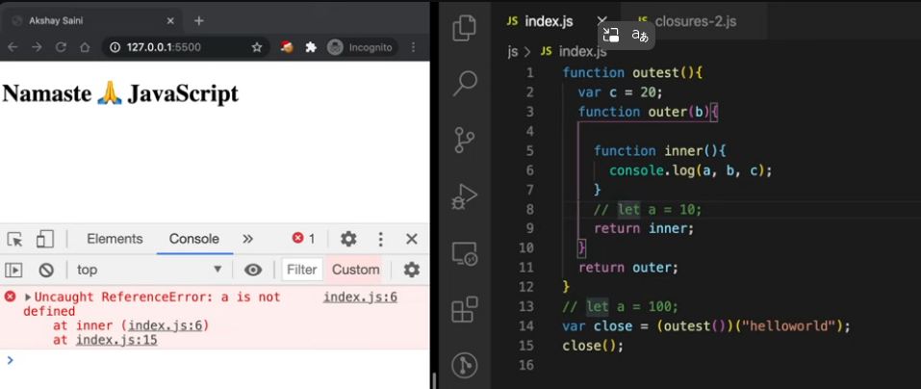

Now we get error because a is not found in the outer most scope of the inner fxn. ReferenceError.

1. Explain the uses of closure
2. Once function
3. Memoization
4. Module design pattern
5. Currying concept
6. setTimeouts
7. What is data encapsulation and how do closures help us to achieve this

Also helps in Data Hiding- Encapsulating data so that other places cannot access it is called data encapsulation and closures help us to achieve data encapsulation.

Example-

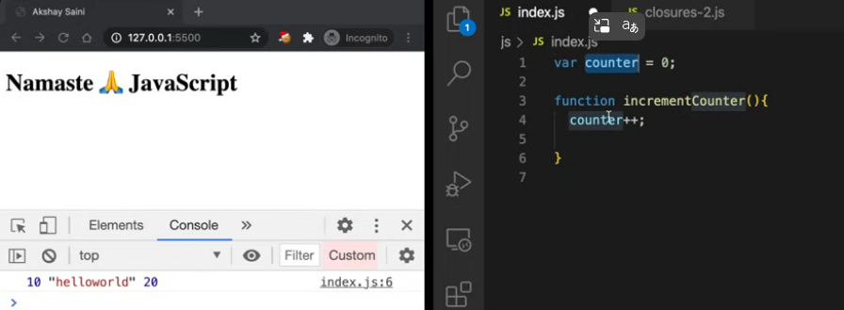

The problem with the above code is that anybody can access the counter variable and change the value of the count.

1. Data hiding -

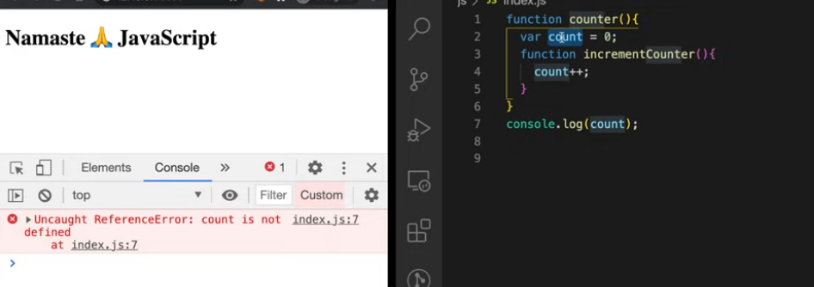

* var **is not global** just because it's var.
* var is **function-scoped**, **not block-scoped**, but it still follows **lexical scoping**.
* Since count is declared **inside the counter function**, it is scoped to that function only.
* You cannot access it **outside** of the counter() function — it **doesn't exist** in the global scope.

To access this inner function we can do this, this way direct access to the variable is prohibited -

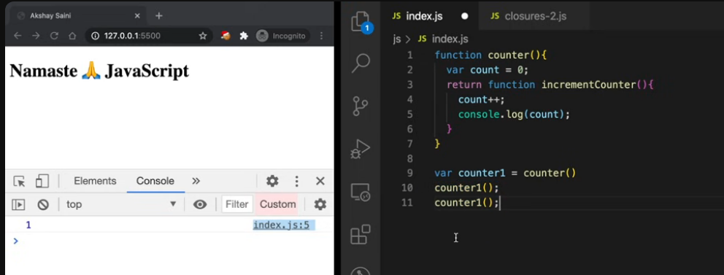

Each call to counter() creates a **new execution context**, with its own separate count variable.

* counter1 is a closure over the first count (which starts at 0).
* counter2 is a closure over a **new** count, also starting at 0.

So:

* counter1() increments its own internal count.
* counter2() has no idea what counter1() is doing — it works with **its own private count**.

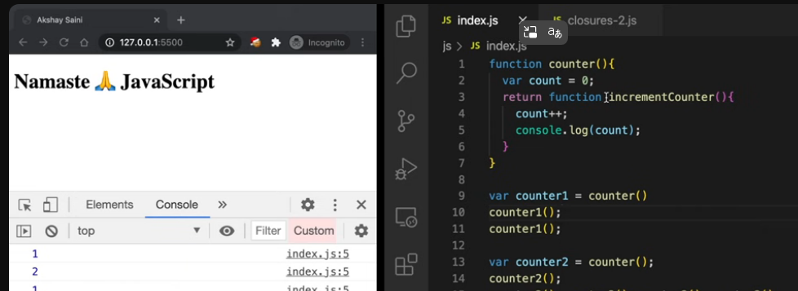

1. Is the above code scalable? What if we want to implement a decrement counter as well and not only an increment counter.

Ans – For that we can use a constructor function to achieve this

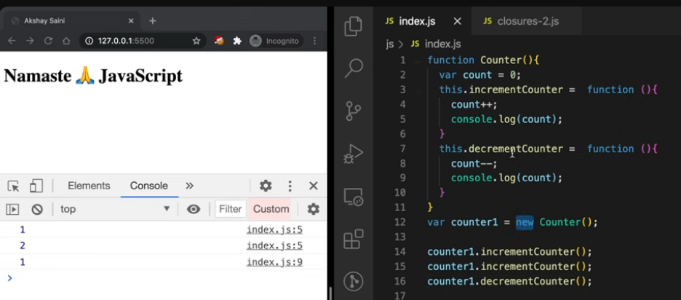

1. What are some of the disadvantages of closures?

Closures can lead to increased memory consumption, especially when many closures are created or when they hold references to large objects. Since closures retain access to their outer scope even after the outer function has finished executing, the closed-over variables are not garbage collected as long as the closure exists.

If not managed properly, this can result in memory leaks, as unused closures and their retained variables accumulate over time. In severe cases, this can degrade performance or even cause the browser to freeze.

What is a garbage collecter?

Garbage collection is a form of automatic memory management used in many programming languages. Its main job is to identify and reclaim memory that is no longer in use by the program so that it can be reused for future allocations.

In simpler terms: when a program creates variables or objects, memory is allocated for them. If the program no longer needs those items (i.e., there are no references to them), a garbage collector will detect that and free up the memory, preventing memory leaks and improving performance.

Languages like JavaScript, Java, Python, and C# have built-in garbage collectors. Others like C and C++ leave memory management to the programmer.

**Garbage collection** in JavaScript is an automatic process where the JavaScript engine frees up memory by removing data (like variables and objects) that are no longer accessible or needed by the program.

In simple terms:  
If there’s no way to reach an object or variable (i.e., no references to it), it’s considered "garbage" and the engine cleans it up to free memory.

This helps prevent memory leaks and keeps your application running efficiently.

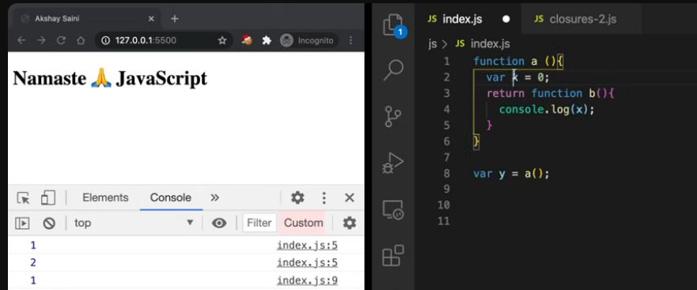

* When a() is called, it:
  + Declares a local variable x
  + Returns the function b, which **closes over x**
* y now holds the reference to function b, **and through that reference, the closure keeps x alive** — even though a() has finished execution.
* When y() is called, it logs 0, because x is still accessible.

**Relation to Garbage Collection:**

Normally, variables like x (inside a function) would be garbage collected once the function finishes.  
**But in this case, x is retained** because:

* Function b (returned and stored in y) still **has a reference to x**.
* As long as that reference exists, x **cannot be garbage collected**.

Smart garbage collection

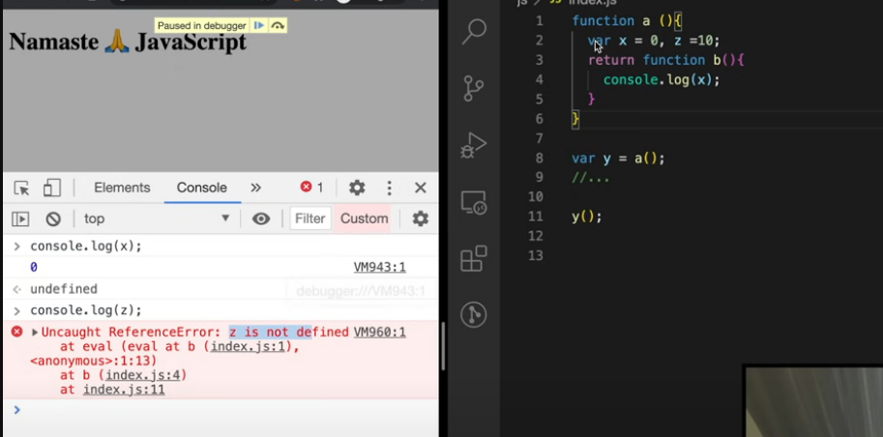

**✅ Why x is accessible:**

* x is **referenced inside the closure** (inside function b()).
* So when a() is executed, the closure (function b) **closes over x** and retains a reference to it, **preventing it from being garbage collected**.
* Hence, x stays in memory, and y() can log 0.

**❌ Why z throws an error:**

* Although z is declared inside the same scope as x, it is **not used inside the returned closure**.
* So once a() finishes executing and returns b, **there are no references to z anymore**.
* Therefore, z is **garbage collected** — and trying to access it later results in a ReferenceError.

This is known as smart garbage collection and it is useful in JS as it prevents overloading the memory heap.

26/4/25

Function statement vs function expression-

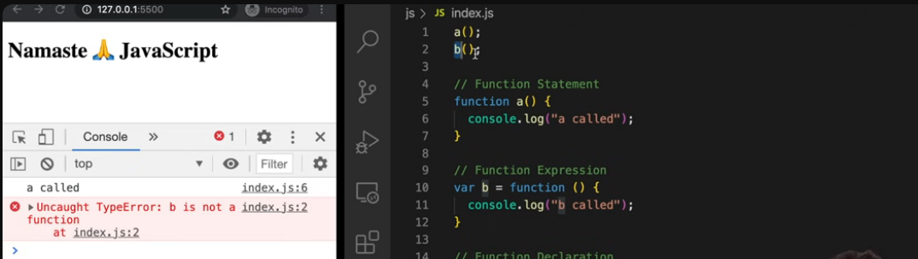

Anonymous function

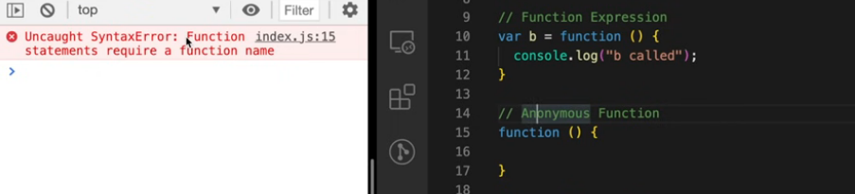

Gives error because anonymous can only be used when we are using fxns as values. Meaning assign this anonymous function to a variable

Named function expression

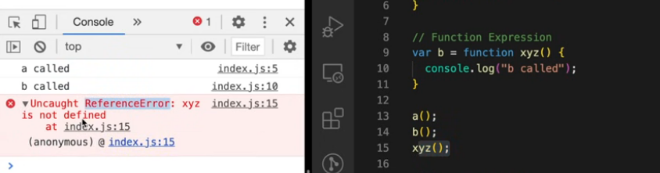

And corresponding Ref error.

First class functions

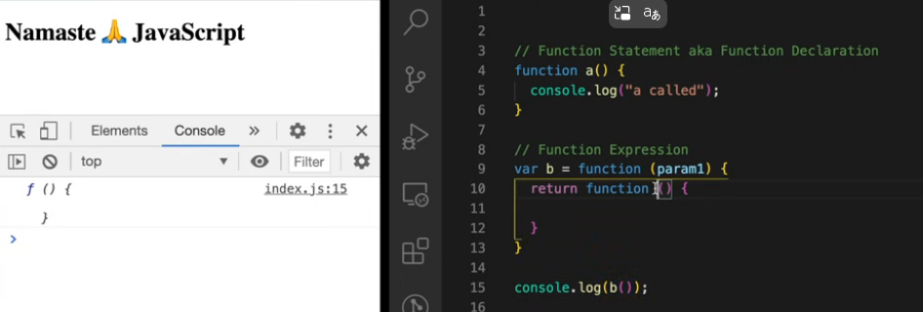

28/4/2025

Callback functions and asynchronousness in JS

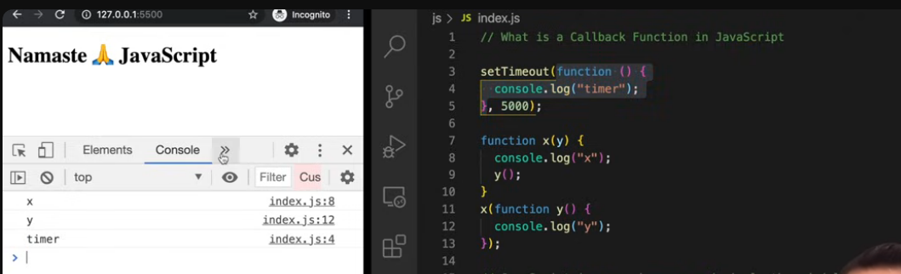

See notes for more.

Callstack demo- first x and y present, then they disappear and then the CB from the setTimout comes into the Cs.

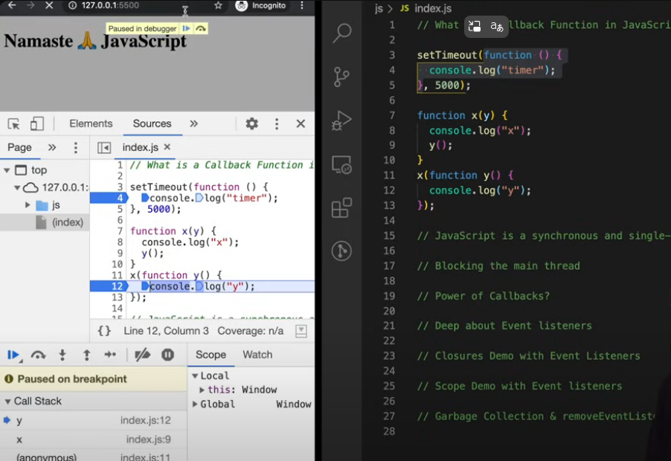

After 5 secs

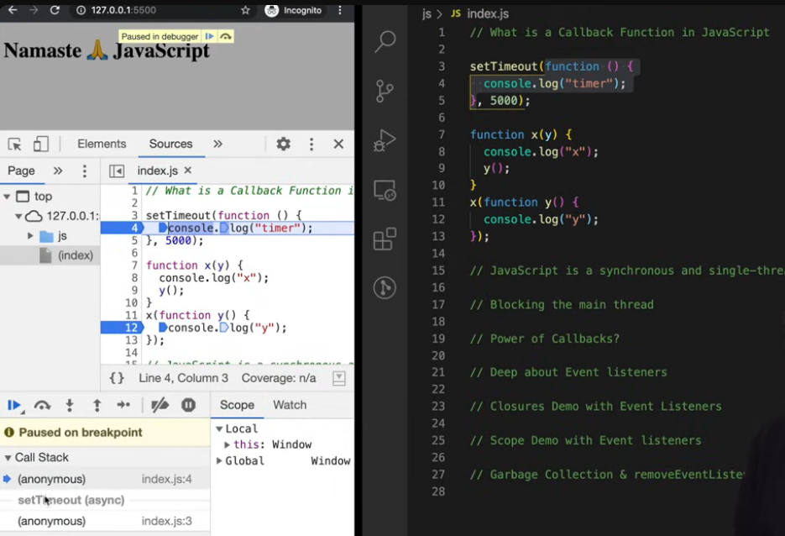

CB and event listeners

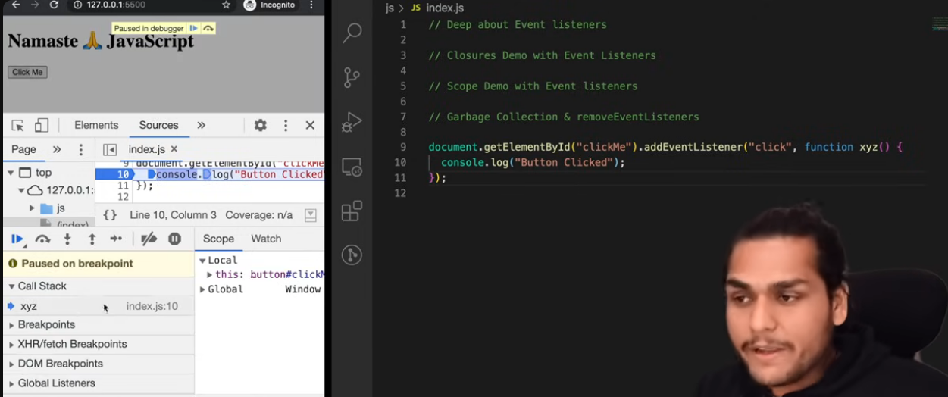

CB is pushed into CS whenever the button is clicked and it is executed. Until then the fxn is stored “Somewhere”.

Important interview qs – How to count button clicks (without react state )-

Soln 1 – using global variable.

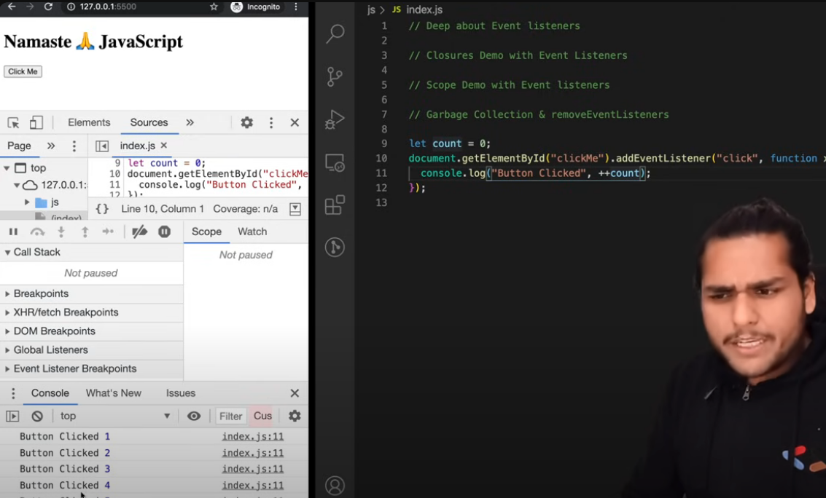

Now do not use global var as it is not a good solution. How would you do it?

How to do it with closure and use data hiding.

Solution

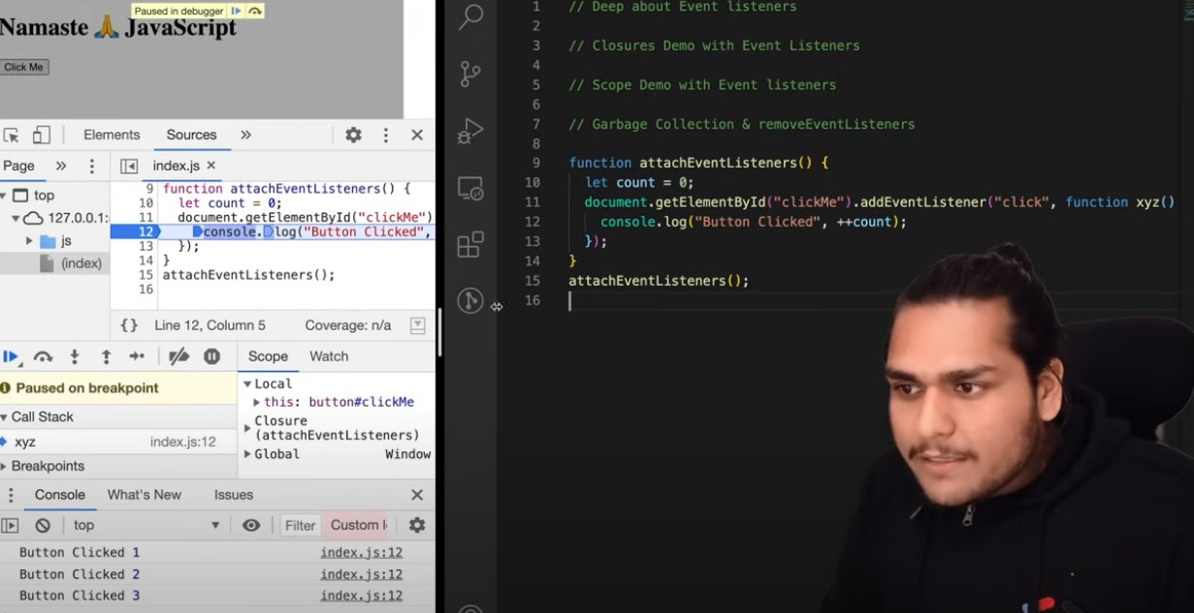

1. The page loads and the script runs.
2. attachEventListeners() is called immediately because of that explicit call.
3. Inside attachEventListeners():
   * It initializes count = 0.
   * It finds the element with id="clickMe".
   * It attaches a "click" event listener to that element.
4. When you **click the button**, the anonymous function xyz() runs, and inside it, it logs Button Clicked with the incremented count.

If you **remove** attachEventListeners(); from the bottom, then **clicking the button won't do anything** because the event listener would never have been attached in the first place.

* When attachEventListeners() is called, it defines the count variable **inside its scope**.
* Then it attaches an event listener to the button.
* The event listener’s callback function xyz() **captures** the count variable from the outer function's scope.
* Even after attachEventListeners() has finished executing, the callback still "remembers" count because of **JavaScript closures**.
* So every time you click the button, the callback accesses and updates the **same** count variable.

🔵 **Closure in simple terms here**:

*A function remembering the variables from the scope in which it was created, even if that outer function has finished execution.*

That's why the count doesn't reset to 0 every time you click the button. It keeps incrementing.

Event listener in tab

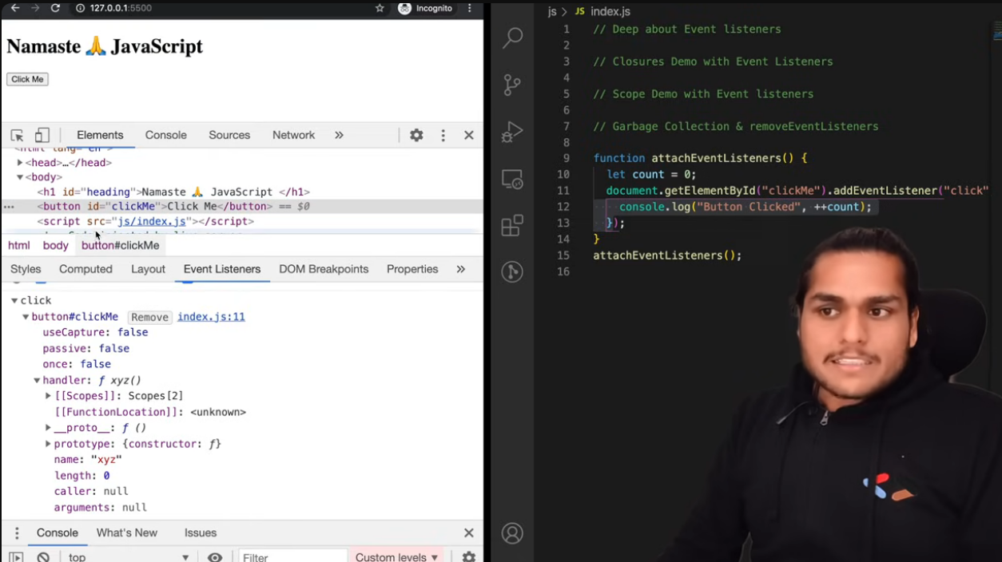

**IMPORTANT**

* attachEventListeners() runs once when your script loads and you call attachEventListeners();.
* Inside it, you set up the event listener: element.addEventListener('click', xyz).
* attachEventListeners() then completes execution and is gone from the call stack.
* Now, every time you click the button, only the xyz callback is triggered — not attachEventListeners() itself.

And because xyz is a closure, it still remembers the count variable from the first and only time attachEventListeners() was called.

Go through this chatgpt thread for clarity -https://chatgpt.com/share/680f9795-7f5c-8012-b7c1-d3decd7e65b6

29/4/25

Simple function execution in JS recap

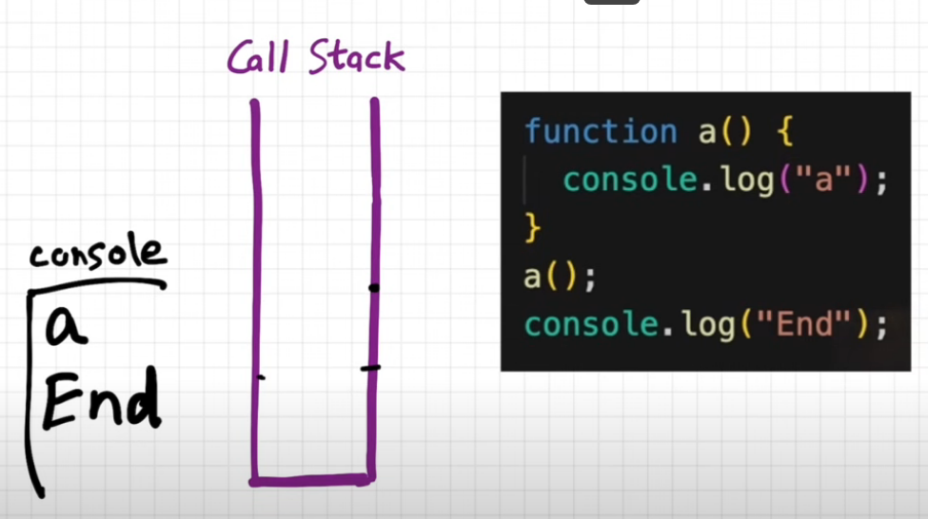

The web browser has many capabilities like timer, Bluetooth, localstorage and geolocation. JS needs some way to access all these browser capabilities

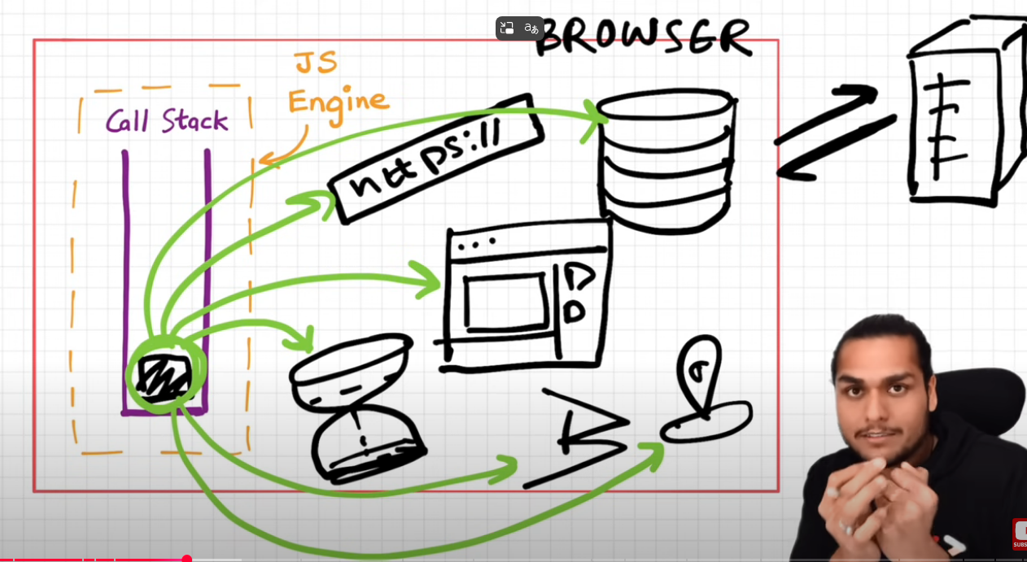

For all this we need WEB APIS

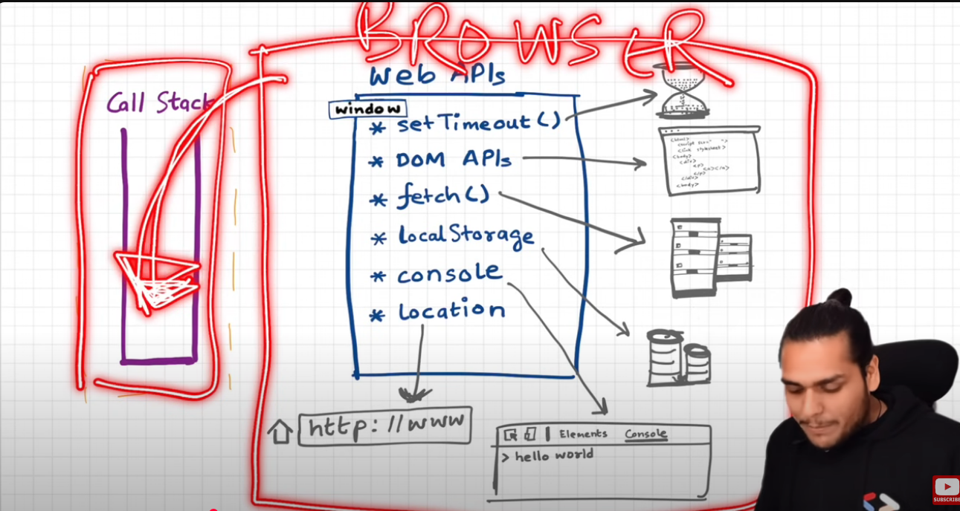

Global object

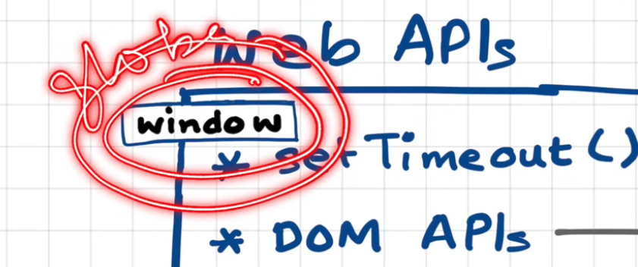

The browser gives JS the ability to access all the superpowers of the browser with the help of the window keyword

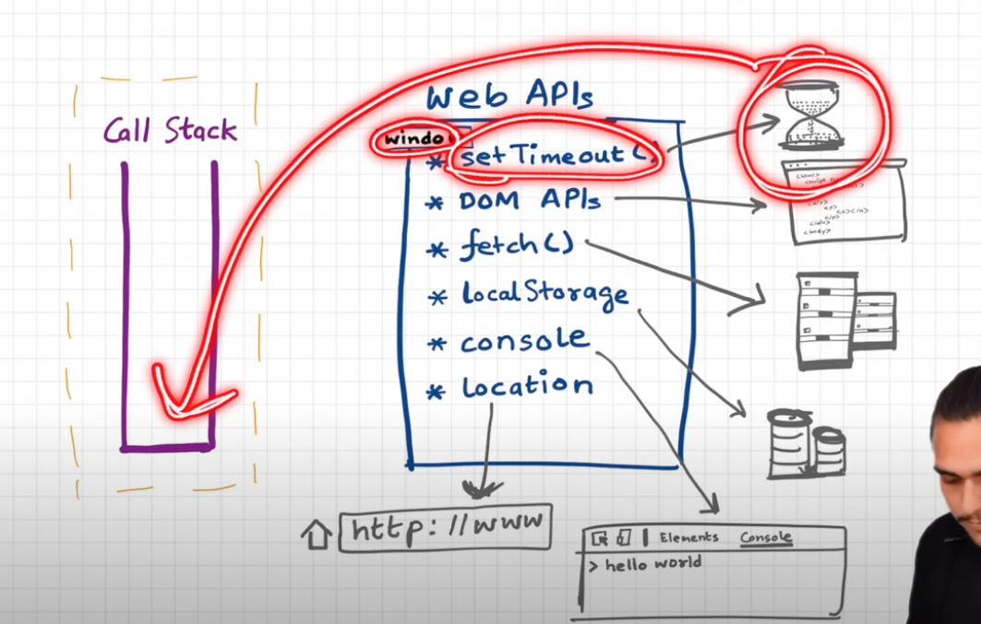

We do something like windiw.localStorage to access localStorage.

Examples

1. 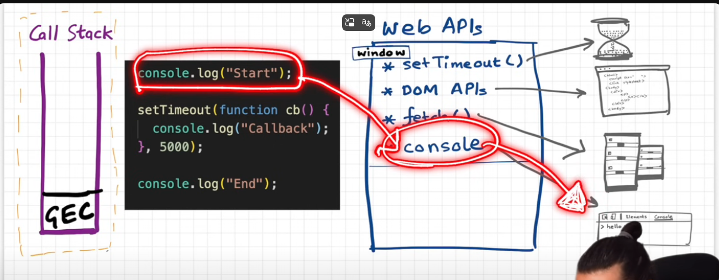

When we say console.log in the GEC, we make a call to the console web API and this internally makes a call to actually modify or log something in the browsers console.

After executing line 1-

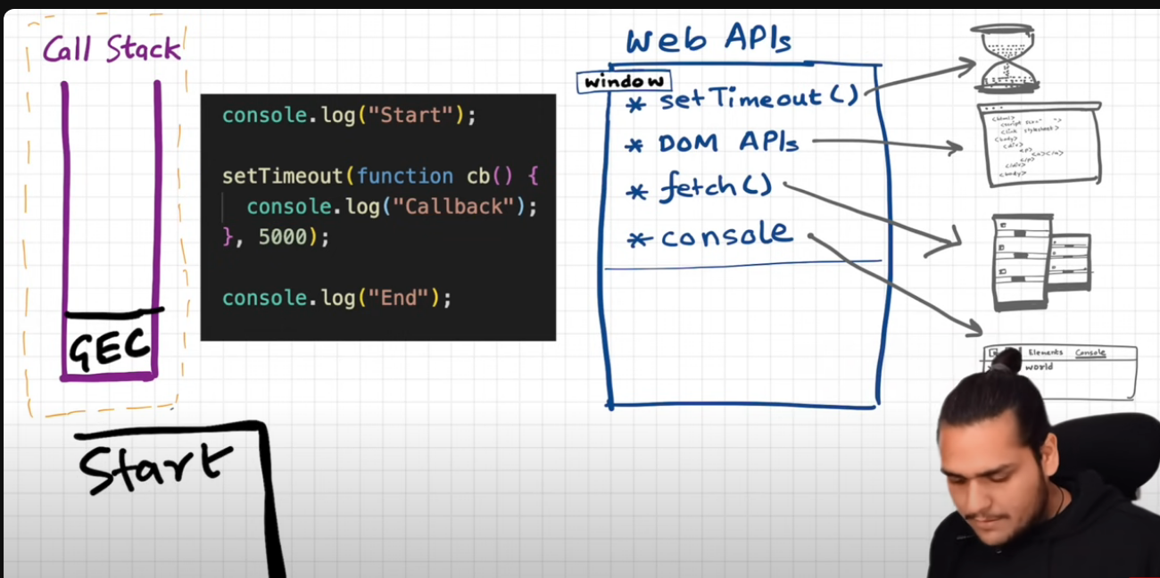

Step 2

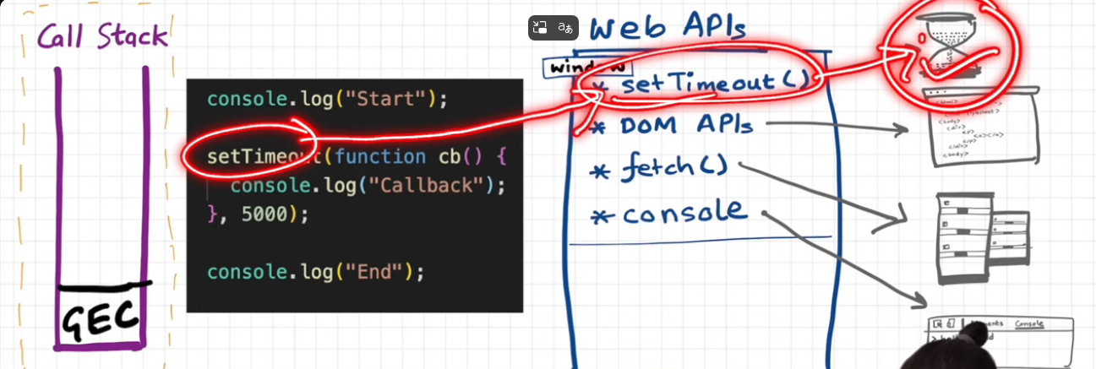

When setTimeout is executed it registers a callback and the timer also starts for 5000ms as soon as invoked and js moves to the next line.

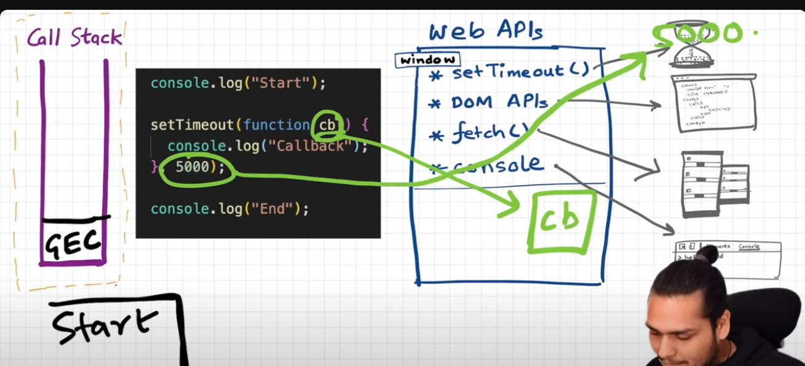

End is printed as js moves to next line

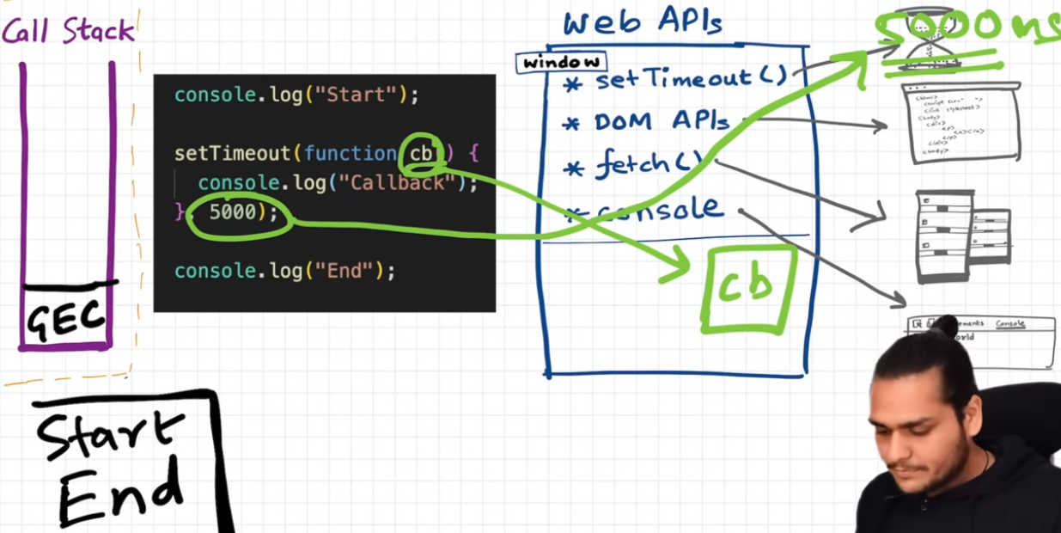

Once all our code has ran, the GEC is popped of from the CS, and while all this happening out timer is still running, doing a countdown.

As soon as timer expires, the callback fxn needs to be executed. And since all of the code is executed in CB, we somehow need this function in our CS.

Now comes event loop and callback queue.

CB cannot directly go to the CS.

It goes through the callback queue.

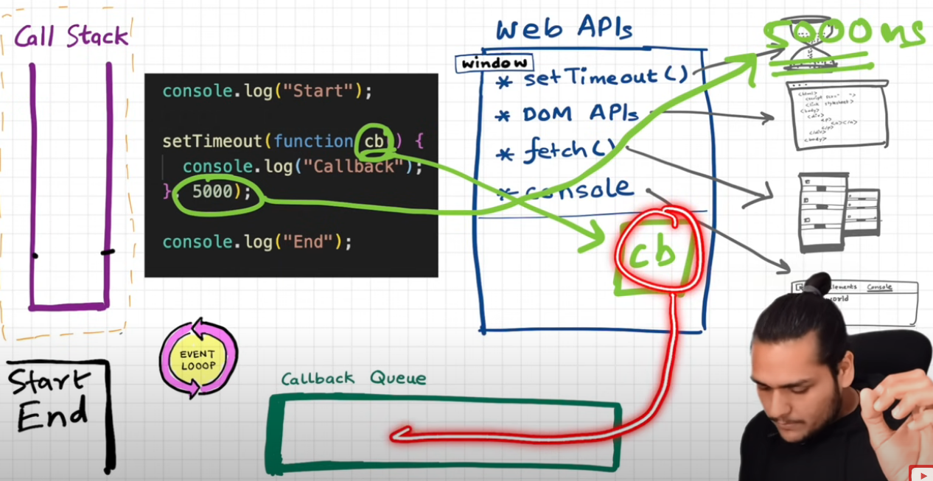

When the timer expires the CB function is added to the CBQ.

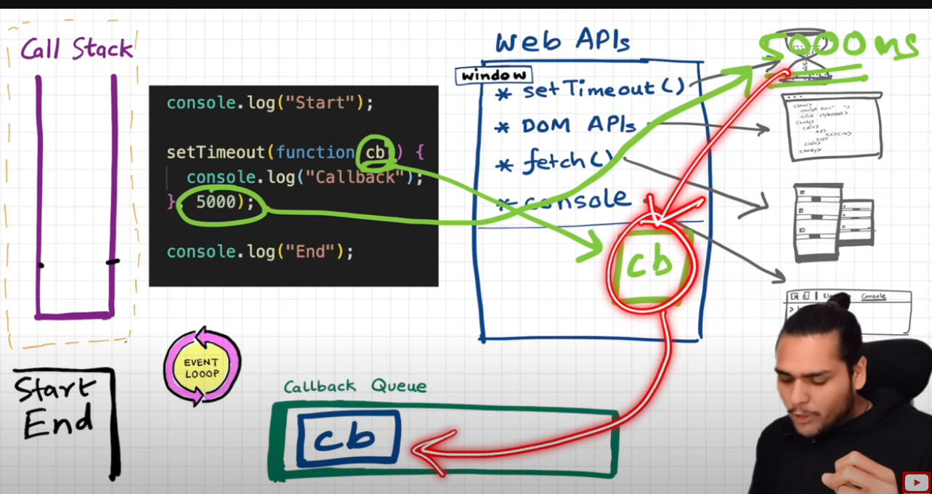

After 5000 ms the timer expires, the CB fxn is added to the CBQ, the event loop (which acts as a gatekeeper) checks the CBQ and it sees the CB in the Q and adds it to the callstack.

And then the CB is executed by the CS.

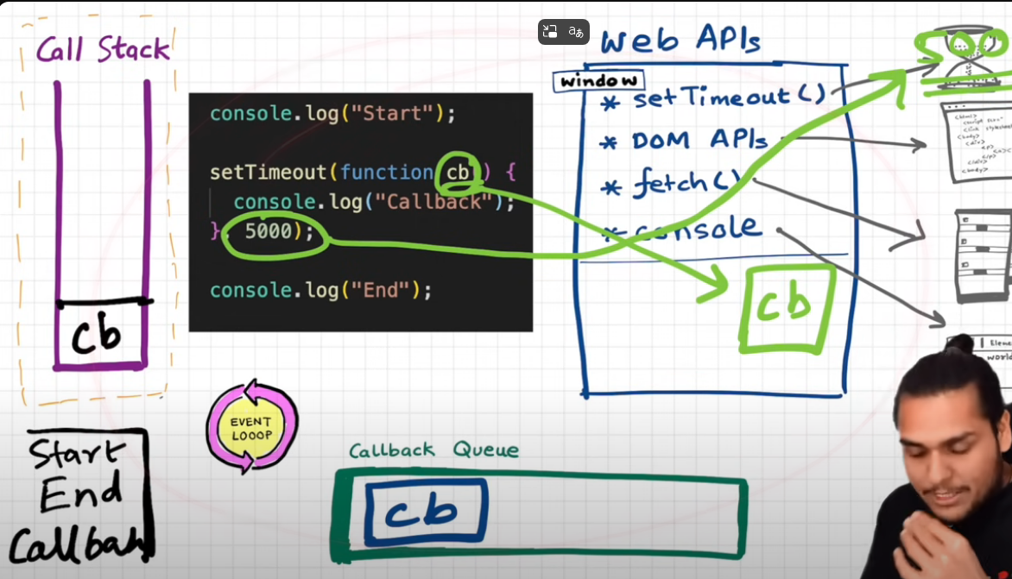

**Updated Flow with Callback Queue (CBQ) Emphasized**

1. **Call Stack starts executing**:
   * console.log("Start") is pushed to the stack → executed → popped.
   * setTimeout(cb, 5000) is called:
     + It registers the **callback cb** with the **Web API**, along with the timer (5000ms).
     + Once registered, setTimeout is **popped off the stack**.
   * console.log("End") is executed next.
2. ✅ **Meanwhile**, the **Web API timer** is running in the browser environment **outside the call stack**.
3. **After 5000ms**:
   * The browser says: "Timer is done! The callback cb() is ready."
   * **The callback is placed into the Callback Queue (CBQ)** — it waits in line.
4. 🕵️‍♂️ **The Event Loop** continuously checks:
   * “Is the **Call Stack** empty?”
   * If yes, it **pushes the callback from the CBQ into the Call Stack**.
5. ✅ The callback function (cb) runs:
   * Executes console.log("Callback")
   * It finishes execution and is popped off the call stack.

**Example 2. (with event listeners)**

**Step 1**

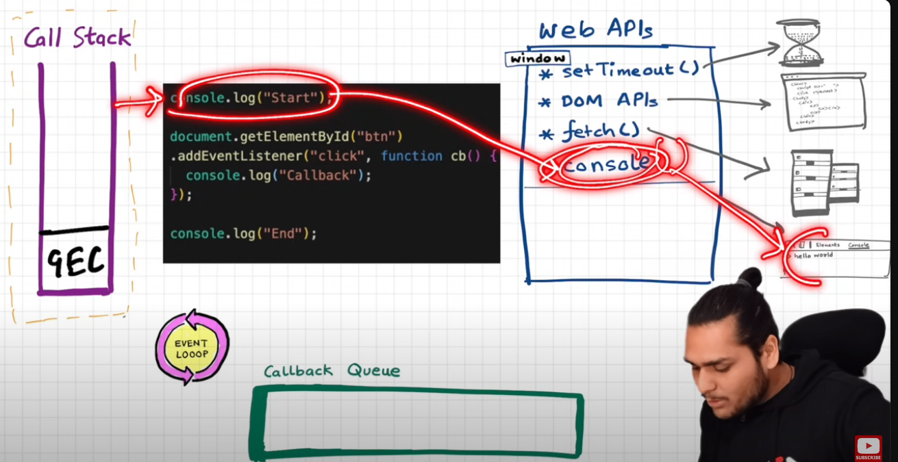

Step 2 – the addEventListener registers the callback in the browser environment and attaches a click event to it

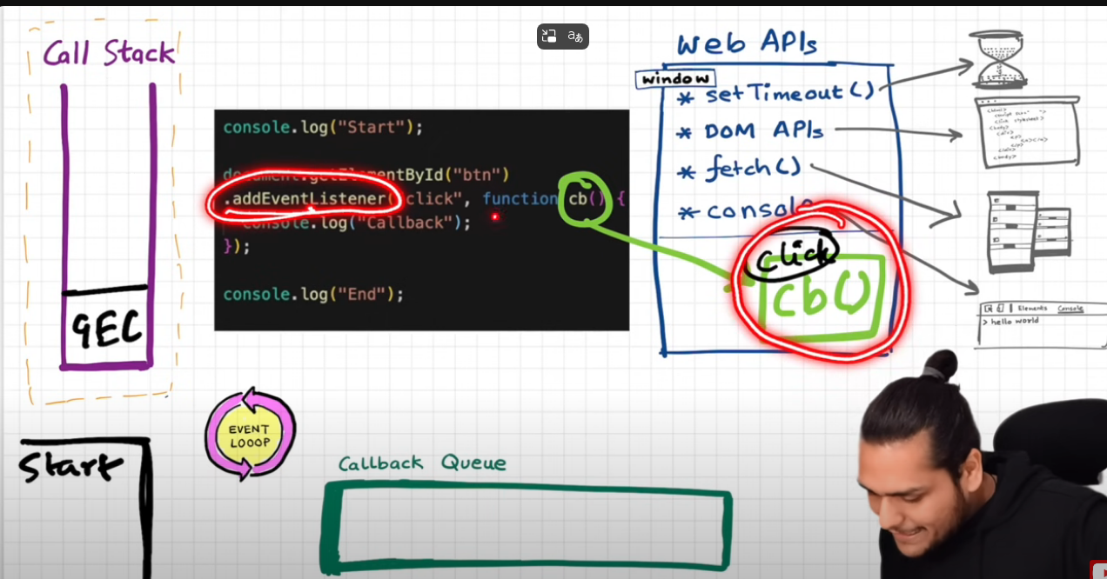

Step 3 – then end is logged and gec is popped

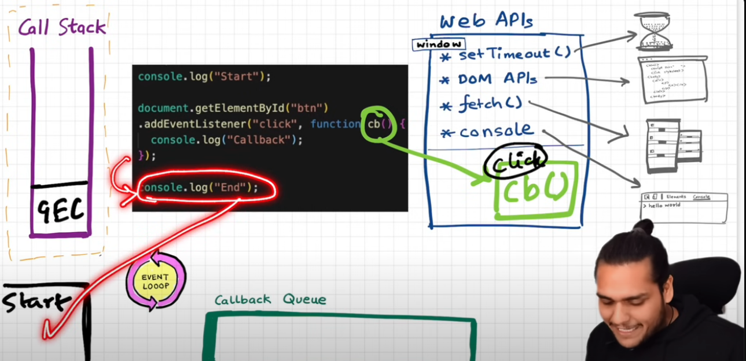

The event listener stays in the WEB apis environment until is explicitly deleted or until the browser is refreshed.

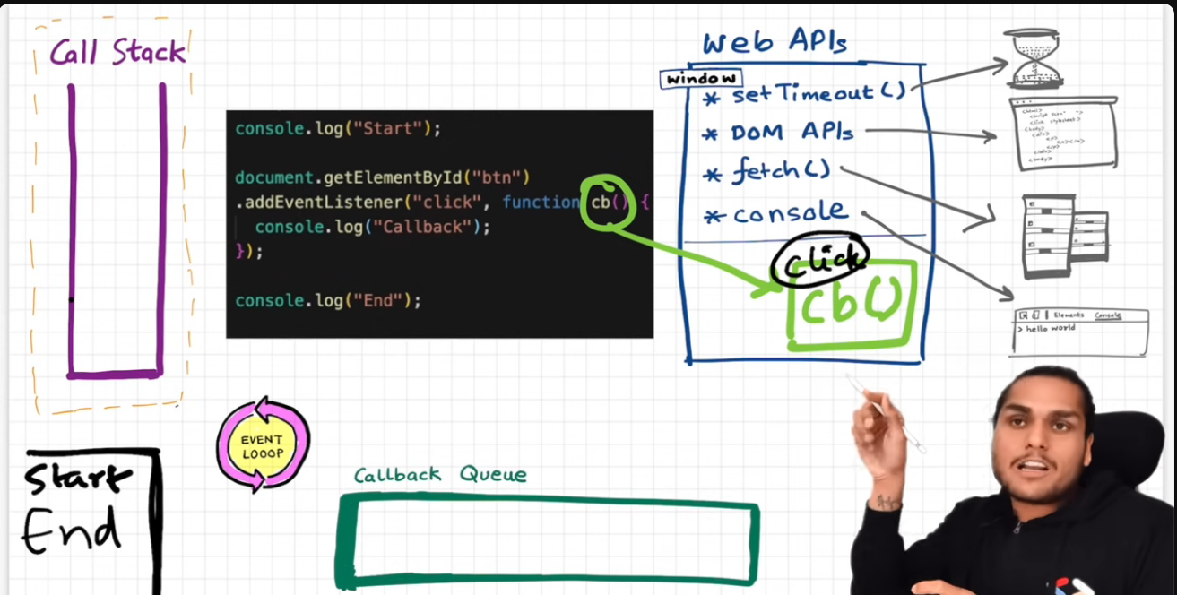

When the button with id btn is cliked, the cb is added to the cbq and waits for the event loop to pick it up and add it to the callstack.

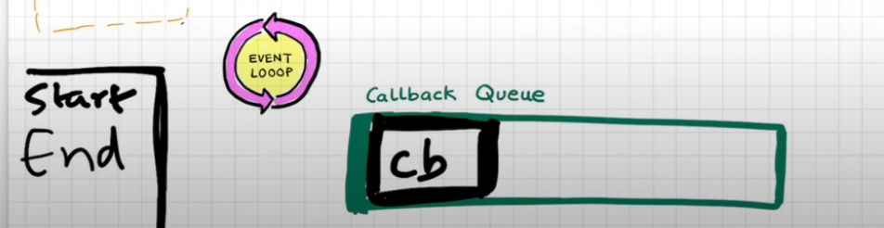

Event loop has 1 job, monitor CS and see if CS is empty then add fxn from CBQ into CS so that it is executed quickly.

Why do we need CBQ ? – check notes – if user clicks button 7-8 times its added to the cbq and the el checks the cs, if its empty add the cb from cbq one by one into the cs to execute it.

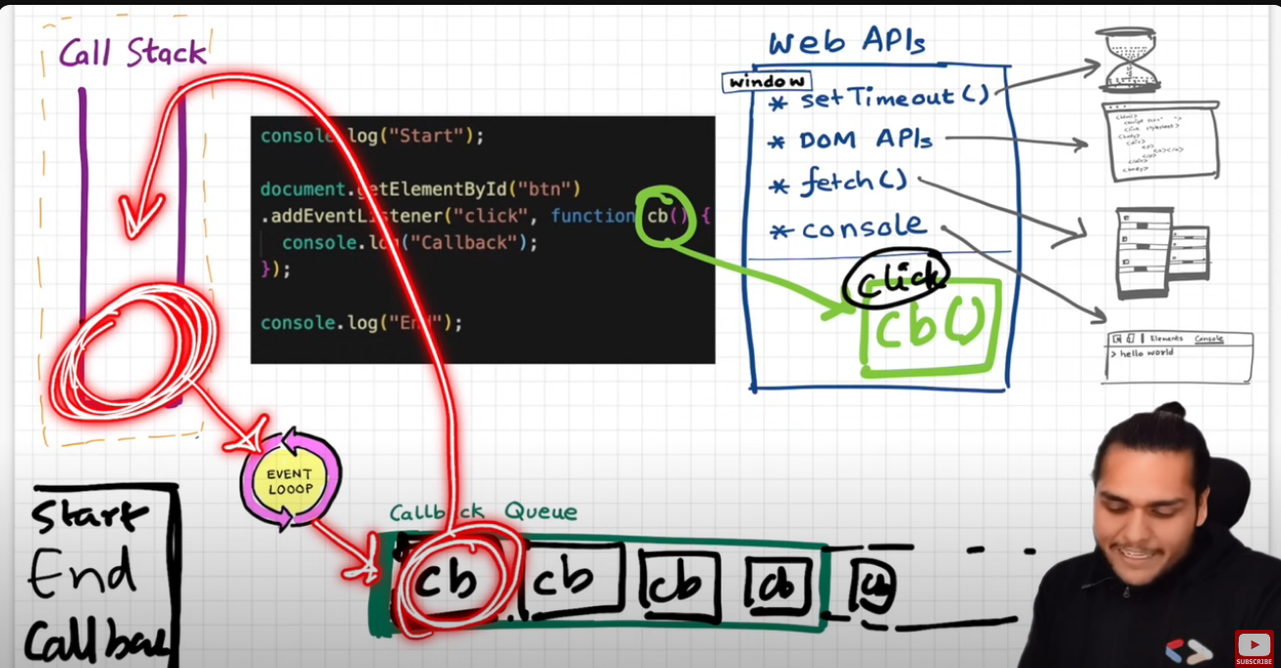

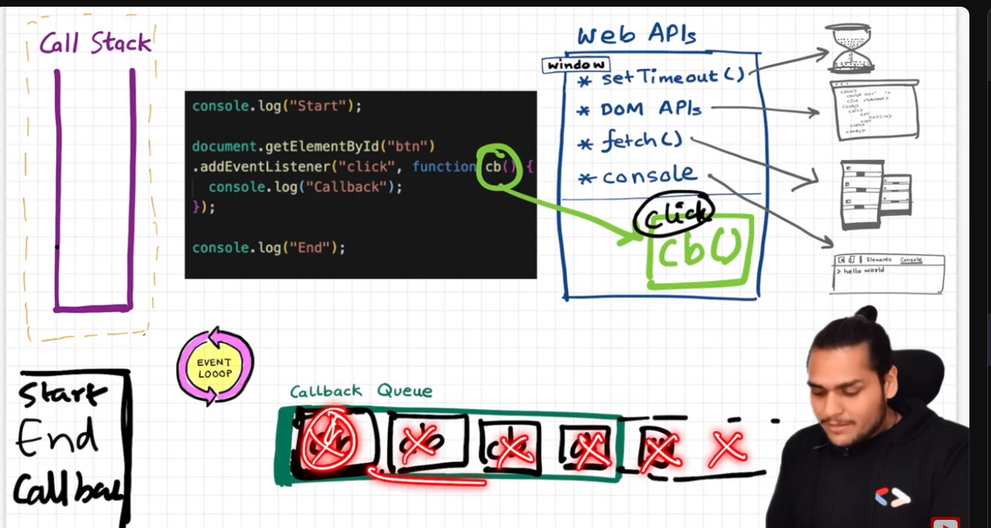

Example Summary-

**🔁 Execution Flow: Understanding addEventListener and the Event Loop**

**🟣 Step-by-step breakdown:**

1. **Line 1: console.log("Start")**
   * The global execution context (GEC) is created.
   * console.log("Start") is called → added to the **Call Stack (CS)** → logs "Start" to the console.
   * It is then popped off the CS.
2. **Line 2–4: Registering the Event Listener**
   * document.getElementById("btn").addEventListener(...) is executed.
   * This registers the **callback function cb** with the **DOM API inside the Web APIs environment**.
   * The function isn't run yet. It waits for a "click" event on the btn element.
   * The callback is **stored by the browser** — not on the call stack.
3. **Line 5: console.log("End")**
   * It logs "End" to the console.
   * After this, the entire **GEC is popped off** from the call stack — JS is now idle and waiting for events.

**🖱️ What happens when the button is clicked?**

1. The **browser detects the click** on the btn element.
2. The registered **callback function cb()** is sent to the **Callback Queue (CBQ)**.
3. The **Event Loop** kicks in:
   * Its job is simple — keep checking:

"Is the Call Stack empty?"

* + If yes, it dequeues the first function from CBQ and pushes it onto the Call Stack for execution.

**🔁 Why do we need the Callback Queue?**

* If a user **clicks multiple times quickly**, each callback is added to the **CBQ**.
* The **Call Stack can handle one function at a time** — so CBQ acts as a buffer, feeding functions to the stack **one by one**.
* Prevents loss of events and ensures **orderly execution**.

**🔍 Why can't we add functions directly to the Call Stack from the browser APIs?**

Imagine a world where, on every button click, the callback is added **directly** to the Call Stack — bypassing the Callback Queue (CBQ). Here's what goes wrong:

**⚠️ Problem 1: The Call Stack might already be busy**

JavaScript is **single-threaded**. It can only execute **one function at a time**.  
If the browser tries to push a callback directly to the stack while it's already processing another function (say a long loop or another callback), it would:

* **Interrupt the running code** unexpectedly.
* Or worse, **crash** or **break the flow**, leading to bugs or inconsistent behavior.

📌 *CBQ provides a structured "waiting area" so callbacks don't pile onto an already-busy stack.*

**⚠️ Problem 2: No control over execution order**

If multiple events happen in quick succession (e.g., multiple clicks or a click + timeout):

* Without the CBQ, they might enter the CS **out of order**, depending on browser internals or timing glitches.
* CBQ guarantees **first-in, first-out (FIFO)** order → ensures **predictable behavior**.

**⚠️ Problem 3: System-level decoupling**

Browser APIs like setTimeout, fetch, or click are handled **outside the JS engine**, often in **separate threads** (handled by the browser's C++ layer).

These environments can’t directly push into the JavaScript engine’s **Call Stack**, which is **owned by the JS runtime**.

So they "hand off" completed callbacks to the CBQ, and the **event loop** acts as the gatekeeper between these layers.

🔁 **Does the Event Loop add a function from the Callback Queue (CBQ) to the Call Stack only if the Call Stack is empty?**  
**Yes. That is exactly how it works.**

**🔍 Why this behavior?**

The Event Loop **waits for the Call Stack to be empty** before pushing the next task from the Callback Queue. This is to:

* ✅ Avoid conflicts between synchronous and asynchronous code.
* ✅ Maintain execution order and prevent the stack from being overwhelmed.

Example 3 , understanding the working of the fetch API.

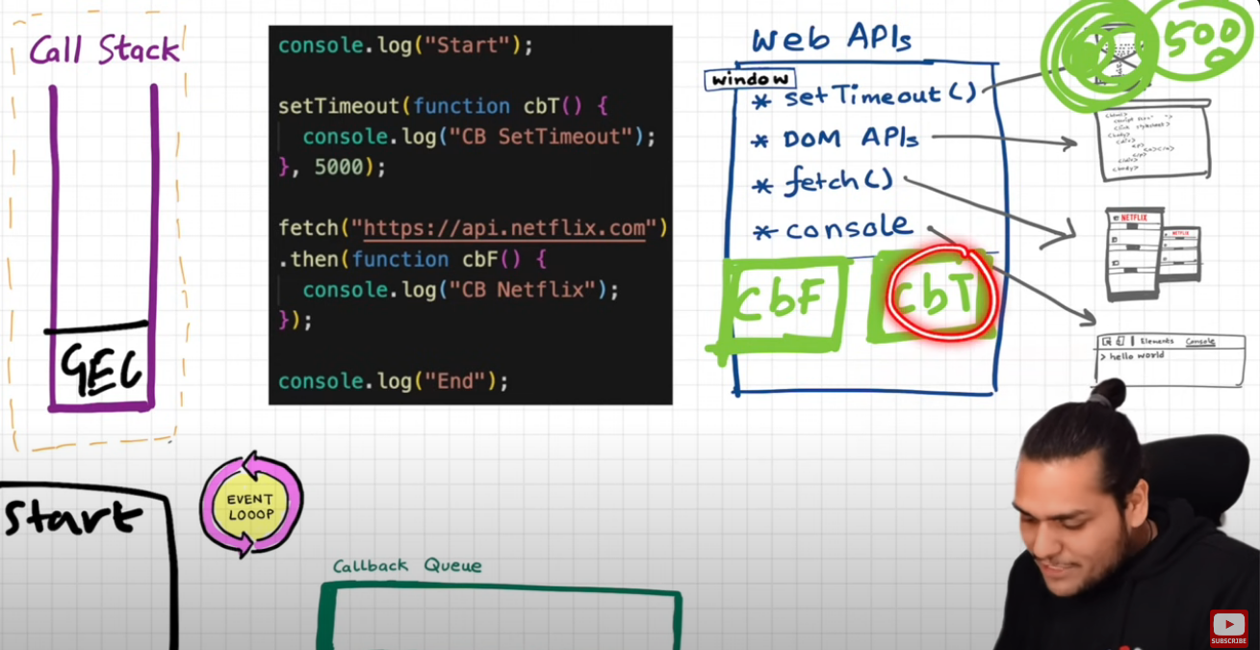

Same initial steps it follows, creation of GEC , registering a setimout callback function and then additionally here the fetch function also registers a callback function in the Web Apis environment as that is an async operation as well. Now both these are in the WEB apis environment.

cbT is waiting for the timer to expire and cbF is waiting for the network to fetch the API response.

Lets suppose Netflix servers are fast and we got the data quickly , Now we think that this cbF will go to the CBQ, but that will not happen , lol, psyched.

Now comes in the microtask queue concept. Just like this cbq there is also a MTQ.

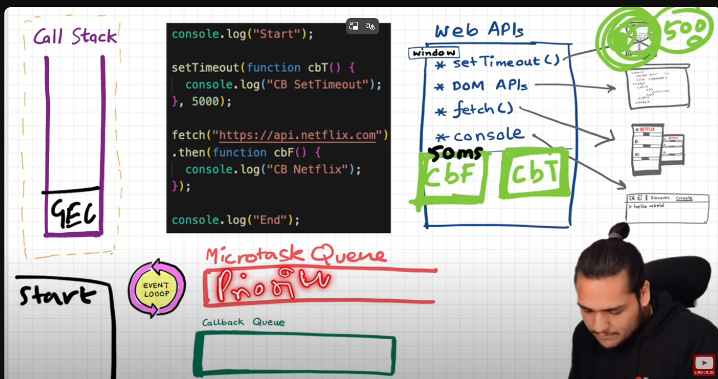

This queue is similar to CBQ but has higher priority. Whatetver comes in MTQ are executed first.

Now what comes inside MTQ. The cbF (cb in case of network calls), will go to the MTQ.

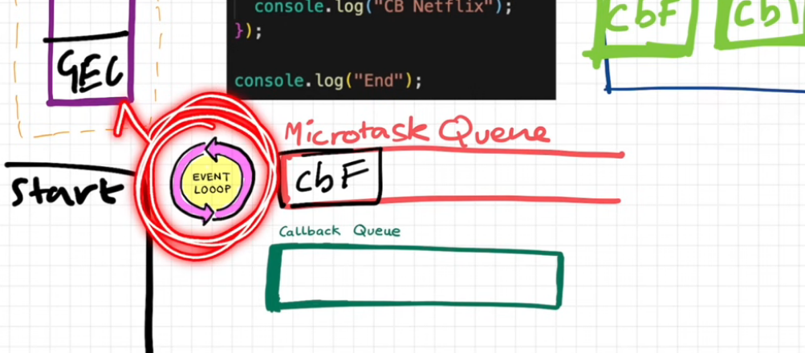

Now lets say that there are many lines in the code and the GEC is not still popped out from the CS and many functions are being executed in the main thread. The main thread is not free still.

Now if the timer expires, cbT also is ready to be executed. It will go into the callback queue

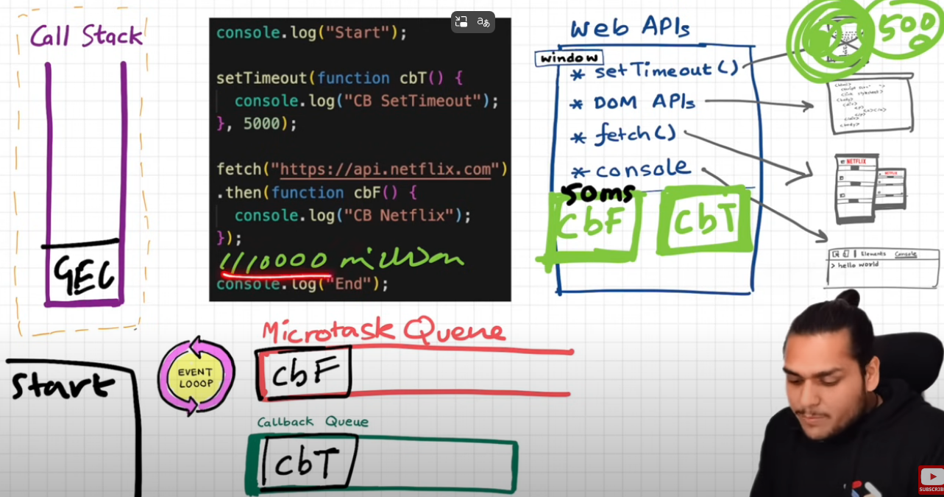

Both of these tasks are waiting to be executed, since GEC is executing.

Now if program ends, end will be logged and gec is popped off.

Now there are tasks in MTQ as well as CBQ.

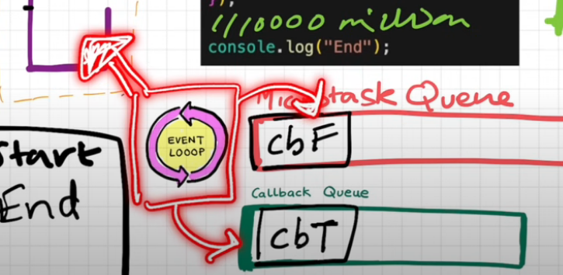

Since mqt is higher priority, cbf is added to CS, it is executed, “CB Netflix” will print, cbf is popped off, and then same task repeats with cbT.

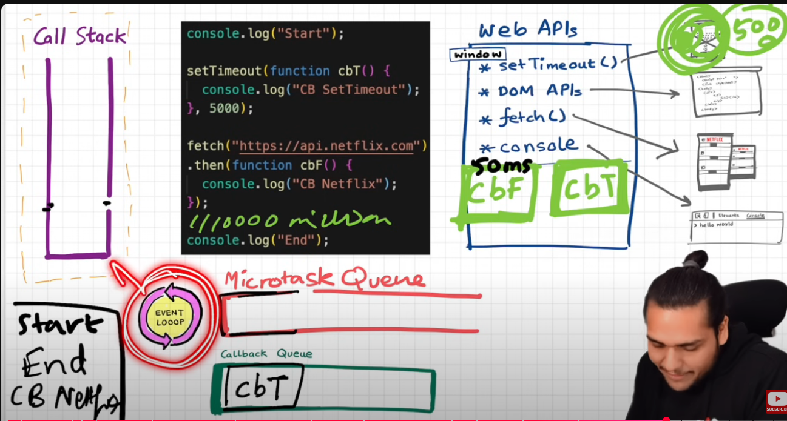

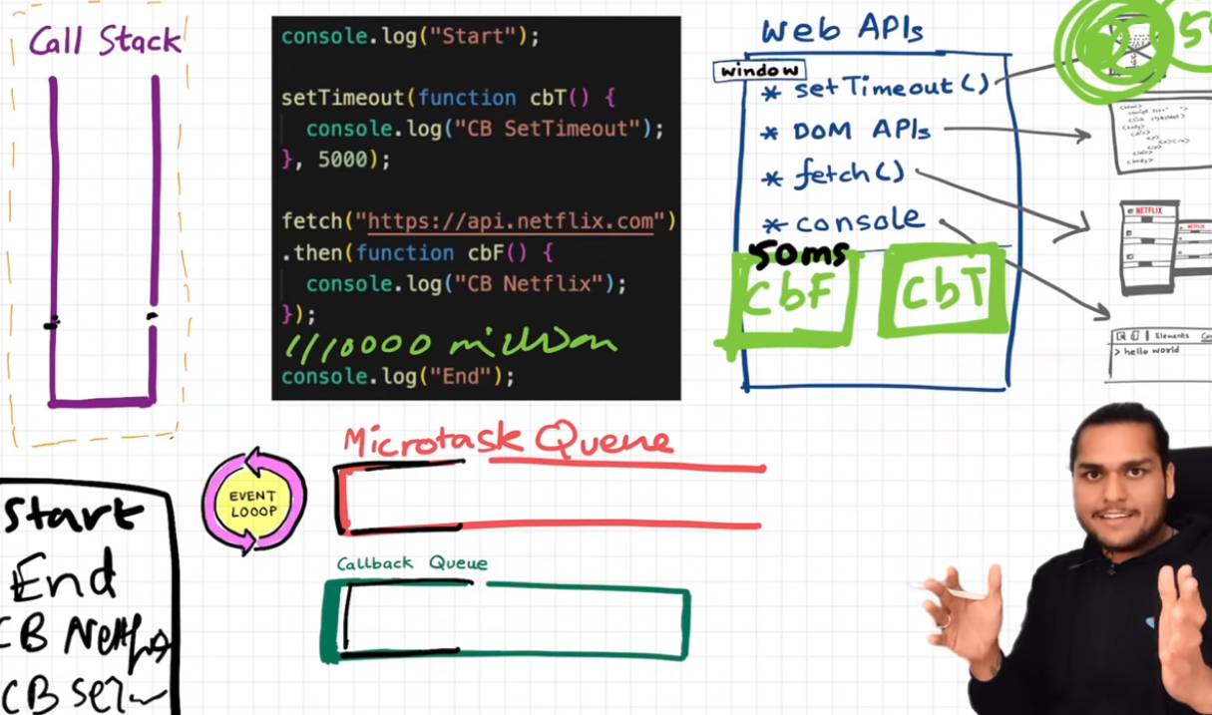

That is how this whole thing works. Oof.

What are microtasks then ?

All callback functions coming from promises are added to the mtq. There is also something called the mutation observer. Even those cbs are added to the microtask queue.

**⚙️ Step-by-Step Execution Breakdown**

**🔹 1. Global Execution Context (GEC) Creation**

* The JavaScript engine begins by creating the **GEC**, pushing it onto the **Call Stack**.

**🔹 2. Synchronous Logs**

console.log("Start");

* "Start" is printed immediately since it's synchronous.

**🔹 3. setTimeout Registration**

setTimeout(function cbT() {

console.log("CB SetTimeout");

}, 5000);

* cbT() is **registered** as a timer in the **Web APIs environment**, and it starts counting 5 seconds in the background.

**🔹 4. fetch() Call**

fetch("https://api.netflix.com")

.then(function cbF() {

console.log("CB Netflix");

});

* The **fetch** request is sent to Netflix servers (asynchronously).
* The .then() callback cbF() is registered to be executed **once the data is received**, handled by **Promises**, which means:

✅ cbF() will be added to the **Microtask Queue (MTQ)** — **not** the Callback Queue.

**🔹 5. Final Synchronous Log**

console.log("End");

* "End" is logged right away since it’s still in the synchronous block.

**🧠 Concept Deep-Dive**

**🔸 Web APIs Environment**

* Both setTimeout and fetch are async functions and are offloaded to the browser's **Web APIs** environment.
* They wait until they’re ready — timer expires, or network response arrives.

**🔸 Microtask Queue vs Callback Queue**

* After 5 seconds, cbT() moves to the **Callback Queue (CBQ)**.
* When the Netflix API responds, cbF() is sent to the **Microtask Queue (MTQ)**.

🔺 **Important Rule:**

The **Event Loop** always gives **priority to the MTQ**. It will **empty** the **Microtask Queue completely** before taking a single function from the Callback Queue.

**🔂 Execution Resumes When Call Stack is Empty**

* After all synchronous code runs, GEC is popped off the stack.
* Now the event loop checks:
  + MTQ has cbF() → it's **added to the Call Stack**, executed, logs "CB Netflix", then popped.
  + Then CBQ has cbT() → it's executed, logs "CB SetTimeout", then popped.

**🚨 What is a Microtask?**

A **microtask** is:

* Any callback attached to a resolved **Promise** (like .then()).
* A **MutationObserver** callback.
* Anything explicitly queued via queueMicrotask().

🧠 **Starvation Warning:**

If microtasks keep being added recursively (e.g., via nested .then()), then **callbacks in the CBQ might never get executed**, leading to **starvation**.

**💡 Summary (TL;DR)**

* The **fetch callback (cbF) goes to the Microtask Queue**, not the Callback Queue.
* **Microtask Queue has higher priority** than Callback Queue.
* Event Loop always **empties the MTQ before** picking anything from CBQ.
* Too many microtasks? → CBQ starves.

**✅ Microtask Queue (high priority, runs immediately after current code):**

* Promise.then(), Promise.catch(), Promise.finally()
* async/await (after await resolves)
* MutationObserver callbacks
* queueMicrotask()

**✅ Macrotask Queue (aka Callback Queue):**

* setTimeout()
* setInterval()
* setImmediate() (Node.js)
* I/O callbacks (e.g. file, network)
* UI rendering callbacks (in browsers)

**ECMAScript (or ES)** is the **official standard** that defines how the **JavaScript language** works. Think of ECMAScript as the **specification**, and JavaScript as one of its **implementations**.

Every modern JavaScript engine (like V8 in Chrome or SpiderMonkey in Firefox) follows the ECMAScript specification. New features in JavaScript — like let, const, arrow functions, classes, async/await — are all **defined in newer versions of ECMAScript**.

**📅 Examples of ECMAScript versions:**

* **ES5 (2009)** – introduced strict mode, Array.forEach(), etc.
* **ES6 / ES2015** – major update with let, const, arrow functions, classes, promises, modules, etc.
* **ES7+ (2016 onward)** – added features like async/await, optional chaining, nullish coalescing, etc.

ECMAScript is the official specification that defines how JavaScript works. JavaScript engines implement ECMAScript to ensure consistency across browsers. Modern JavaScript features (like arrow functions, classes, async/await) come from updates to the ECMAScript standard.

1/5/25

JS runtime environment

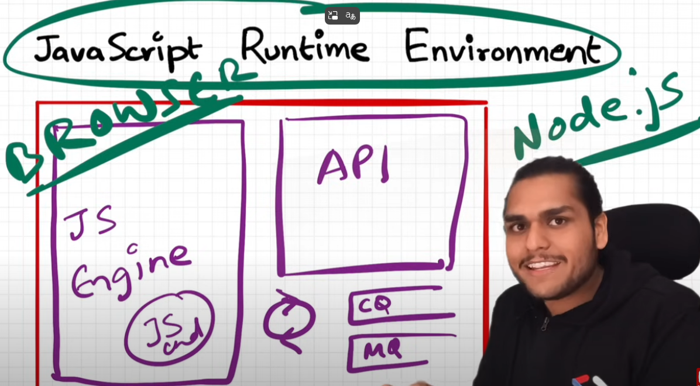

Heart of the JS runtime env is the JS engine.

JS Engine Architecture

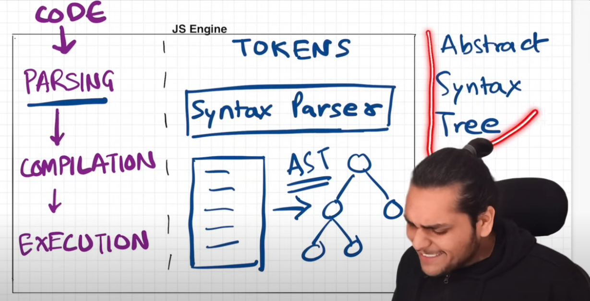

JS engine - It takes code as input, and performs 3 major actions – Parsing, Compilation and Execution

* 1. Parsing – Breaks code into tokens and the SyntaxParser converts code into AST (Abstract Syntax Tree)

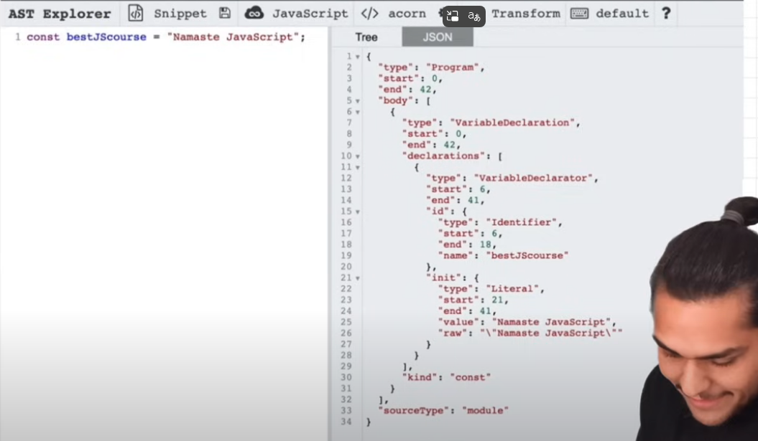

AST is like a big json object with various fields, this is the AST for one line of code.

Once AST is generated the AST is passed on to the compilation phase.

* 1. Compilation – JS JIT (Just in time compilation)

Before that interpreted lang. vs compiled lang.

Interpreted – line by line execution- 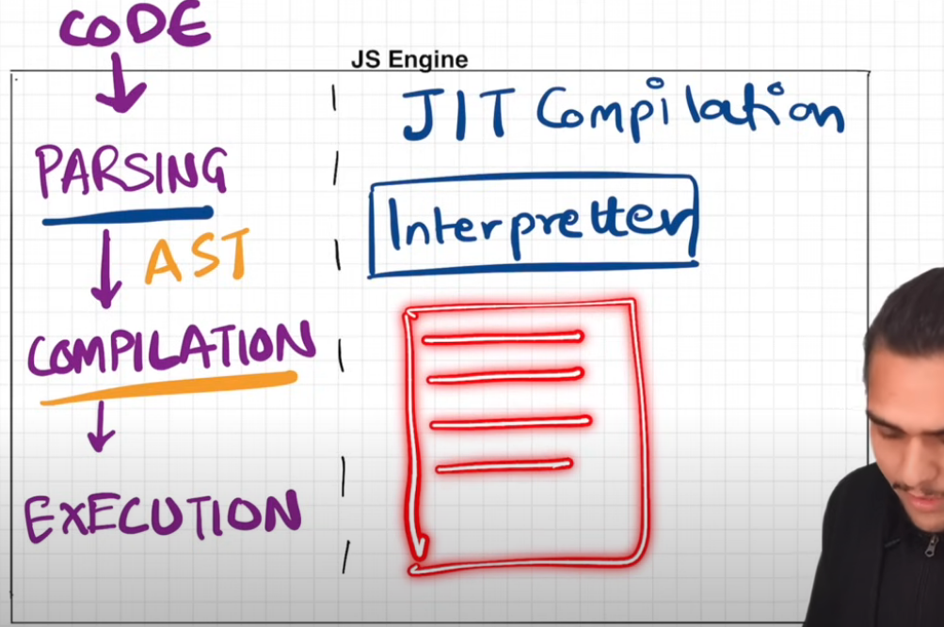

Compiled – code is first compiled then it is executed. More efficiency as optimized code runs rather than human code

Interpretted code is fast but compiled is efficient.

JS can behave as an interpretted language or a compiled language based on which JS engine is used.

JIT compilation – refer notes for in depth

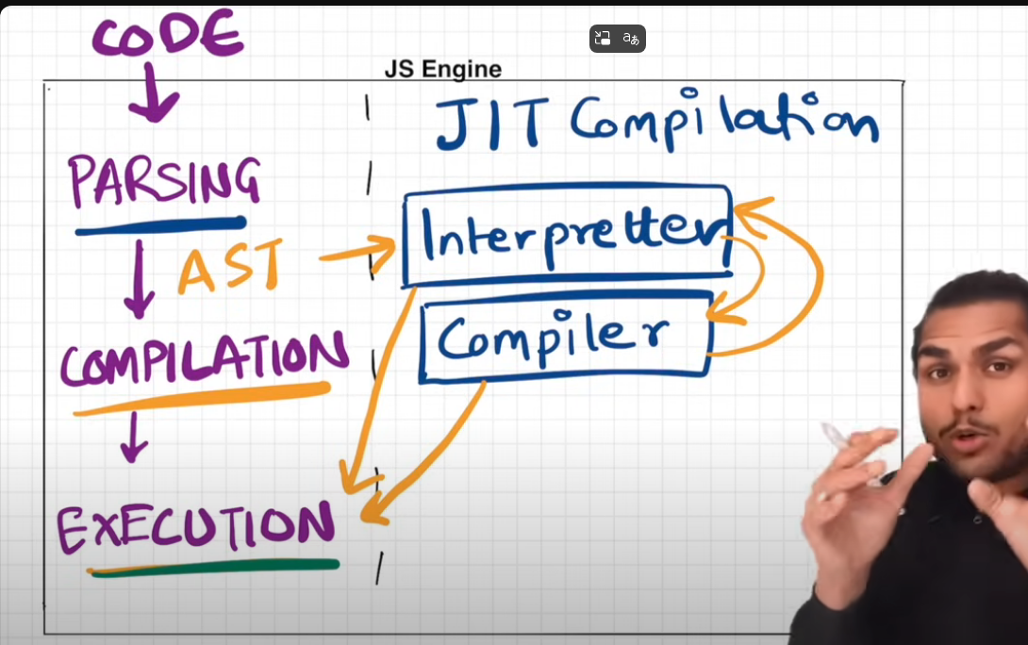

* 1. Execution

Happens due to the presence of the call stack, memory heap and garbage collector as shown in the next slide.

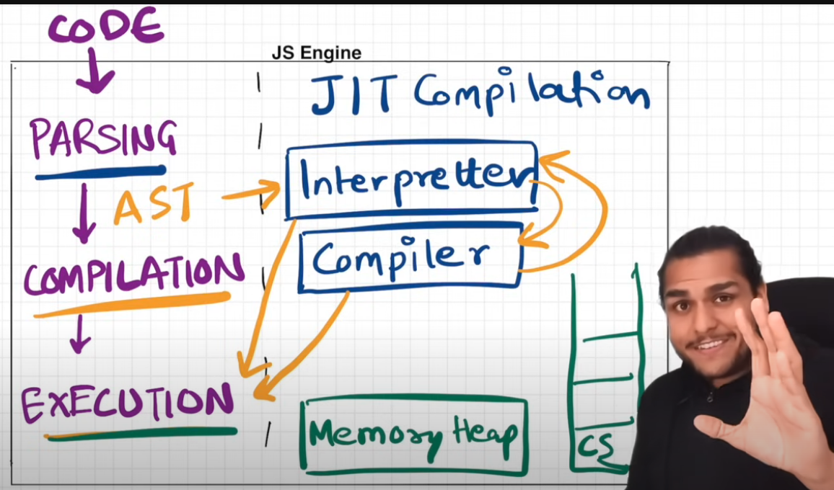

Garbage collecter (GC) – uses mark and sweep algorithm

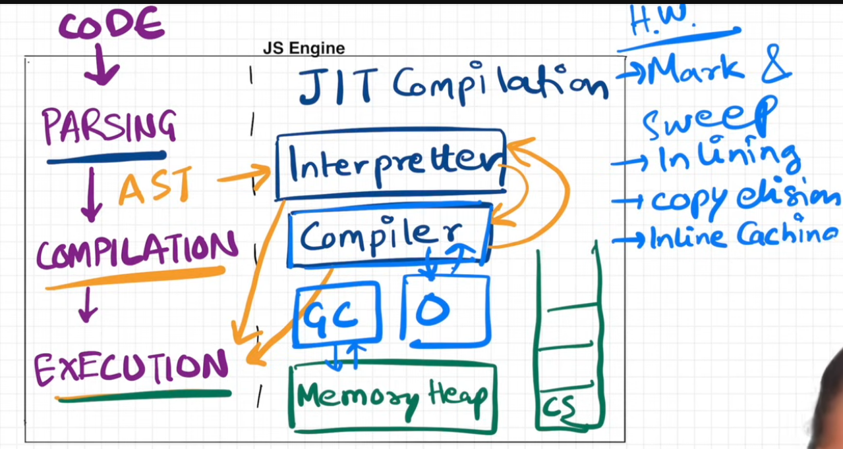

The mark-and-sweep algorithm is how JavaScript performs garbage collection. It marks all reachable objects starting from root references, and then removes (sweeps) any objects not marked — freeing memory that’s no longer in use.

Imagine your memory is like a big office. You start at your desk (root), and mark all the folders (objects) that are connected to your work. Anything **not connected to your current tasks** gets thrown away during the sweep phase.

The mark-and-sweep algorithm in JavaScript performs garbage collection in two steps: first, it **marks all reachable objects** starting from root references; then it **sweeps away all unmarked (unreachable) objects** from memory, freeing space and preventing memory leaks.

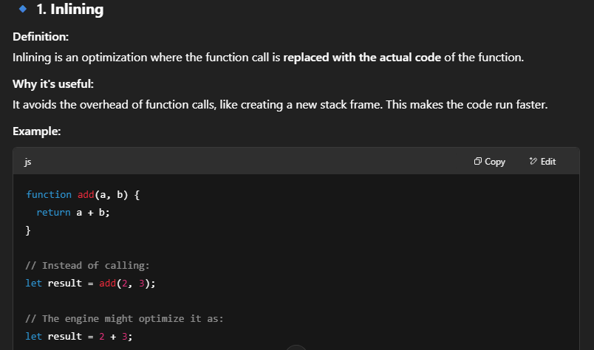

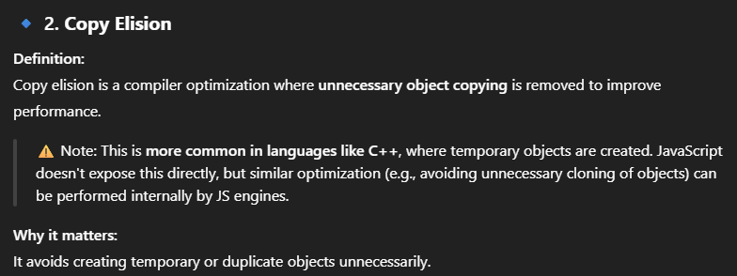

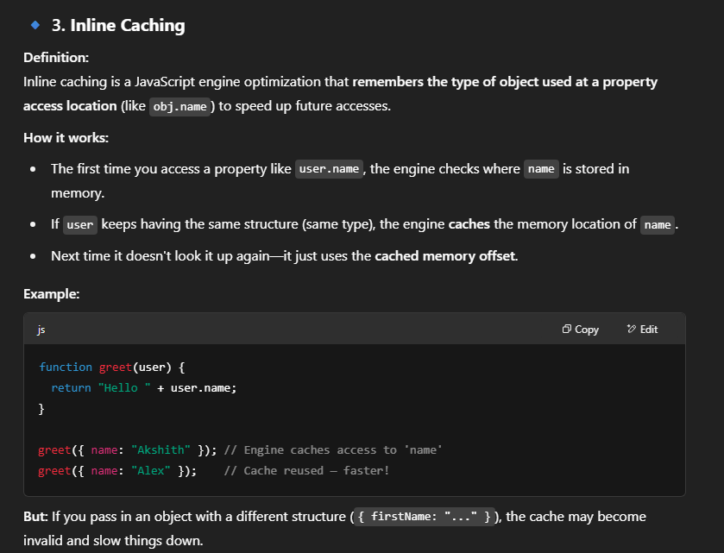

Google’s V8 JS engine architecture.

Interpretter is called Ignition, optimizing compiler is called TurboFan.

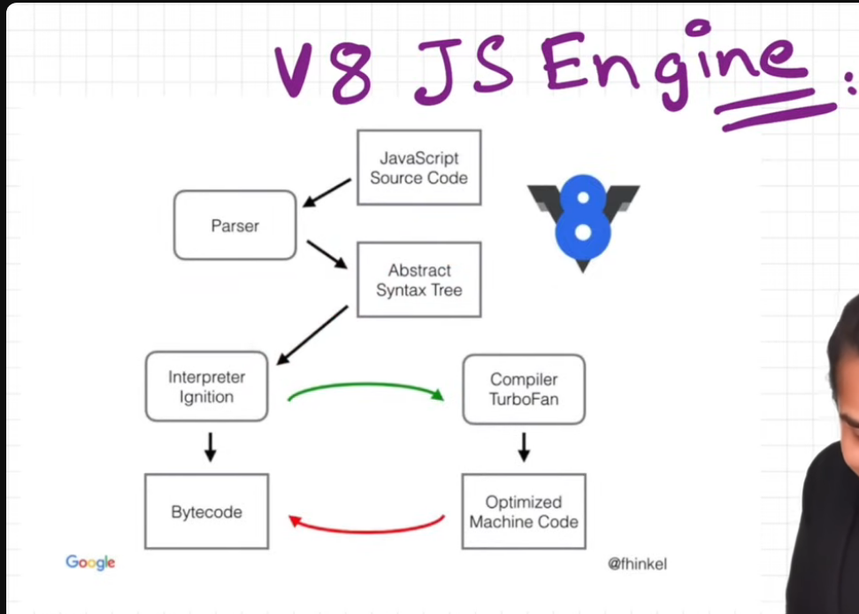

2/5/2025

Trust issues with setTimeout. - See notes for explanation.

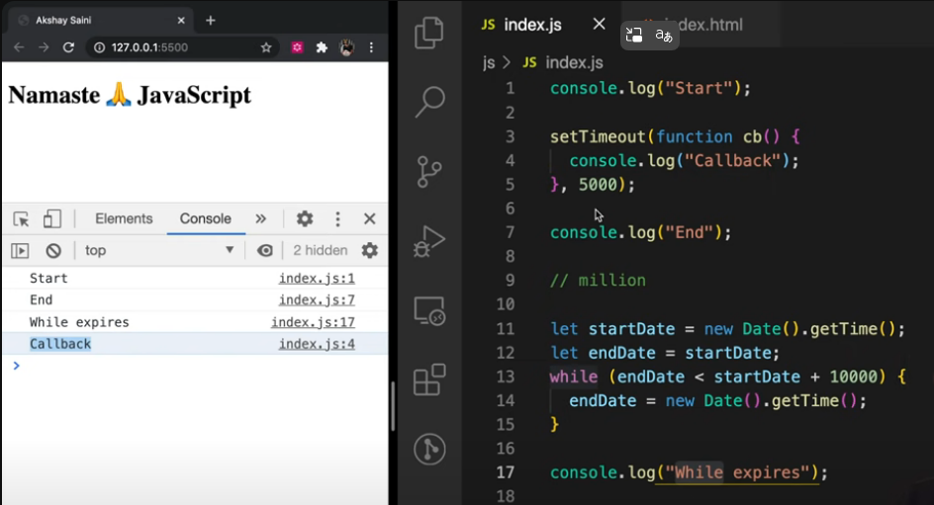

Case 2, settimeout 0

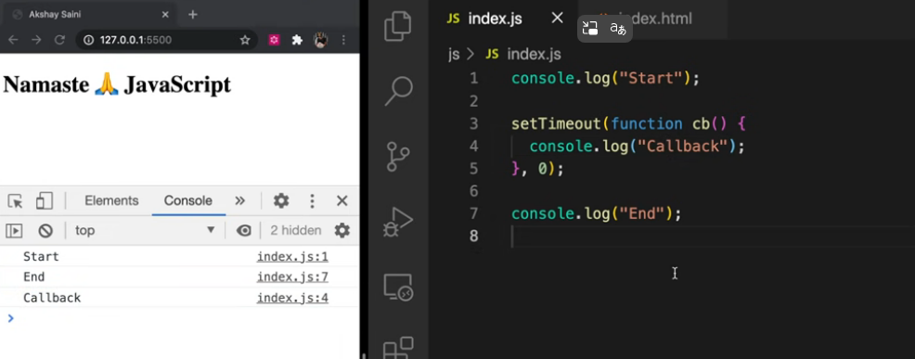

3/5/25 – Higher order functions

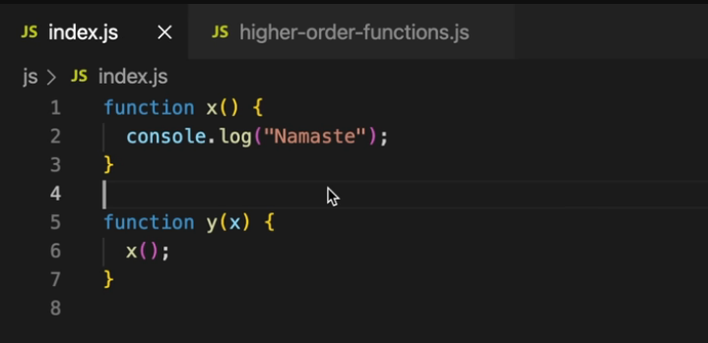

Here y is the higher order function and x is the callback function.

Basic problem to find area of squares where radius is given

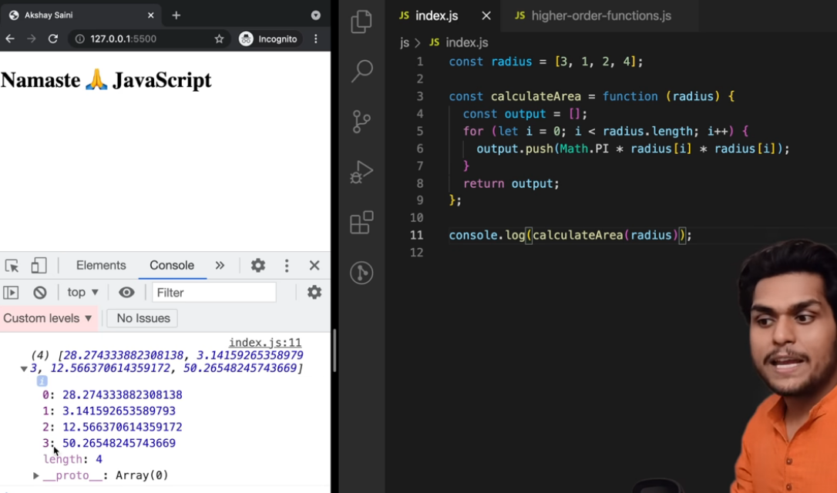

Now if we want to find circumference and diamter for the given circles we would do something similar-

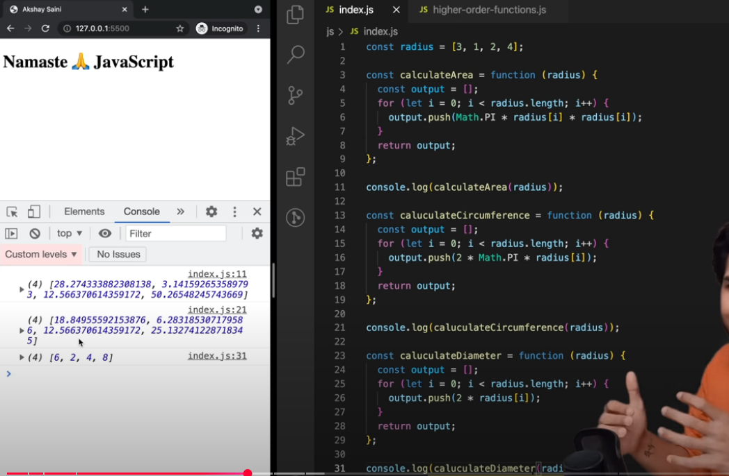

Here we have written 3 separate functions. This is not a good way, we are repeating code

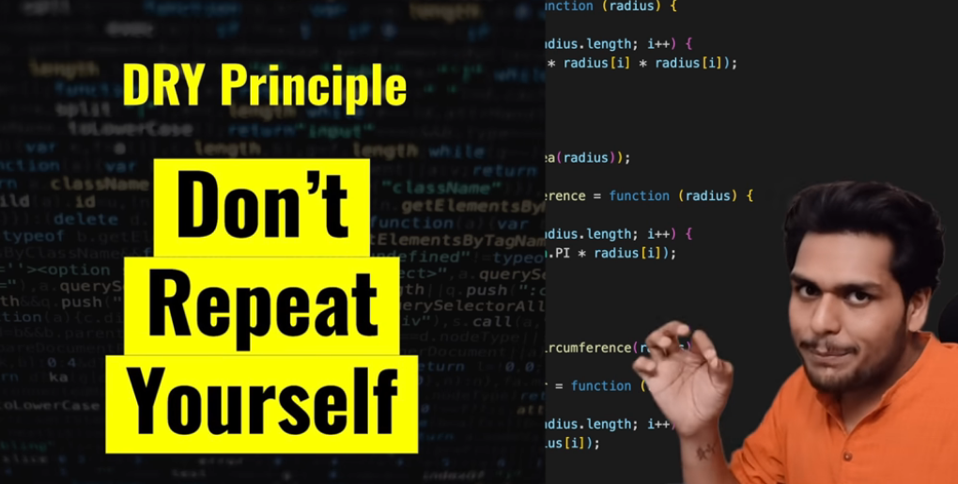

Instead pass logic or a function into another function and make the function more generic as shown below-

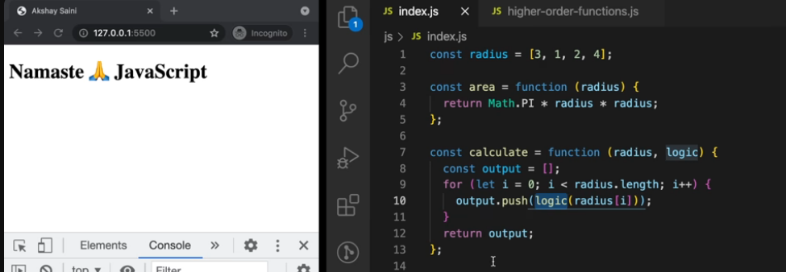

Instead of copy pasting multiple lines of code we are abstracting our logic outside and then passing it into the function wherever required.

This is the logic behind functional programming. Whenever we are in a coding interview it is best to follow this kinf of logic.

This is also a better way of writing code as each function has its own task.

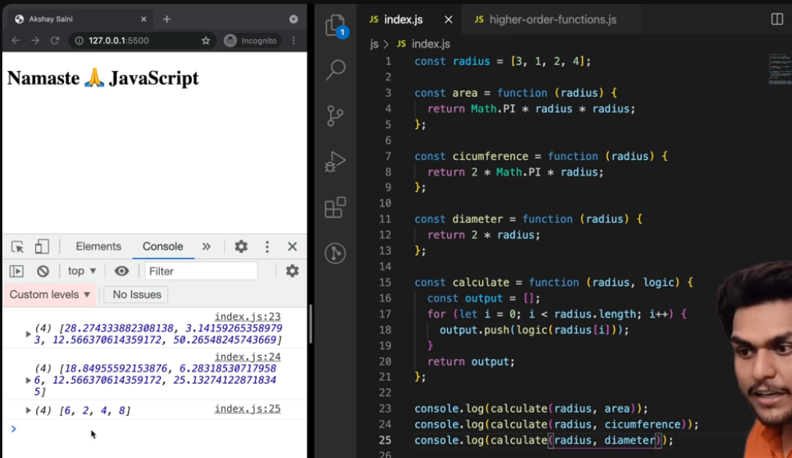

Here calculate is a higher order function and area,dia, circum are cb functions.

This calculate function is very similar to map fuction in js

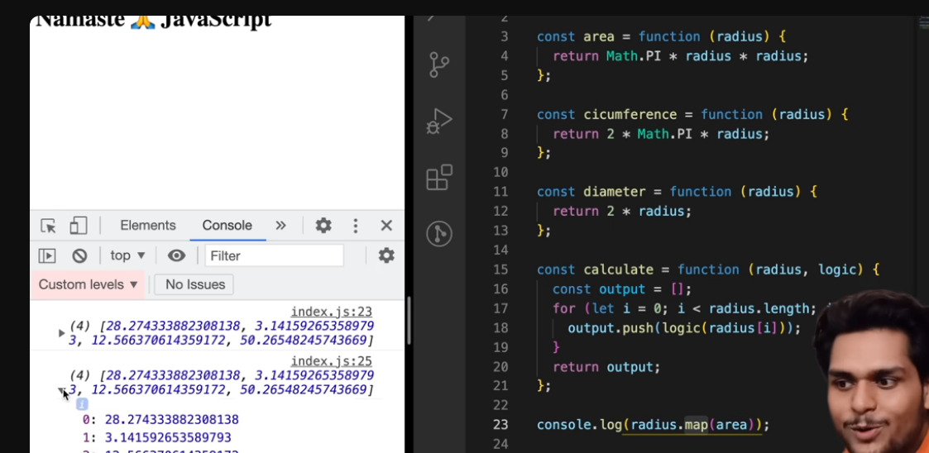

Caluclate and map function gives similar result. We kind of wrote our implementation of map here.

Making our calculate function exactly similar to map function

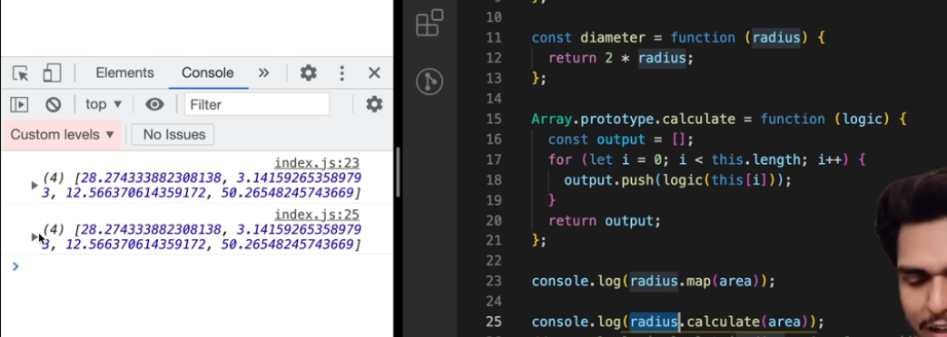

Array.protype makes calculate available on every array. “this” will point to the array.

4/5/2025

Map function usage-

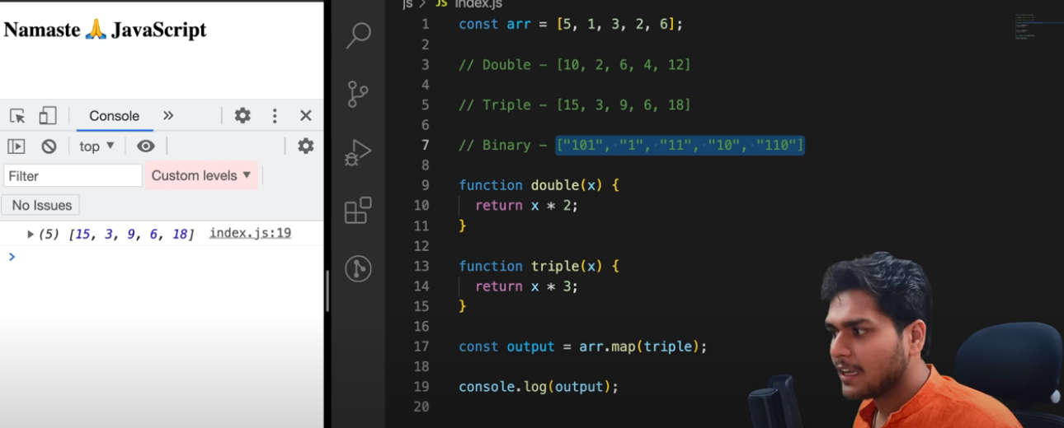

Converting to binary

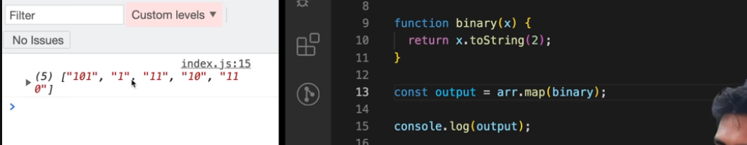

Also valid js

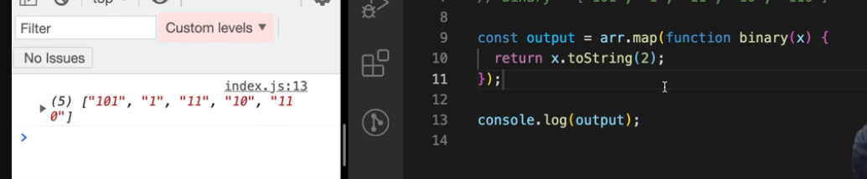

Anonynous cb function

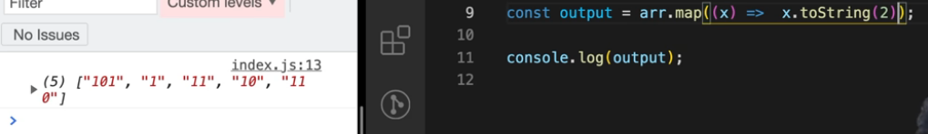

Filter function

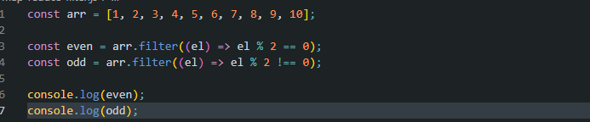

Reduce function

Find sum using reduce

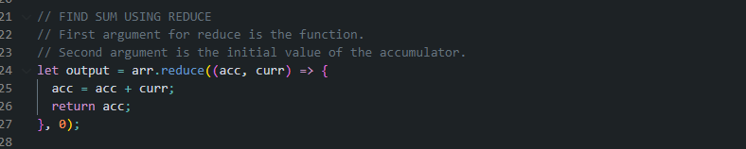

Find max using reduce

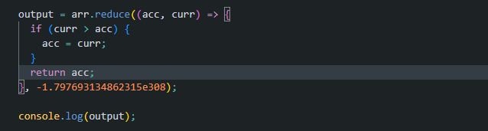

Good examples

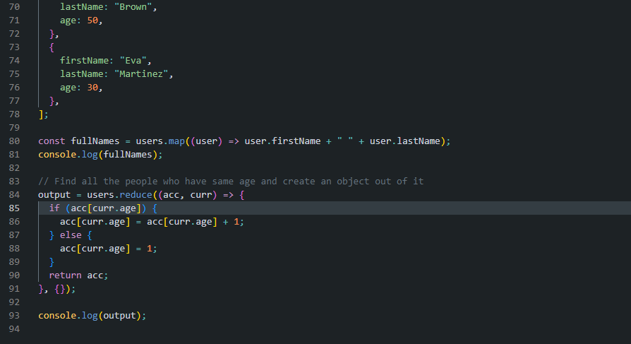

Combining functions

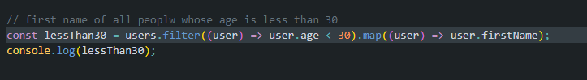

Season 2 – 5/5/25

Advantage of callback - helps us to perform async operations in JS.

Example 1

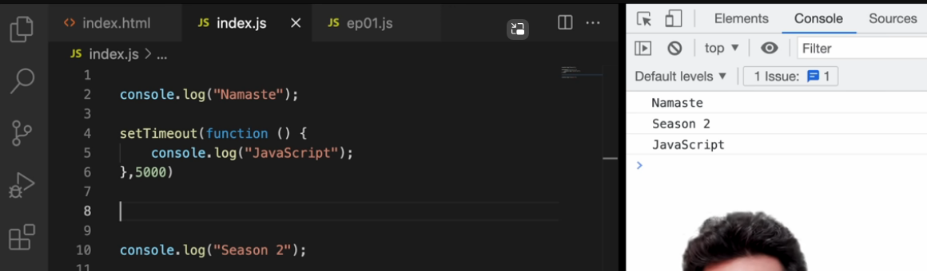

Example 2

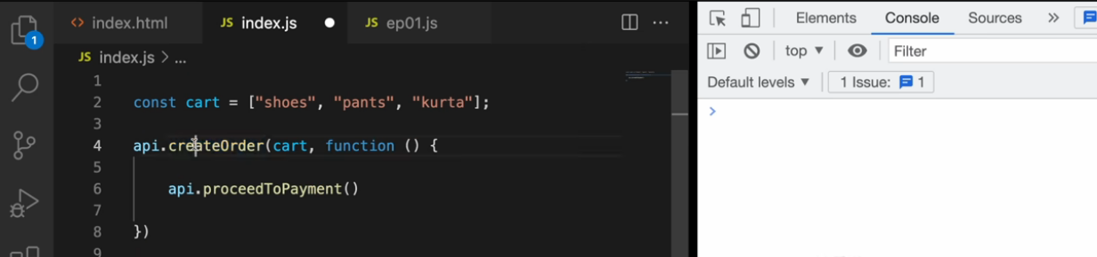

Now the proceedToPayment() function is passed as a callback function to the createOrder function. It is the responsibilityof the creatOrder function to create an order and then call the proceedToPayment function back.

This way we handle async operations.

Now we want another operation i,e the order summary and want it to be executed after the payment.

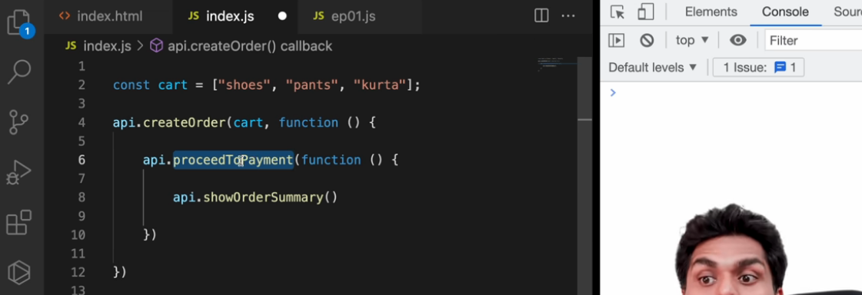

Now showOrderSummary is the responsibility of proceedToPayment as it is passed as a callback fucntion and it is dependent on the parent function.

Now if we want to update wallet –

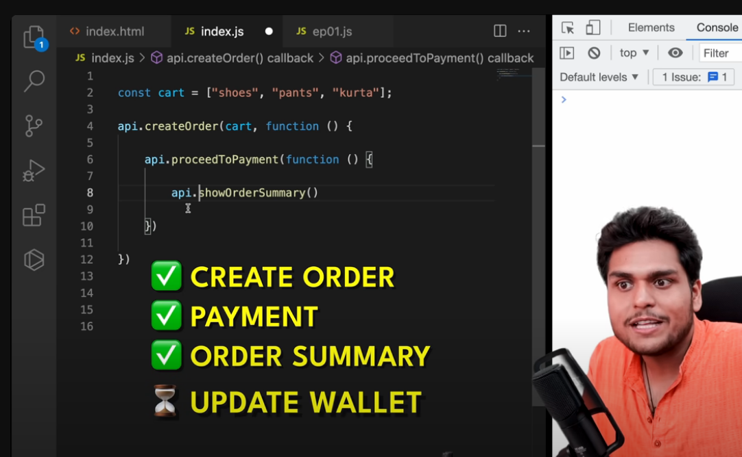

We do this – and this leads to callback hell, where we are calling one callback inside another callback, inside another callback, and it goes on and on. When we have a large application it becomes difficult to handle these callbacks.

Our code starts to grow horizontally instead of vertically.

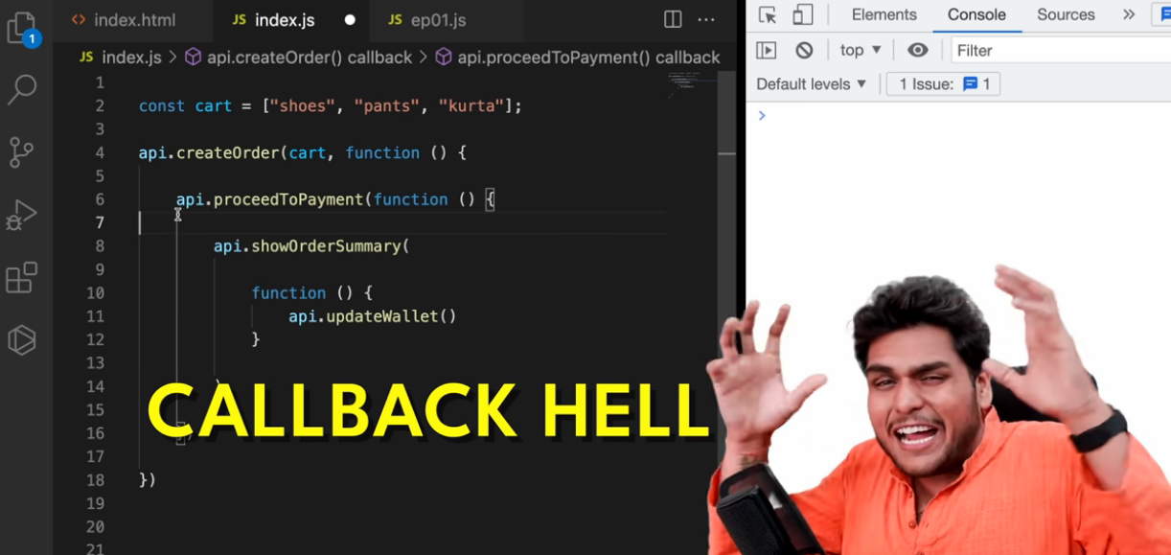

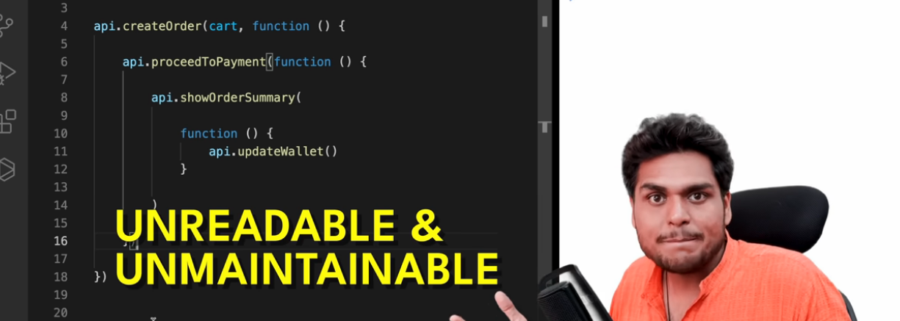

This horizontal structure is also known as pyramid of doom.

**2nd problem of callbacks – Inversion of control**

We lose control of our code.

We gave the control of the CB to the parent function(create order) and we think that at some point this function will be executed(proceedtopayment)

This is very risky because the parent function might have a lot of bugs inside it, might have many other dependencies or the CB might never get executed at all due to other problems insde the parent function. We are blindly trusting it.

There is a posibility that our CB might be called twice as well!

Summary-

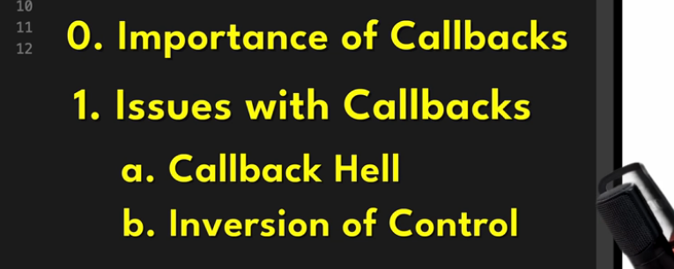

6/5/25 – Promises

Example – 1

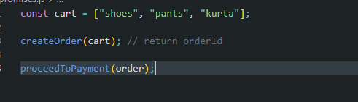

Imagine we can do proceedToPayment only after we gave createdOrder. How would we handle this ?

We do this using Callbacks -  
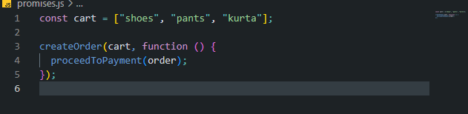

Issues of CB – inversion of control and callback hell.

Solution – use promises

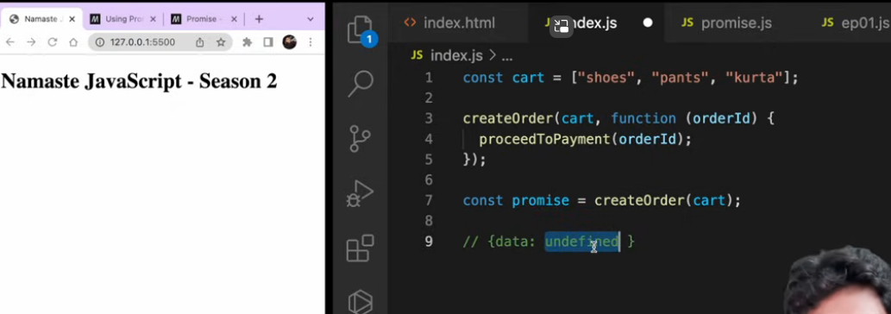

Promise returns this empty object with data and JS continuos execution. Once the async time has elasped and api returns data it will be populated in this promise object

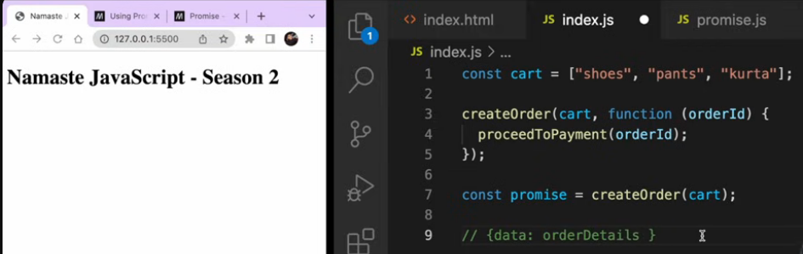

Once the promise returns data and data is populated, the callback function inside the .then() will get executed automatically.

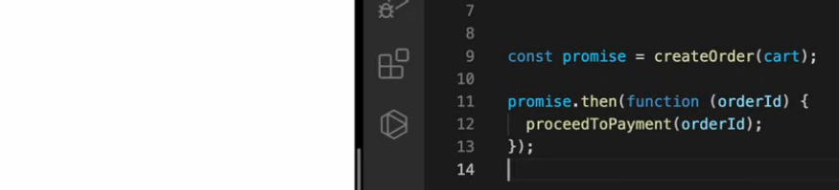

But here we are still passing the callback. What is the advantage?

In the firstcase without promises, we were passing a callback function into another function. But in the case of promise, we are attaching a callback function to the promise object.

**Passing a Function vs. Attaching a Function to a Promise**

* **Passing a function (e.g., as a callback)** means handing over full control of when and how the function is executed to the parent function. The parent function decides *when* to invoke the callback.
* **Attaching a function to a Promise** (using .then(), .catch(), or .finally()) allows us to maintain more control. The attached function only executes *after* the Promise is fulfilled (i.e., when the asynchronous operation completes and data becomes available). This allows us to chain and structure asynchronous logic in a more predictable and readable way.

The fetch function by default returns a promise-

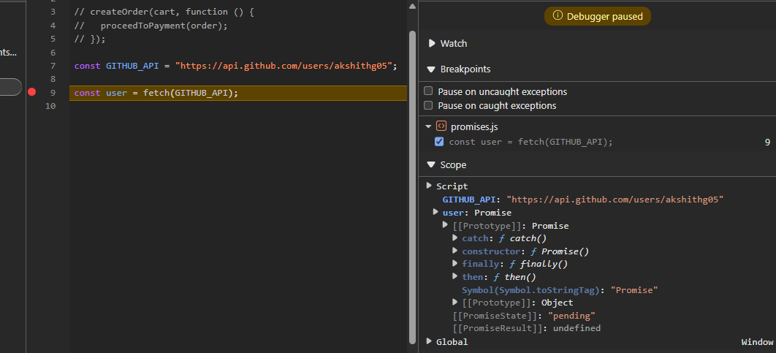

The promise object has many fields, the promiseResult actually holds the data. This will be populated when the api returns data. This promise is in a pending state. Once completed it will show “fulfilled” state.

Example- This will print pending state , because js waits for none. It does not wait for promise to be fulfilled, it just directly prints the promise object as is.

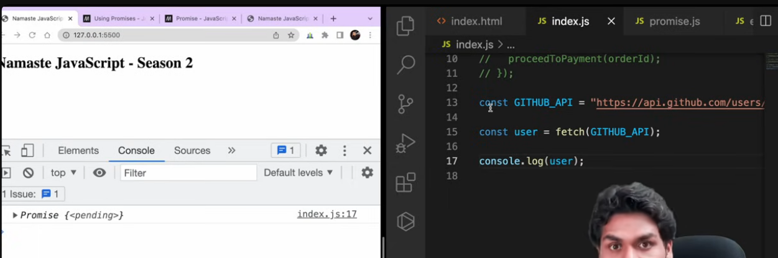

When it was logged it was in pending state, but when we expand the object we see fulfilled because browser updates it when the data is fetched.

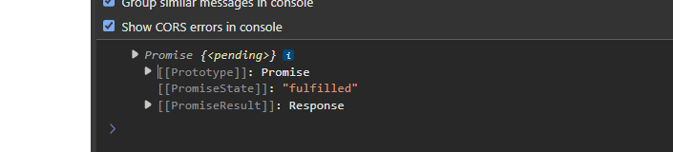

Hence we see this discrepency in the above image.

Attaching a callback with a then function

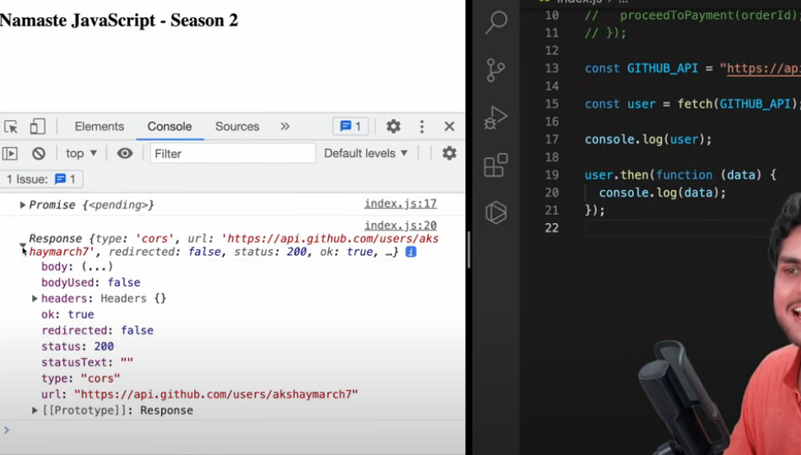

JS guarentees that a promise can be resolved only once. This builds a lot of trust in our application.

There can be only 3 states in promises – pending , fulfilled and rejected

**Promise objects are immutable**

**INTERVIEW PART**

1. What is a promise ?

a. Promise object is a placeholder, for a certain period of time until we receive a value from an asynchronous JS operation.  **OR**

b. It is also called as a container for a future value. **OR**

c. (best) – Promise is an object representing the eventual completion or failure of an asynchronous javascript operation.

Promise chaining –

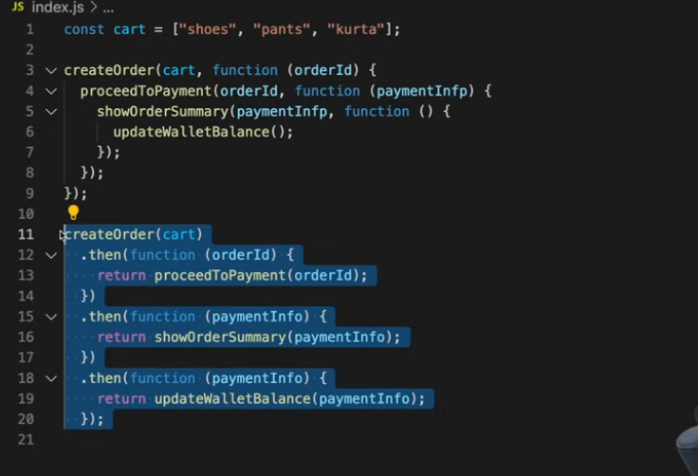

We can chain multiple functions with the then

Also can be written like this using arrow functions.

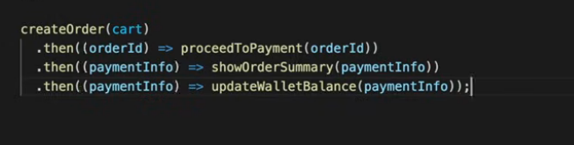

7/5/25 – Creating and understanding promises

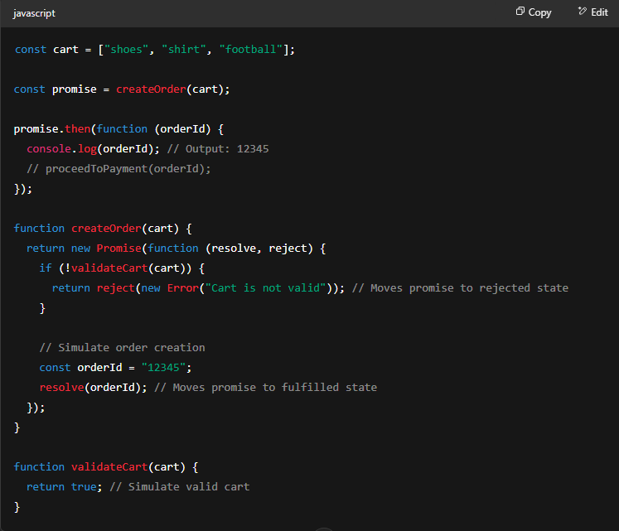

**✅ Key Concepts**

* **new Promise()** creates a promise and takes a callback with resolve and reject.
* **resolve(data)** → Fulfills the promise. The passed data (orderId) becomes available in .then().
* **reject(error)** → Rejects the promise. The error can be handled with .catch().
* **.then()** is used to handle the **fulfilled** state and receive the result.
* **Promise flow**:
  + Validate the cart
  + If valid → resolve with orderId
  + If invalid → reject with an error

**💡 Summary**Use resolve() to send data when a task succeeds and reject() to report errors.  
.then() is where you handle the result once the promise is fulfilled.

Same example with delay

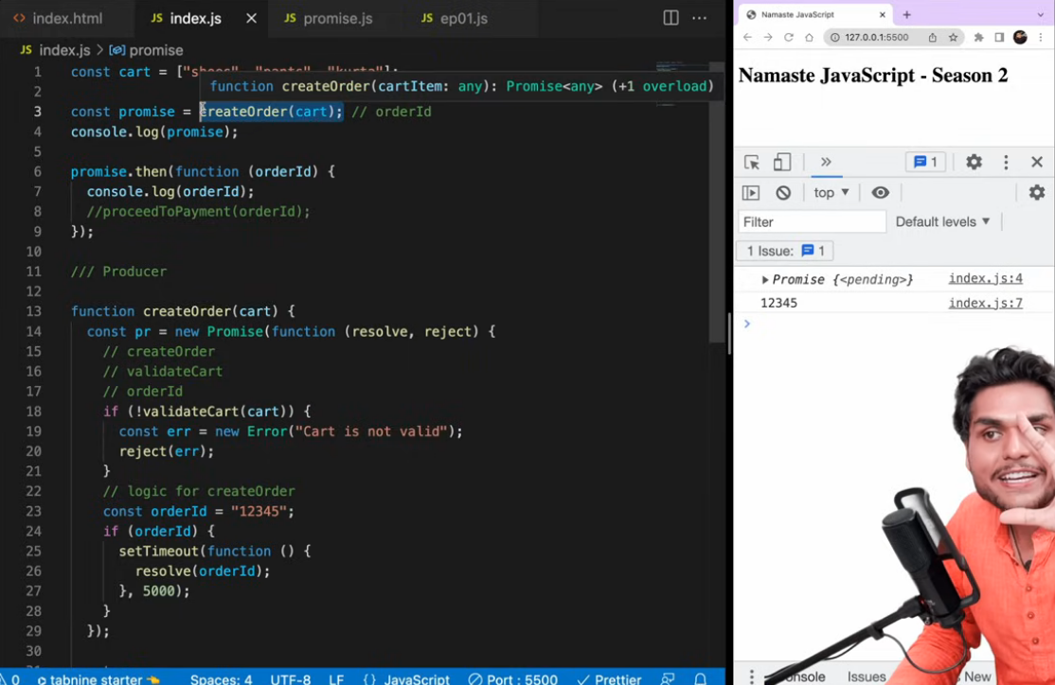

**⏱️ Key Insight**

* When createOrder(cart) is called, it returns a **pending promise immediately**.
* JavaScript logs the promise (Promise { <pending> }) right away because **JS is non-blocking**.
* The actual orderId is printed only **after 5 seconds**, when the promise is resolved.
* The logic inside .then() runs **after the delay**, once the promise is fulfilled.

**💡 Summary**

Promises in JS **don't block the main thread**.  
If the async task is delayed (like via setTimeout or fetch), the .then() is triggered **only after the promise resolves**.

If we suppose set the validateCart function to false, then there will be a failure

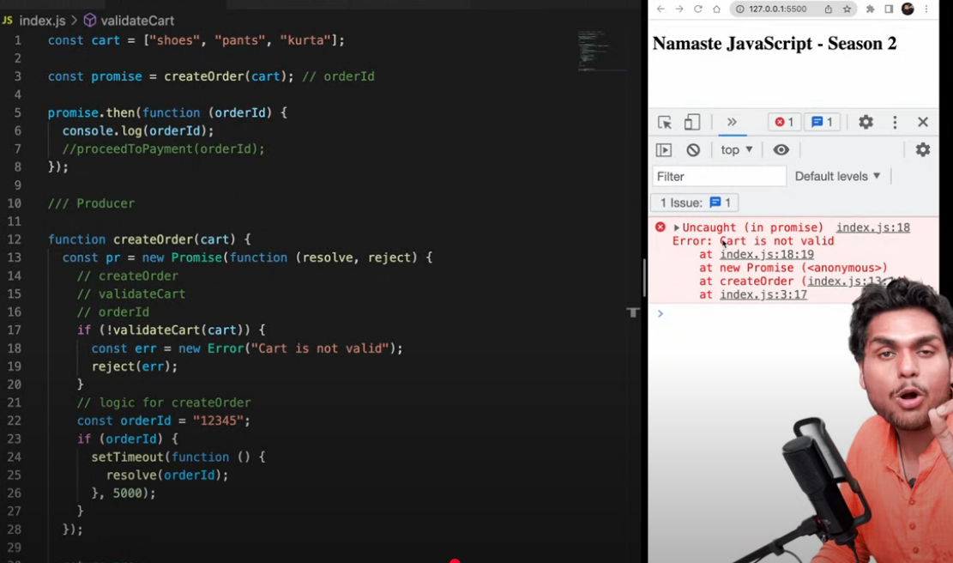

We should never push thins kind of code to production, we have to always handle the failure gracefully.

**❌ Handling Errors in Promises**

If validateCart() fails, the reject() call causes the promise to **enter the rejected state**, and the error shows up in the browser console.

❗ Never let such unhandled errors reach the user — this is **not production-safe**.

**✅ How to Handle Promise Errors Gracefully**

* Use **.catch()** to handle promise rejections.
* It works like .then(), but for failures.
* The function passed to .catch() is a **failure callback** — it runs **only if the promise is rejected**.

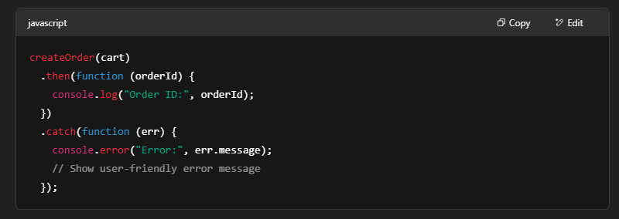

Promise chaining-

Example 1- Here the catch statement is valid for the entire promise chain as it is at the end of the chain

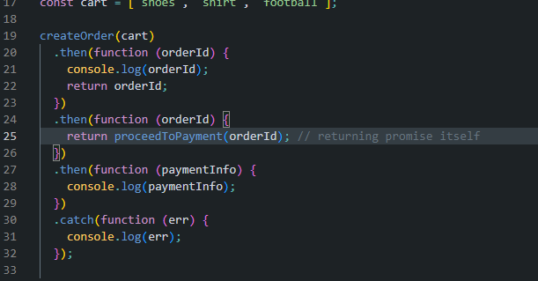

Example 2-

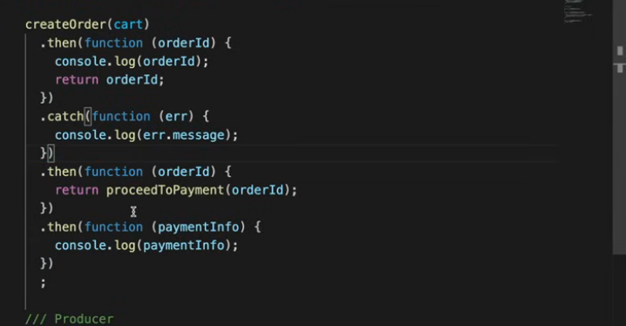

By doing this the catch statement is only valid for the first promise and not for the remaining ones.

Output –

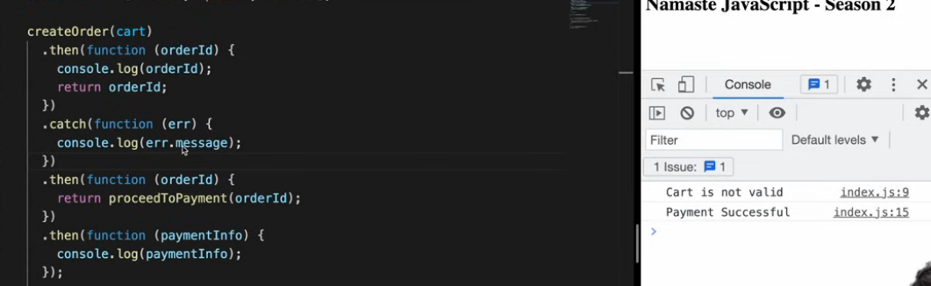

Whenever we have catch statement , whatever “then” method is there after catch, will definitely be called no matter what happens.

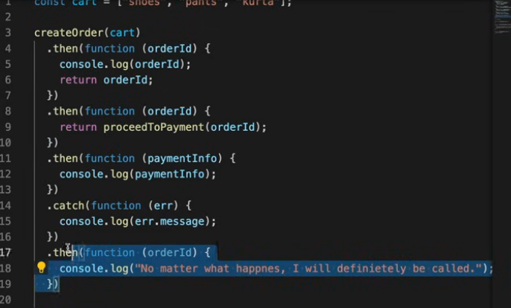

Here the last line will always run as its after the catch block.

9/5/2025 – Different promise apis (refer notes)

* + 1. Promise.all()

All promises success case-

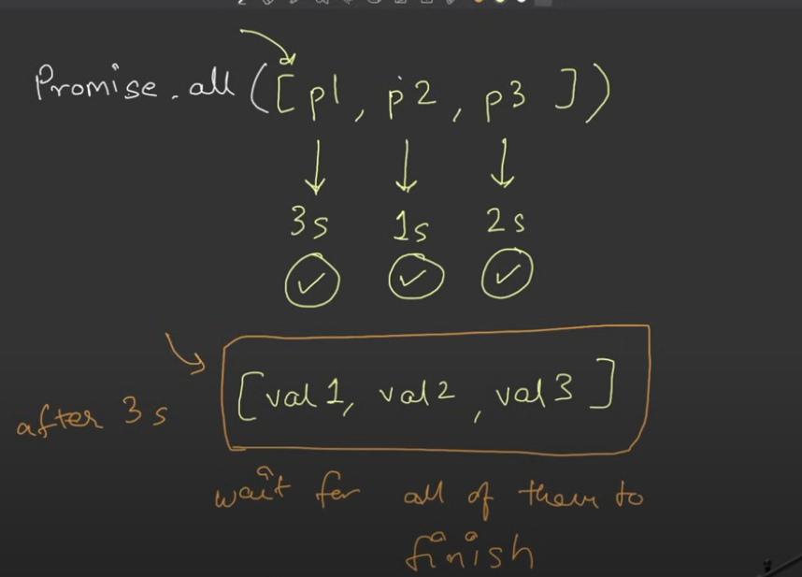

One of the promise rejected case

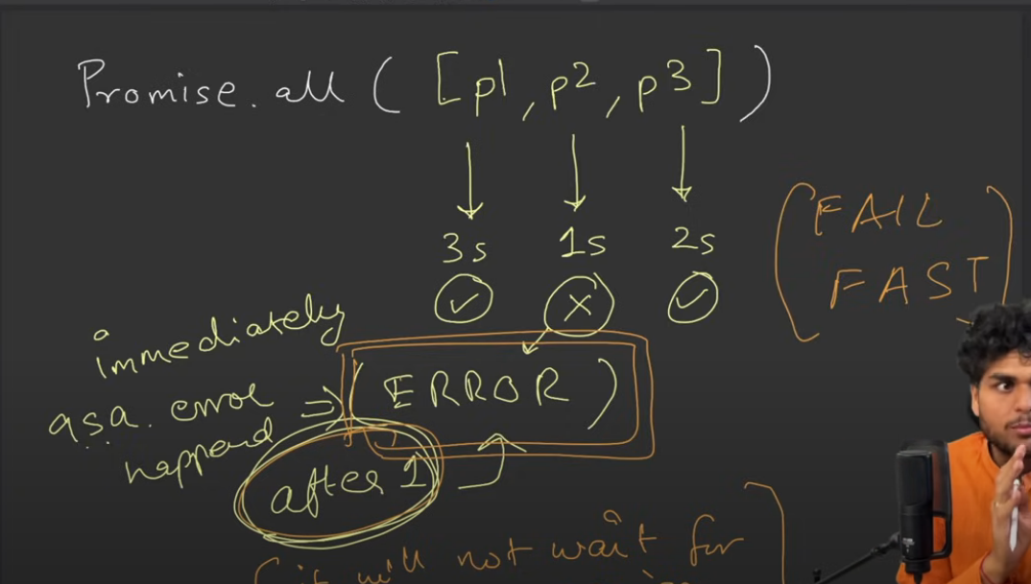

See notes for all remaining cases and scenarios.

* + 1. Promise.allsettled()

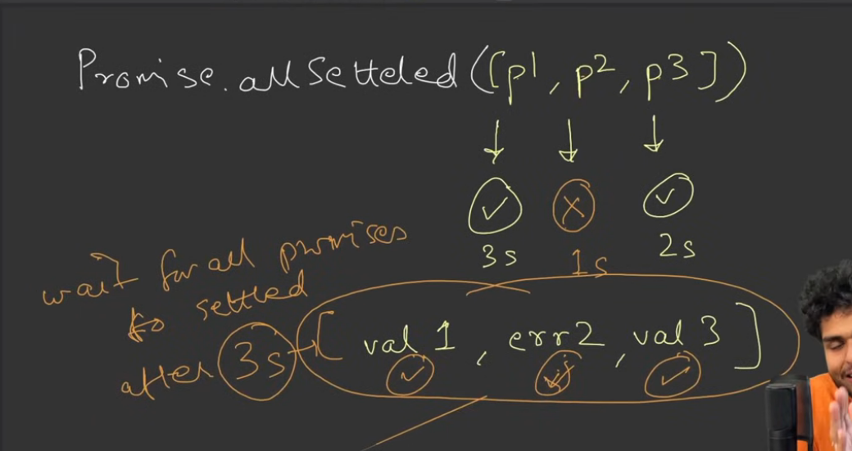

* + 1. Promise.race()

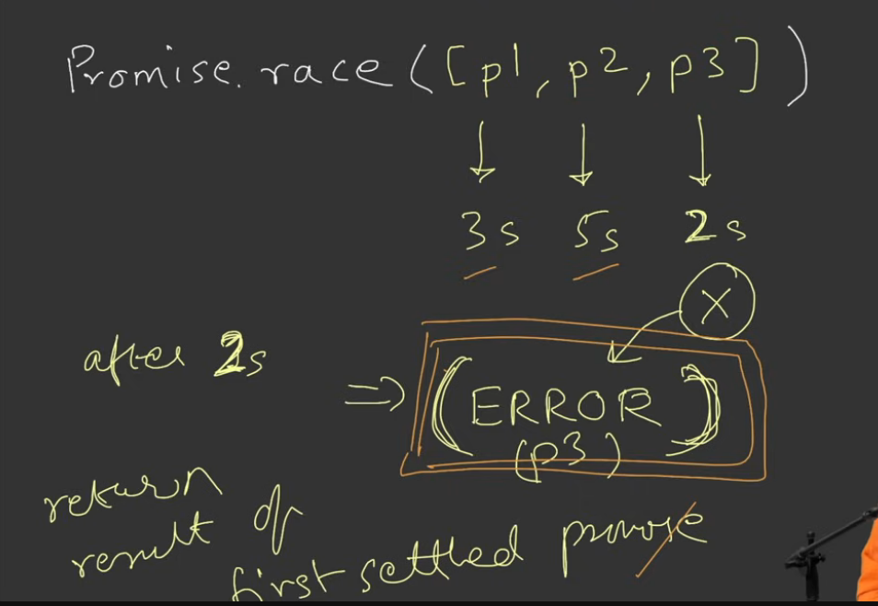

* + 1. Promise.any()

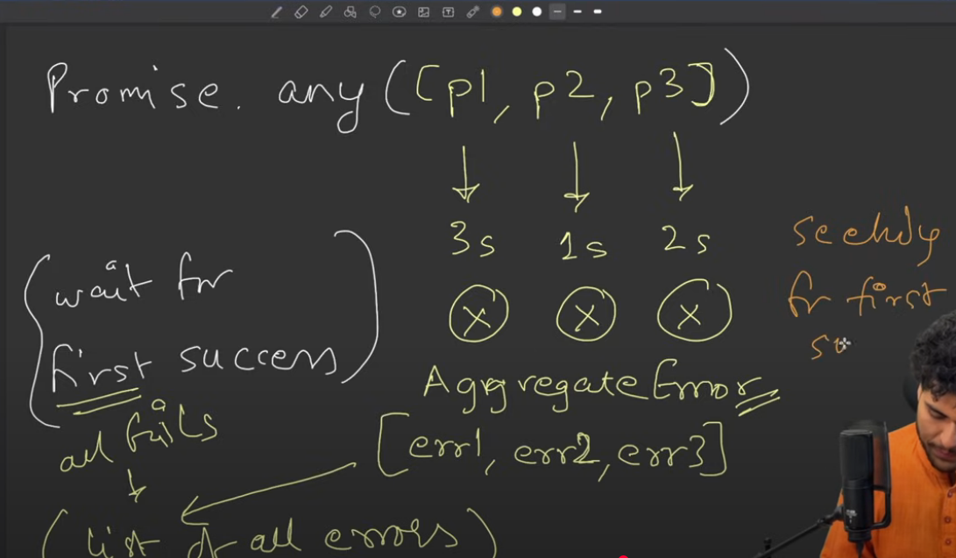

Code examples-

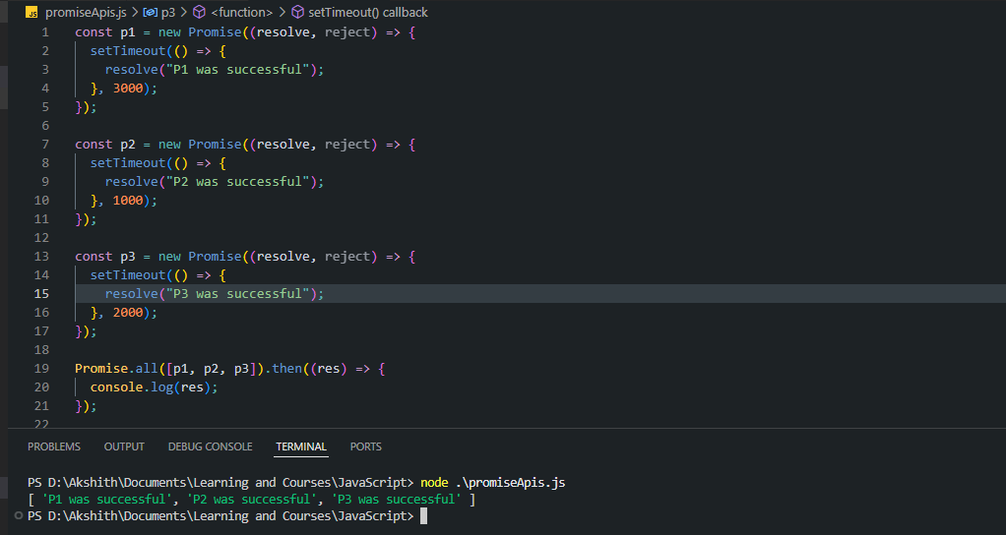

2.

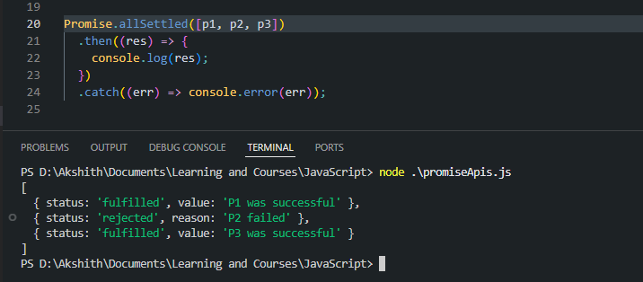

3.

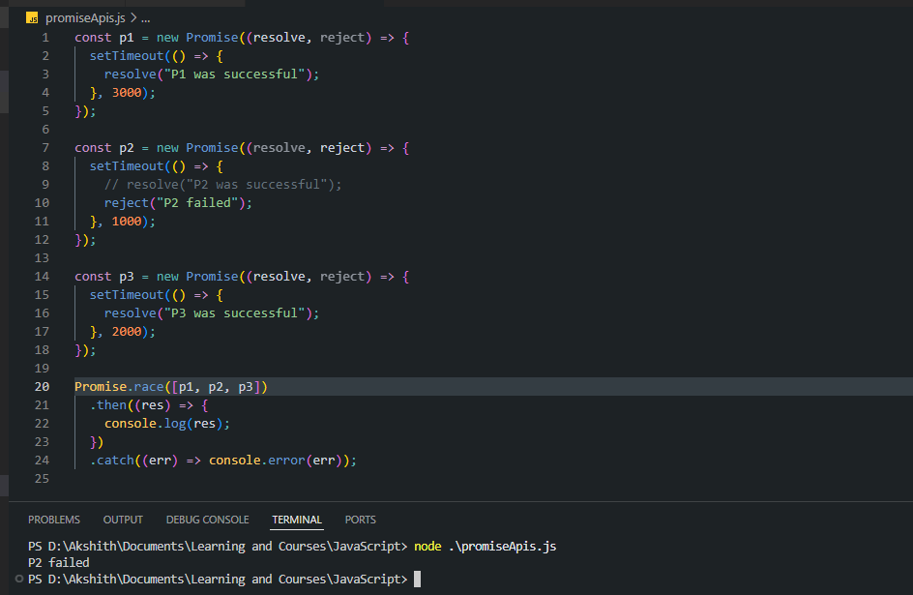

4.

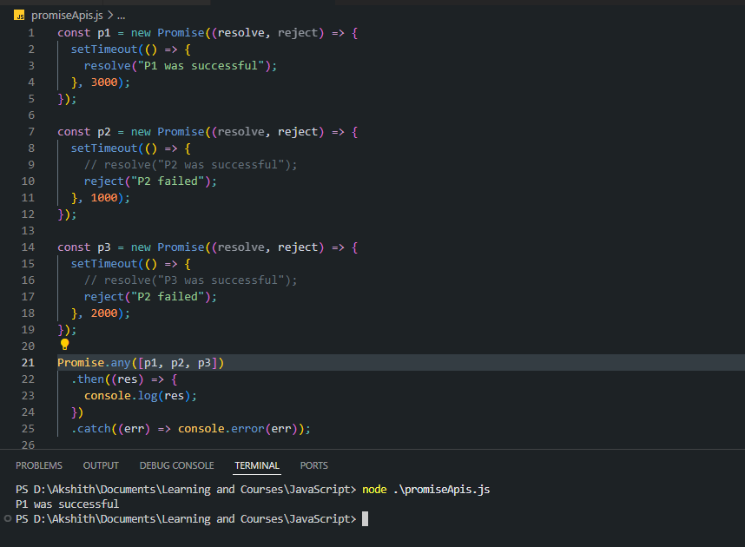

4b.

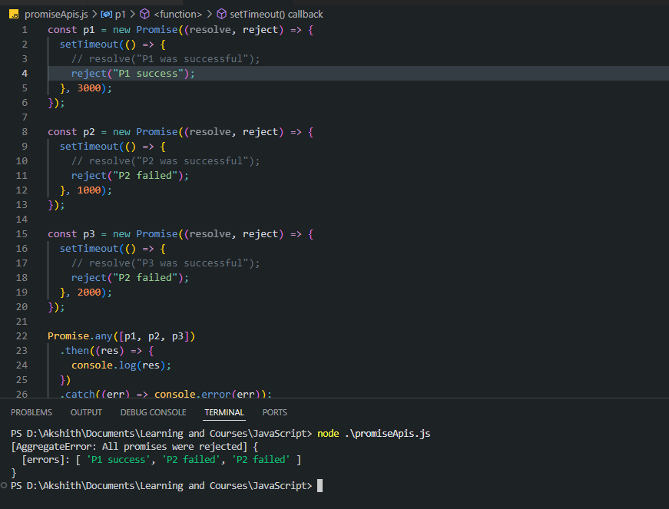

13/5/2025 – Async Await

Topics covered

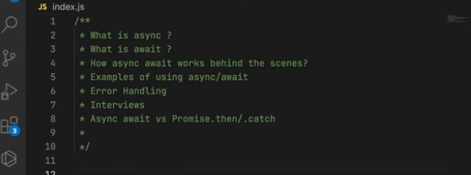

1. Async fxn always returns promise or value wrapped in a promise if we return str,bool,int.

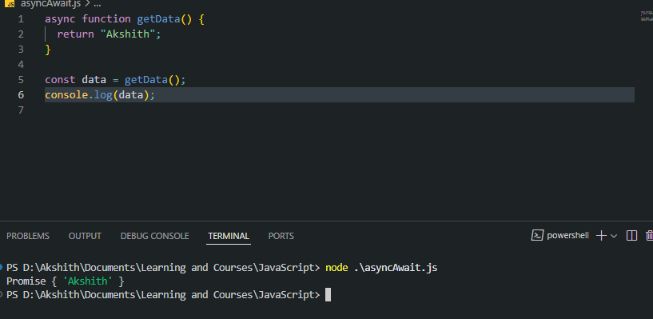

2. How to return the value from the promise (by using the then fxn as previosly seen)

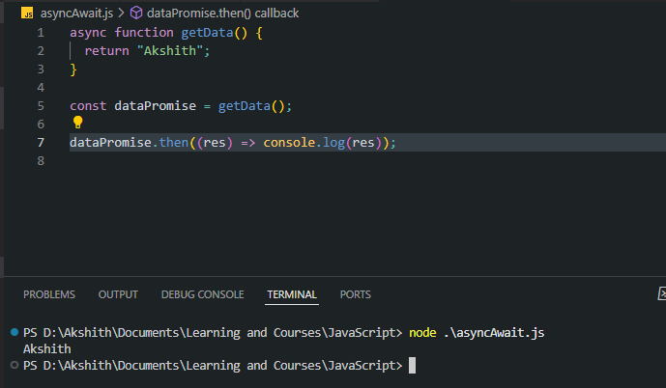

3. If we return a promise only from an async function it will return the promise as is and will not be wrapped inside another promise.

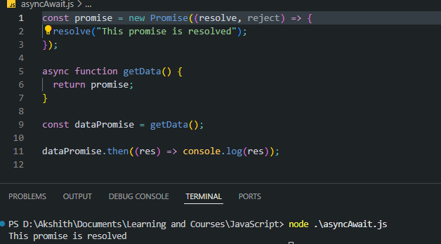

Just summary –

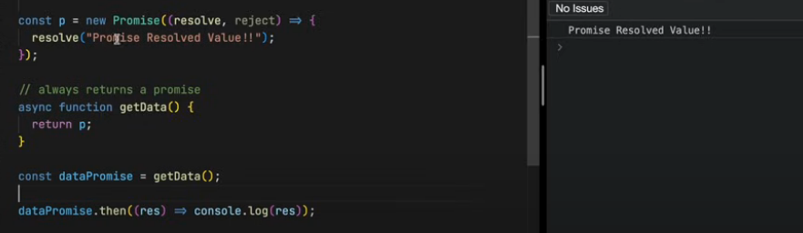

4.How we used to handle promises before using async await –

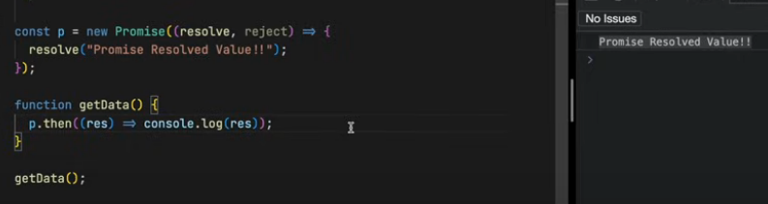

Trivia – Both these return the same result, as returning a promise within an async function will not wrap it inside another promise, it ill return the same promise.

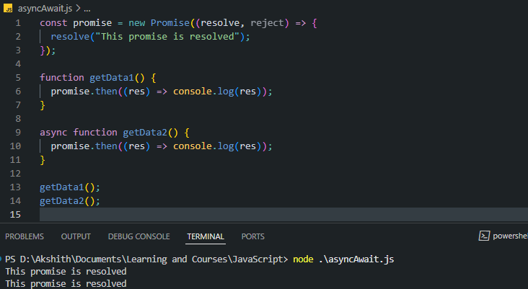

5. Using await, returns the value inside the promise once it has been resolved. Then we can use it and process it.

**Await can only be used inside an async function**

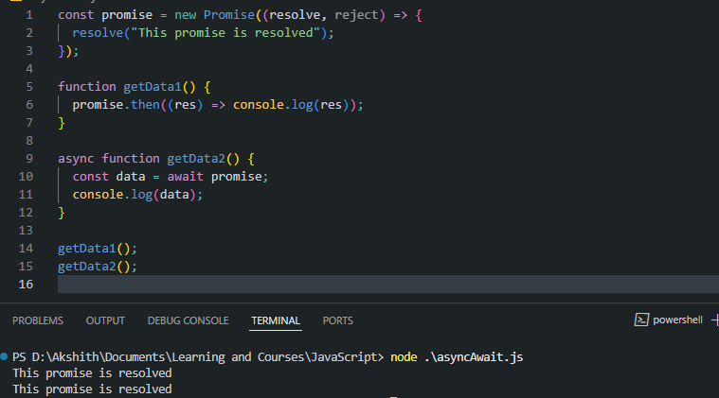

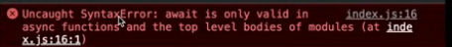

6.Classic difference between using promises with .then() vs using async await.

Case 1- Using .then() method

As previosly discussed, time, tide and JS waits for none. In this code, as soon as getData1() is called, the setTimeout registers the CB function is the JS web APIs env and begins execution. JS goes to the next line and prints the ‘Hi welcome’. Js engine will not wait for promise to be resolved. Once the timer runs, the CB fxn of setTimeout in added to the CS and then executed. Hence we see the below output.

This was confusing for many developers. They used to think program will wait

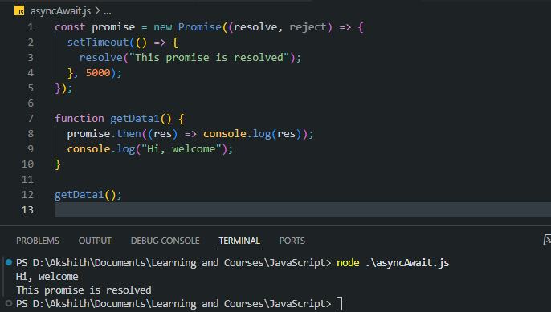

Case 2- Using async-await

Mind blown, program waits. ‘Hello World’ is printed immediately. When the await line is encountered the program/ JS egine waits for 10s, for the promise to be resolved and then it will print the Namaste JS line and the promise resolved line.

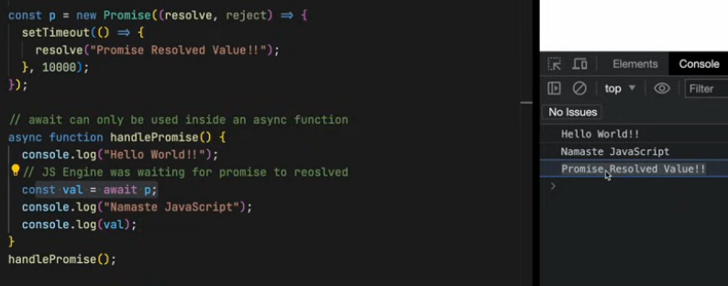

**Special case (likely possible in interview) –** We are awaiting the same promise twice in our code.

Here hello world is printed immediately. Then after 10 seconds everything else is printed.

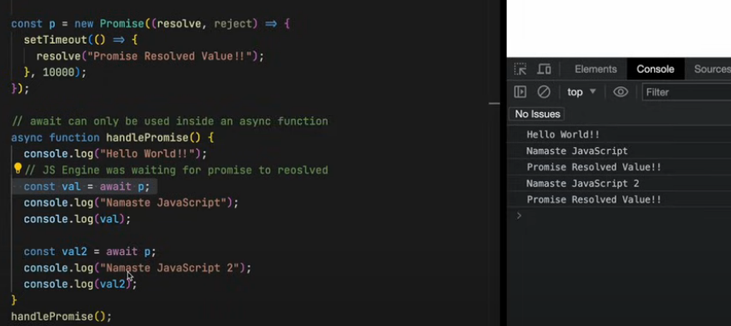

In the below case even though 2nd promise is resolved after 5secs, first Hello world is printed immediately. Then code waits for 10 secs and then all other lines are printed. So JS is trying to maintain the order of execution and promises are resolving parallely. Total exec time 10s.

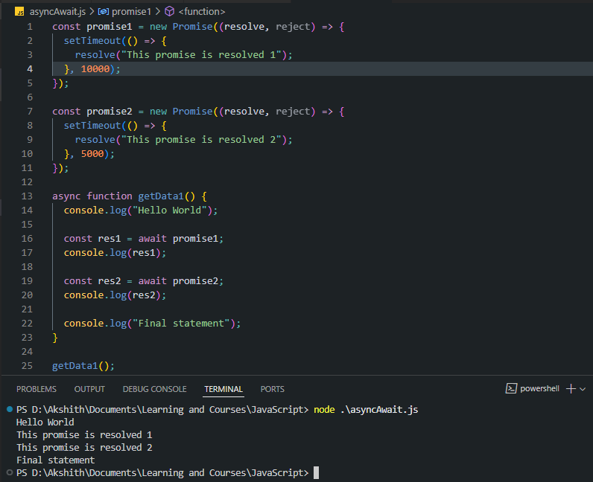

**Now if we resverse the order of time** – Here hello world gets printed immideately, after 5 seconds promise 1 is resolved and the value is printed on screen and after another 5 seconds (total 10 seconds) the promise 2 is resolved and result is printed on screen.

Total execution time is 10s.

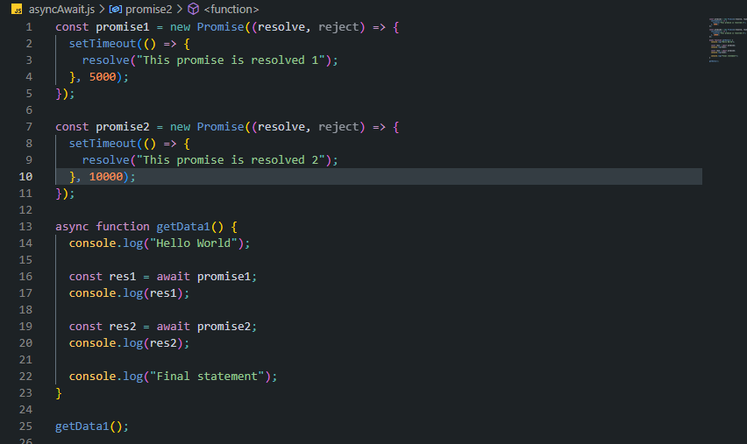

Above actually JS is still waiting for none. The code **appears to be waiting**  but actually it is not waiting, the call stack is not occupied.

Actual Working of async await for the above example Behind the scenes (14/5/2025) –

Working of call stack –

Initially call stac is empty, as soon has getData1() is called it will come inside CS. Since JS is single threaded and Sync. It will execute line by line

It will log Hellow World to the console.

It will encounter the first await line (await promise1)

JS doesn’t wait here. It will **suspend** the getData1() function and this fxn will be removed from the call stack. JS will look for the next function in the code and begin its execution.

In suspended state the function will wait until p1 is resolved and then only move to the next line.

P1 resolved after 5s. After 5s getData1() will again come into the CS. And it will start executing from where it left.

Again when JS encounters the await keyword, function will be suspended and moved out of the CS. Once the promise is resolved it is added back to the CS and execution will continue.

Ques). for those who thinks if code reaches await of p1 suspends function execution and after 5 sec it should go to await p2 the timer for p2 should start and should take 10 sec there so overall function execution should be 15sec? Ans). the timer ticking doesn't start at await, instead it started in the beginning of the code only where promise was declared.

**1. Web APIs Environment (e.g., setTimeout)**

When you do something like:

const promise = new Promise((resolve) => {

setTimeout(() => {

resolve("done");

}, 1000);

});

**Promises are resolved (i.e., fulfilled or rejected) in the Web APIs environment**, and their continuation (.then, await) is handled **via the Event Loop**, **not** the Call Stack directly.

* setTimeout is a **Web API** (provided by the browser or Node.js).
* It registers a timer and returns immediately.
* After 1000ms, the callback (resolve(...)) is pushed into the **Task Queue**.

**2. Promise Resolution Happens in Web APIs**

* resolve() is called inside the callback (which is in the Web APIs environment).
* Once called, it **schedules the .then() or await continuation** to run via the **microtask queue** (also called the **Job Queue**).

**3. Call Stack + Event Loop**

* When the call stack is empty, the **event loop**:
  1. First drains the **microtask queue** (promise callbacks, queueMicrotask, etc.)
  2. Then processes **macrotasks** (e.g., setTimeout, setInterval, IO).

So await or .then() is executed as a **microtask**, only **after** the current synchronous code finishes executing and the call stack clears.

Real world examples of async await using fetch

1. Check how fetch works in notes

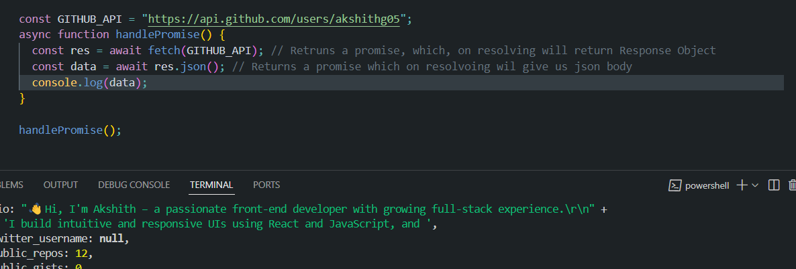

Handinling errors- We will use a try catch block in async await

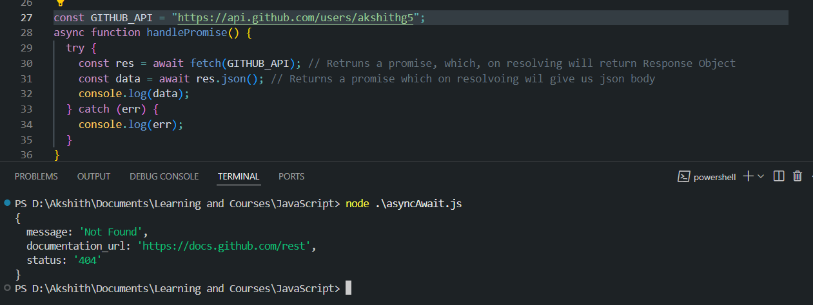

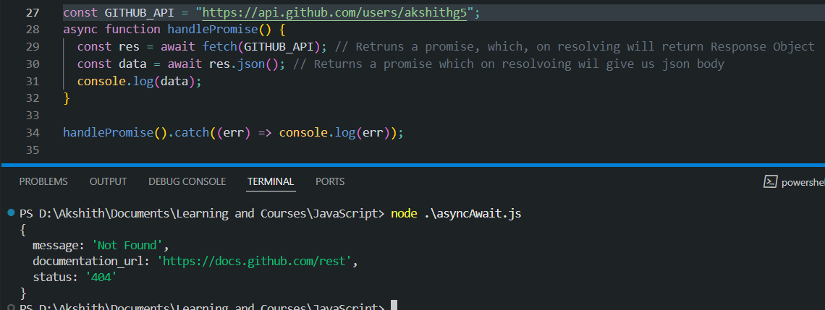

Above is another way of handling errors with old .catch() method as well.

16/5/25 – The This keyword

Topics covered-

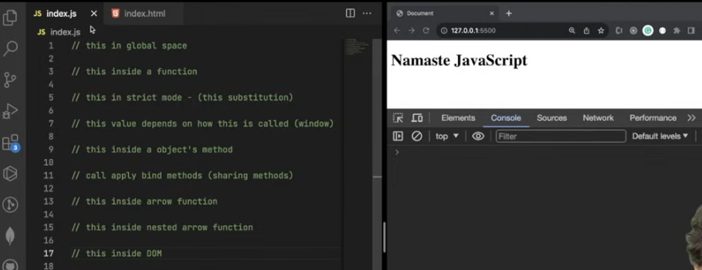

1.“this” keyword in the global space or global scope-

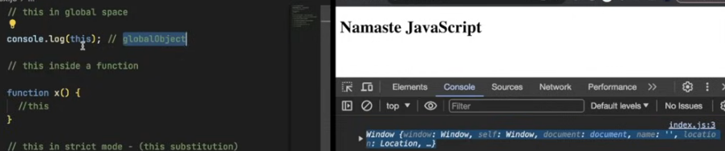

1. In strict mode if we try to print “this” within a function we will get “undefined”.But if we call it on the window object as shown on the last line of the below ss, it will print the global window object.

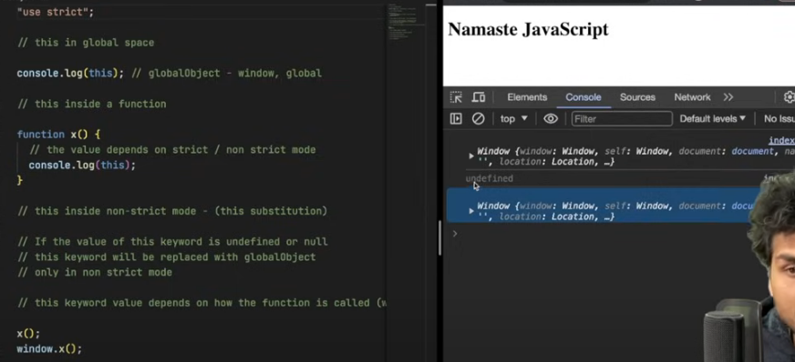

**1. First console.log(this); (Global Scope)**

In **non-strict mode**, at the **top level of a script in a browser**, this refers to the **global object**, which is:

**2. Inside function x()**

When you call a function like x(); (i.e., as a regular function, not as a method of an object), the value of this inside it depends on whether **strict mode** is enabled:

* In **non-strict mode**, this inside x() will also refer to the **global object (window)**.
* In **strict mode**, this would be undefined.

When the this is referenced inside the object it will point to the object itself and print the object.

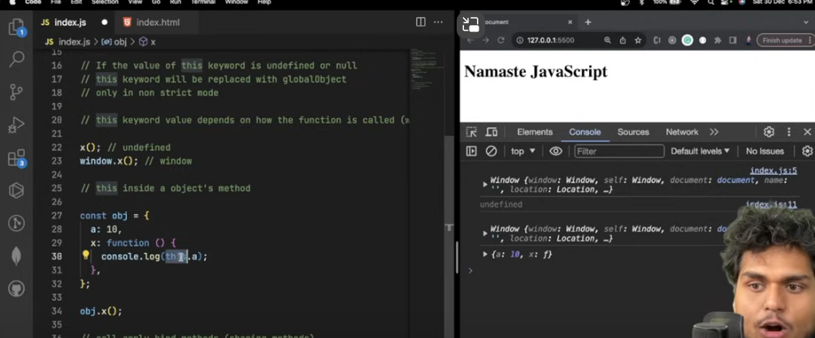

Call, apply and bind methods – These methods are used for sharing functions amongst objects. Now we can see below that the printName function is definied for the first object. Now if we want that method to be available on the second object as what to do?

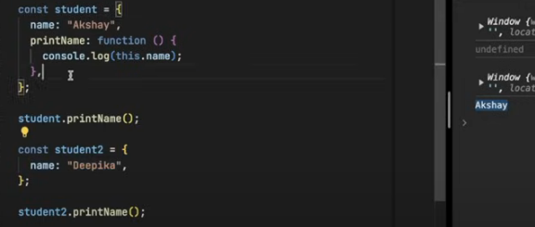

We can do that by overriding the value

The value of the this keyword can be modified by using the call, apply and bind method.

Using the call method to call a function of one object on another object in which the method does not exist.

Call() method

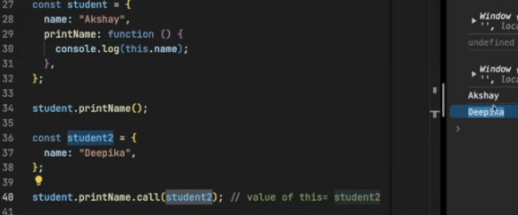

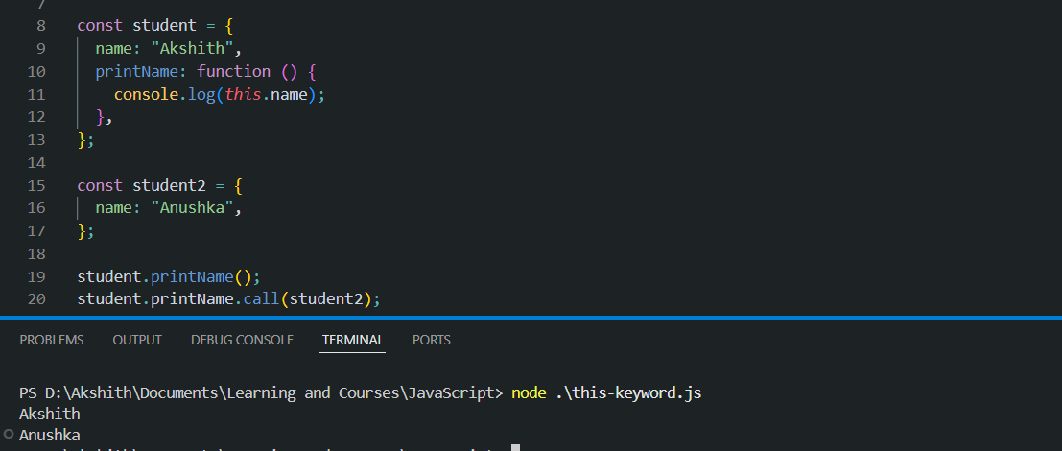

Another use case of call, how it is actually used in prod –

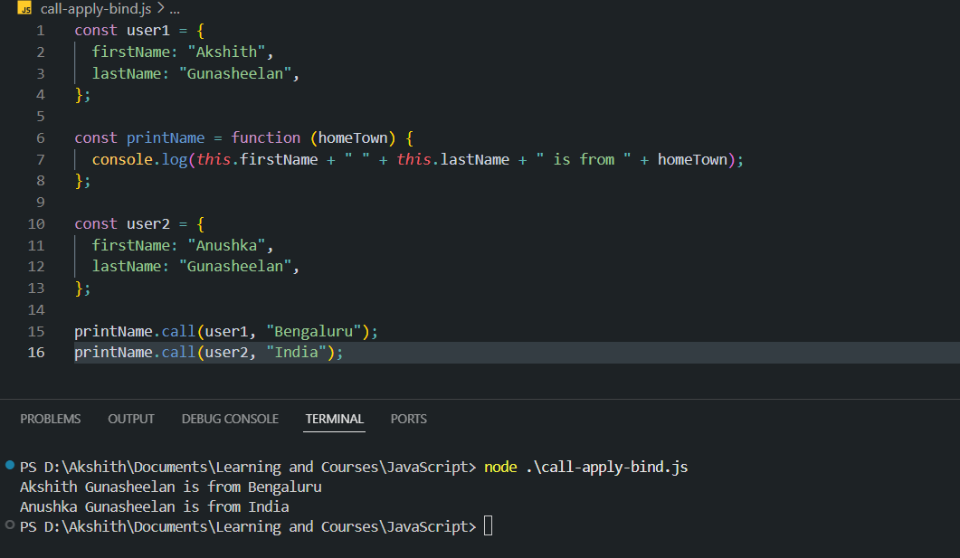

Apply() method – the only difference between the call and apply method is the way we are passing in the arguments to the function. In apply we pass the this object and then a list of arguments. See example below

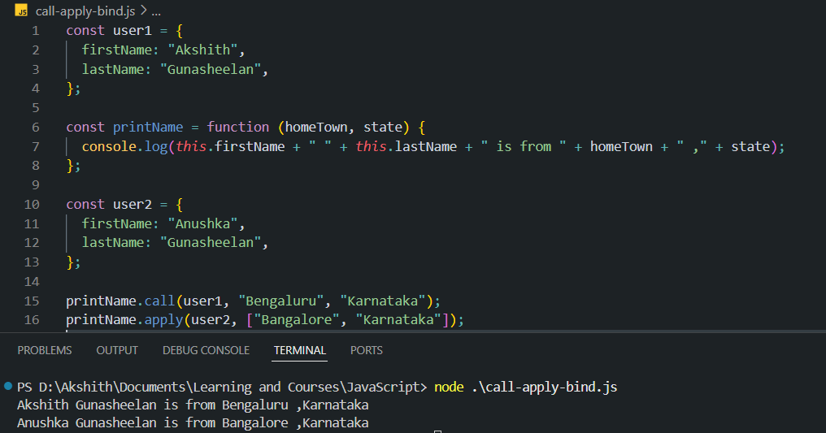

Bind() method - it is very similar to the call method. 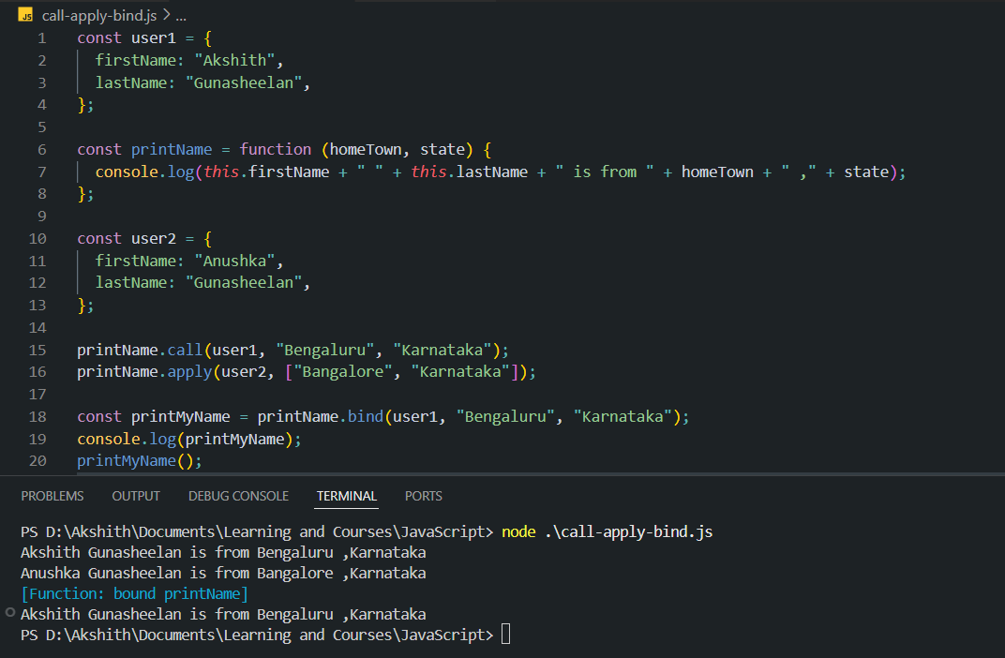

This keyword in arrow functions will print the value of the lexical env it is in.

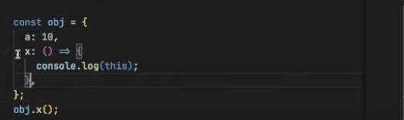

Op will be window object

1. Here op will be the object the arrow function is enclosed in.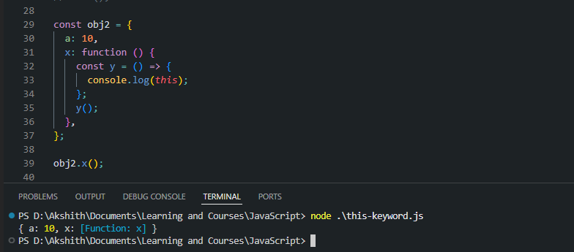

This element on DoM elements.

Summary-

* 1. "this" in global scope always points to the globalObject (globalObject depends on javascript runtime env) 2. "this" in a function depends on
  2. things a. strict / non strict mode (in strict mode, "this" is undefined, in non strict mode, "this substitution" takes place and "this" points to globalObject) b. how the function is being invoked (if we invoke the function using the global object in strict mode, then "this" will point to that globalObject)
  3. "this" in a method always points to the object that is used to invoke the method.
  4. call, apply & bind are used to share a method with another object (hence the "this" keyword reference would also change accordingly)
  5. "this" inside arrow function refers to the enclosing lexical context
  6. "this" in DOM points to the HTML element itself on which it is being used